**Experiment 1: Reading resistor from color codes and AVO meter**

* 1. **Reading resistor from color band**

Read the values of the five different resistors given below using the color codes. Also consider the tolerance value.

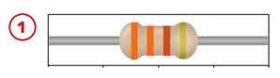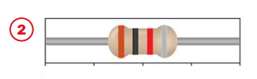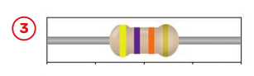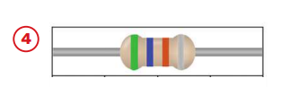

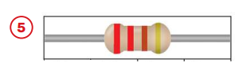

* 1. **Reading resistor from AVO meter**

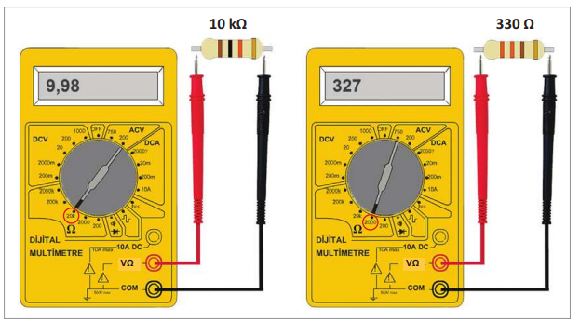

For the most accurate measurement, the tap switch should be set to the closest but not smaller tap to the size to be measured. If the value of the quantity to be measured is not known clearly, the tap switch should be set to the maximum value and the tap switch must be reduced until the value is measured.

Read the values of the five different resistors given in step 1.1 by using AVO meter. Compare your result.



**Three Band Resistor Color Codes**

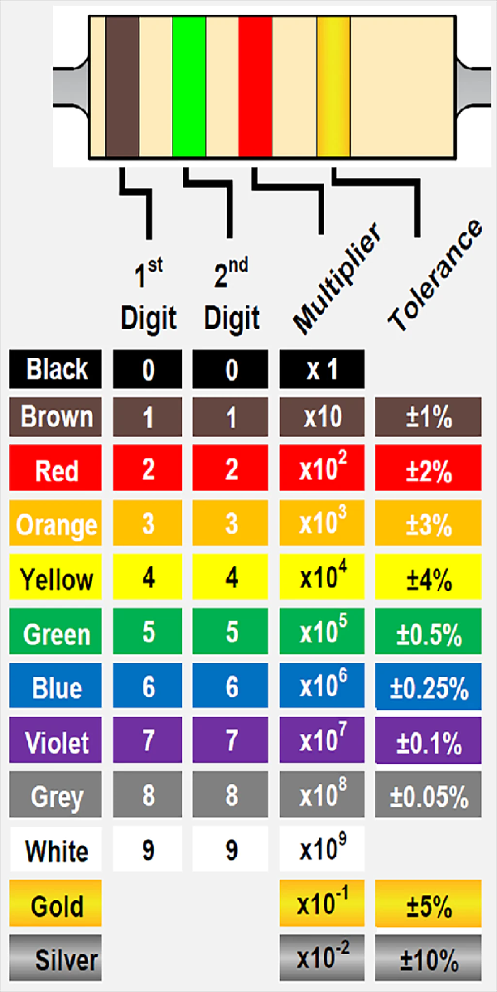

**Experiment 2: Ohm s Law**

In this experiment, you will construct a simple circuit using a single known resistance, R. Then you will use an ammeter to measure the current, I, through the resistance and a voltmeter to measure the potential difference, V, across the resistance. With this data, you can check the validity of Ohm's Law (V = IR) in the circuit. Connect the circuit shown below using a fixed resistance R = 1 kΩ.

 An ammeter must always connect in series. As the ammeter measures current in a circuit/loop it must be connected along with a circuit element.

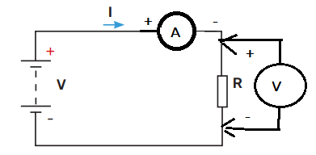

You can get different readings of the current I and voltage V by varying the battery source. Record the value of the current through the resistance and the voltage across it. A Voltmeter measure voltage across a circuit element, hence it must be connected parallel to the element that we have to measure voltage.

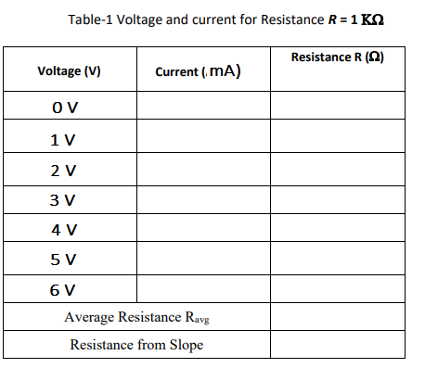

Plot a graph of the voltage (V) and the current (I), with V on vertical axis and (I) on horizontal axis. Draw the best straight line fit of the data. Determine the slope of the straight line which is the resistance R in this case.

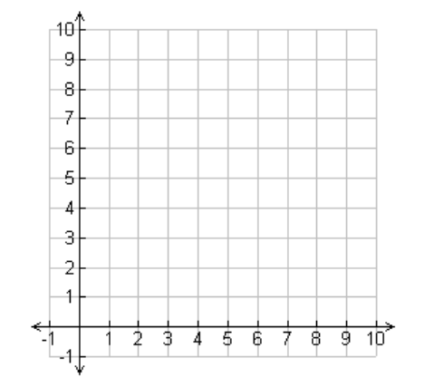

**Experiment 3: Series and Parallel Circuits**

**3.1 Series Circuit**

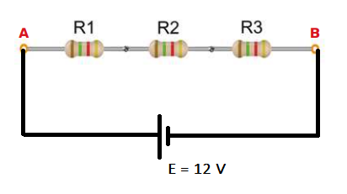The circuit shown in Fig.3.1 is a simple series circuit with three different resistor. Before starting the experiment, answer the following questions where **R1= 1kΩ, R2= 2.2 kΩ and R3= 3.3 kΩ**

**Fig.3.1** Series circuit

**Analysis of Circuit in Fig.3.1**

1. What is the total resistance of the circuit?
2. What is the value of current through each resistor?
3. What is the voltage across each resistor?
4. What is the total current flowing through the power supply into the entire circuit?
5. What is the power dissipated (as heat) in each resistor?

**Construct and study series circuit**.

1. Measure the current through each resistor (IR1, IR2 and IR3) showing on a circuit diagram exactly how and where the ammeter is connected in the circuit for each of the measurements.
2. Measure the voltage across each resistor (VR1, VR2 and VR3) showing on a circuit diagram exactly how and where the voltmeter is connected in the circuit for each of the measurements.
3. Measure the total current flowing through the circuit (I) showing on a circuit diagram exactly how and where the ammeter is connected in the circuit.

Complete Table 3.1 with your theoretical and practical findings

|  |  |  |  |  |  |  |
| --- | --- | --- | --- | --- | --- | --- |
|  | **IR1 (mA)** | **IR2 (mA)** | **IR3 (mA)** | **VR1 (V)** | **VR2 (V)** | **VR3 (V)** |
| **Theoretical** |  |  |  |  |  |  |
| **Practical** |  |  |  |  |  |  |

**Table 3.1**

**How to find the total resistance of the circuit in Fig.3.1 practically?**

1. One way is RT = where E is your applied voltage to the circuit and I is the total current flowing through the circuit.

RT = ………….

1. 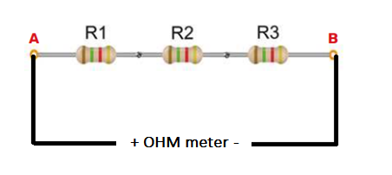Second way is use Ohm section of multimeter. By disconnecting 12 V power supply from the circuit use your AVO to measure the total resistance of the circuit.

RT = ………….

Compare your theoretical result with practical results.

**3.2 Parallel Circuit**

The circuit shown in Fig.3.2 is a simple parallel circuit with three different resistor. Before starting the experiment, answer the following questions where **R1= 1kΩ, R2= 2.2 kΩ and R3= 3.3 kΩ**

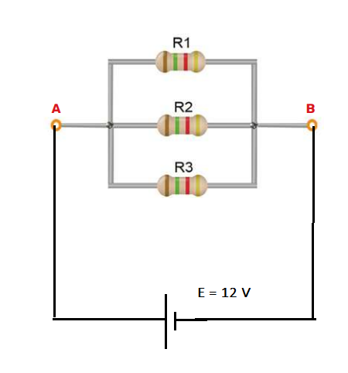

**Fig.3.2** Parallel circuit

**Analysis of Circuit in Fig.3.2**

1. What is the total resistance of the circuit?
2. What is the value of current through each resistor?
3. What is the voltage across each resistor?
4. What is the total current flowing through the power supply into the entire circuit?
5. What is the power dissipated (as heat) in each resistor?

**Construct and study parallel circuit**.

1. Measure the current through each resistor (IR1, IR2 and IR3) showing on a circuit diagram exactly how and where the ammeter is connected in the circuit for each of the measurements.
2. Measure the voltage across each resistor (VR1, VR2 and VR3) showing on a circuit diagram exactly how and where the voltmeter is connected in the circuit for each of the measurements.
3. Measure the total current flowing through the circuit (I) showing on a circuit diagram exactly how and where the ammeter is connected in the circuit.

Complete Table 3.2 with your theoretical and practical findings

|  |  |  |  |  |  |  |
| --- | --- | --- | --- | --- | --- | --- |
|  | **IR1 (mA)** | **IR2 (mA)** | **IR3 (mA)** | **VR1 (V)** | **VR2 (V)** | **VR3 (V)** |
| **Theoretical** |  |  |  |  |  |  |
| **Practical** |  |  |  |  |  |  |

**Table 3.2**

**How to find the total resistance of the circuit in Fig.3.2 practically?**

1. One way is RT = where E is your applied voltage to the circuit and I is the total current flowing through the circuit.

RT = ………….

1. Second way is use Ohm section of multimeter. By disconnecting 12 V power supply from the circuit use your AVO to measure the total resistance of the circuit.

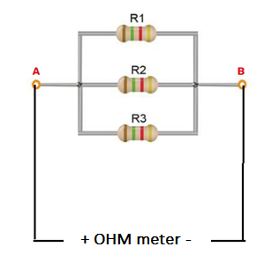

RT = ………….

Compare your theoretical result with practical results.

**Experiment 4: Combined Series and Parallel Circuits**

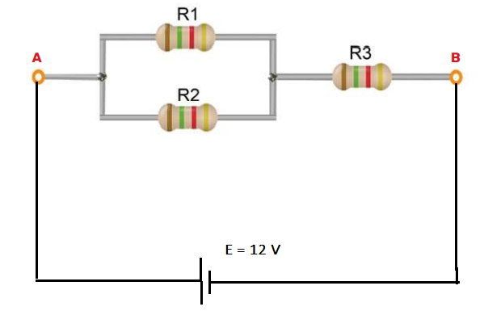The circuit shown in **Fig.4.1** is a combined series and parallel circuit with three different resistor. Before starting the experiment, answer the following questions where **R1= 1kΩ, R2= 2.2 kΩ and R3= 3.3 kΩ**

**Fig.4.1**

**Analysis of Circuit in Fig.4.1**

1. What is the total resistance of the circuit?
2. What is the value of current through each resistor?
3. What is the voltage across each resistor?
4. What is the total current flowing through the power supply into the entire circuit?
5. What is the power dissipated (as heat) in each resistor?

**Construct and study combined series and parallel circuit**.

1. Measure the current through each resistor (IR1, IR2 and IR3) showing on a circuit diagram exactly how and where the ammeter is connected in the circuit for each of the measurements.
2. Measure the voltage across each resistor (VR1, VR2 and VR3) showing on a circuit diagram exactly how and where the voltmeter is connected in the circuit for each of the measurements.
3. Measure the total current flowing through the circuit (I) showing on a circuit diagram exactly how and where the ammeter is connected in the circuit.

Complete Table 4.1 with your theoretical and practical findings

|  |  |  |  |  |  |  |
| --- | --- | --- | --- | --- | --- | --- |
|  | **IR1 (mA)** | **IR2 (mA)** | **IR3 (mA)** | **VR1 (V)** | **VR2 (V)** | **VR3 (V)** |
| **Theoretical** |  |  |  |  |  |  |
| **Practical** |  |  |  |  |  |  |

**Table 4.1**

**How to find the total resistance of the circuit in Fig.3.2 practically?**

1. One way is RT = where E is your applied voltage to the circuit and I is the total current flowing through the circuit.

RT = ………….

1. Second way is use Ohm section of multimeter. By disconnecting 12 V power supply from the circuit use your AVO to measure the total resistance of the circuit.



RT = ………….

Compare your theoretical result with practical results.

**Experiment 5:**

**Measuring the time constant of an RC circuit using a Digital Oscilloscope**

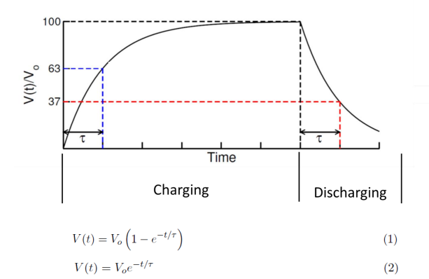Time constant of an RC circuit can be measured in two different ways using a digital oscilloscope. The charging and the discharging curves of an RC circuit are shown is shown in the following figure. The time constant theoretically given by τ = RC, is the time taken by the circuit to charge the capacitor from 0 to 0.632 times of the maximum voltage. This can be derived from the charging equation of an RC circuit given in equation 1.

In case of discharging, the time constant is the amount of time required to reduce the voltage across the capacitor from the maximum value to 0.368 of the maximum value. This relation can be derived from equation 2 by replacing t by τ

**5.1** Warm up to Digital Oscilloscope and Function Generator

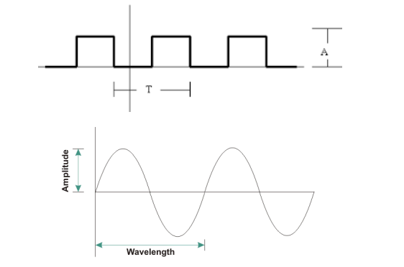**1**.

Get a function generator and connect its output to the oscilloscope and display the output as sinusoidal wave, square wave and triangular wave. Set the frequency at 100Hz and the amplitude at 5V. Get snapshot of each wave and attach them with your report.



**2.**

Practice to change the frequency and the amplitude of the generator output. Learn to measure them from the oscilloscope. Get help from the instructor.

**3.**

Make sure you are doing it correctly. Get help from the instructor.

* 1. **RC Circuit**

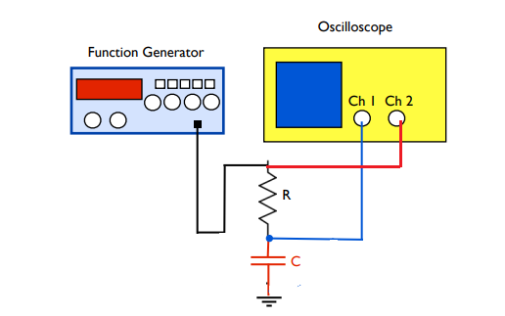

**Fig.5.1**. RC circuit where R = 10kΩ and C = 100 nF

Complete the RC circuit on the circuit board as shown in the Fig.5.1. Get help from the instructor if required.

Connect the function generator output to channel 2 using a BNC Tee and the voltage across the capacitor to channel 1. Set the output of the generator amplitude at 5V and the frequency at 100 Hz. Show your oscilloscope display to the instructor to make sure it is correct. Measure the time constant from the charging and discharging curves. To measure the time constant precisely make sure the corresponding curves fully cover the display screen as shown below. Once the time constant is measured from both curves, next overlay the channel 1 and channel 2 curves on top of each other and take a snapshot. This snapshot also should go on your report.

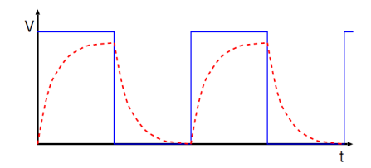

**Fig. 5.2** Square wave applied to RC circuit in blue and voltage across capacitor in dashed red vs. time.

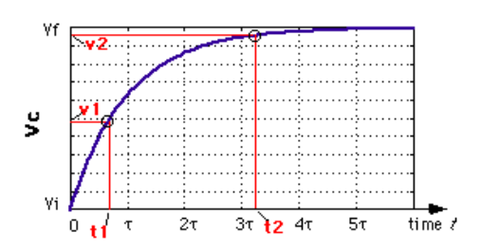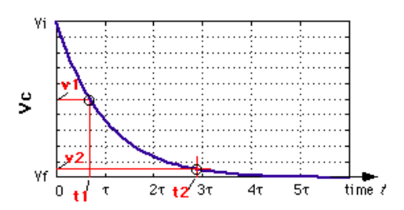

Now record the time (τ) it takes for the voltage of the capacitor to reach 63% of the highest voltage. Similarly, record the time when the discharging voltage decreases 36% from its highest voltage. These two values should be roughly identical.

**Step 5.1** For R = 10 kΩ, complete the following Table 5.1

|  |  |  |
| --- | --- | --- |
|  | **Charging time constant (msec)** | **Discharging time constant (msec)** |
| **Theoretical calculations** |  |  |
| **Practical measurements** |  |  |

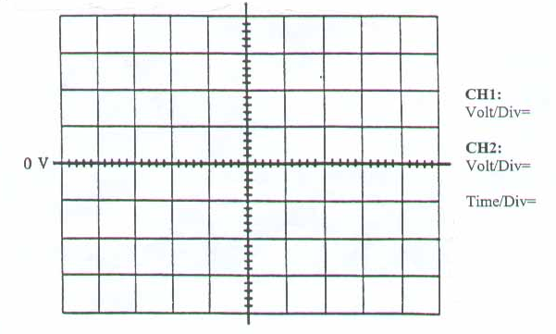**Table 5.1**

**Step 5.2** For R = 100 kΩ, complete the following Table 5.2

|  |  |  |
| --- | --- | --- |
|  | **Charging time constant (msec)** | **Discharging time constant (msec)** |
| **Theoretical calculations** |  |  |
| **Practical measurements** |  |  |

**Table 5.2**

**Questions**

As you know τ = RC is the time constant in an RC circuit. Using the equations in 1 or 2 find out expressions for the times required to charge from zero to half of the maximum voltage or to discharge from maximum voltage to the half voltage. Apply your theoretical findings to **Step 5.2** and compare with practical measurements.

**Theoretical calculations for half charging and discharging time.**

**Practical measurent for half charging and discharging time.**

**Experiment 6: Diode in DC Circuits**

Before starting the experiment, for **Fig. 6.1** please calculate and fill the required current and voltages shown on **Table 6.1** by considering the bias state of diodes. Get help from the instructor. By constructing your circuit on breadboard measure the related parameters in Table 6.1 and fill it.

|  |  |  |  |  |  |  |  |
| --- | --- | --- | --- | --- | --- | --- | --- |
|  | ID1 (mA) | ID2 (mA) | IR1 (mA) | VD1 (Volt) | VD2 (Volt) | VR1 (Volt) | VR2 (Volt) |
| Theoretical |  |  |  |  |  |  |  |
| Practical |  |  |  |  |  |  |  |

**Table 6.1**

**Fig 6.1**

Before starting the experiment, for **Fig. 6.2** please calculate and fill the required current and voltages shown on **Table 6.2** by considering the bias state of diodes. Get help from the instructor. By constructing your circuit on breadboard measure the related parameters in Table 6.2 and fill it.

|  |  |  |  |  |  |  |  |
| --- | --- | --- | --- | --- | --- | --- | --- |
|  | ID1 (mA) | ID2 (mA) | IR1 (mA) | VD1 (Volt) | VD2 (Volt) | VR1 (Volt) | VR2 (Volt) |
| Theoretical |  |  |  |  |  |  |  |
| Practical |  |  |  |  |  |  |  |

**Table 6.2**

**Fig 6.2**

**Experiment 7: Zener Diode and Regulation**

The aim of this experiment is to recognize and understand the effect of voltage regulators with Zener diodes, which keep the output voltage constant at the operating voltage value of Zener against the changes in the input voltage and load value in AC/DC converters.

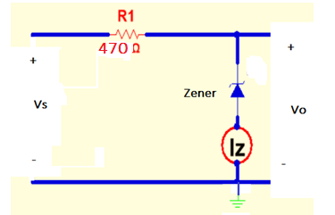

**Fig.7.1** Voltage regulator without load.

Increase the dc voltage *Vs* in steps of 1.0 V up to 12V. Record the voltage *Vz* across and the current *Iz* through the zener diode in Table 7.1.

|  |  |  |
| --- | --- | --- |
| ***Vs***  **(V)** | ***Vz***  **(V)** | ***IZ***  **(mA)** |
| **0** |  |  |
| **1** |  |  |
| **2.** |  |  |
| **3.** |  |  |
| **4.** |  |  |
| **5** |  |  |
| **6** |  |  |
| **7** |  |  |
| **8** |  |  |
| **9** |  |  |
| **10** |  |  |
| **11** |  |  |
| **12** |  |  |

**Table 7.1**

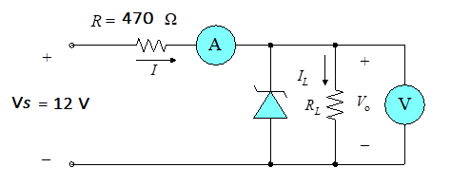

**Fig.7.2** Voltage regulator without load.

Construct the circuit shown in Fig.7.2 and then record the measured values in Table 7.2

|  |  |  |  |  |  |
| --- | --- | --- | --- | --- | --- |
| **RL** | **VR** | **Vo** | **IR** | **IZ** | **IL** |
| 470 Ω |  |  |  |  |  |
| 1kΩ |  |  |  |  |  |
| 2.2kΩ |  |  |  |  |  |

**Table 7.2**

Calculate **only for** 1kΩ load the **VR , Vo , IR , IZ and IL**

State any conclusions that you may draw from this experiment regarding the characteristics and application of zener diodes.

**Experiment 8: Half wave and Full wave rectifiers**

A **rectifier** is an electrical device that converts [alternating current](http://en.wikipedia.org/wiki/Alternating_current) (AC) to [direct current](http://en.wikipedia.org/wiki/Direct_current) (DC).

In half wave rectification, either the positive or negative half of the AC wave is passed, while the other half is blocked. A full-wave rectifier converts the whole of the input waveform to one of constant polarity (positive or negative) at its output.

While half-wave and full-wave rectifiers deliver a form of DC output. In order to produce steady DC from a rectified AC supply, a filter circuit is required. In its simplest form this is achieved by shunting the resistor with a capacitor. There will still remain an amount of AC ripple voltage where the ripple voltage is defined as the deviation of the load voltage from its average or dc value.

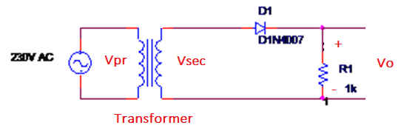

**Fig.8.1 Half wave rectifier**

**1**   
Construct the circuit as shown in Fig.8.1. Take the seconder supply of 12V rms sinusoidal wave from the seconder of transformer with a frequency of 50Hz. Put the DSO probes at input and sketch the input waveform obtained.

Measure the frequency, period, peak and peak to peak voltage on the DSO screen and record your result.

Frequency = ………… Hz Period = …………. msec Vp = …………….V and Vpp = …………… V



**2**.

Put the oscilloscope probes across the resistor and sketch the output waveform obtained. Measure and record the DC level of the output voltage either your DVM or DSO screen.

V avg = ,,,,,,,,,,,,,,,,, V



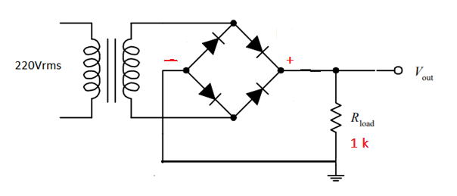

**Fig.8.2 Full wave rectifier**

**1.**

Construct the circuit as shown in Fig.8.2. Take the seconder supply of 12V rms sinusoidal wave from the seconder of transformer with a frequency of 50Hz. Put the oscilloscope probes across the seconder of the transformer.

Measure the frequency, period ,peak and peak to peak voltage on the DSO screen and record your result.

Frequency = ………… Hz Period = …………. msec Vp = …………….V and Vpp = …………… V



**2**.

Put the oscilloscope probes across the resistor and sketch the output waveform obtained.

Measure the frequency, period and peak voltage of the resistor load on the DSO screen and record your result.

Frequency = ………… Hz Period = …………. msec Vp = …………….V

Measure and record the DC level of the output voltage either your DVM or DSO screen.

V avg = ,,,,,,,,,,,,,,,,, V



**Experiment 9: Capacitor filter and voltage regulators**

**9.1 Capacitor filter**

We know that a pulsating dc wave is the output of the rectifier circuit. Our ultimate aim is to obtain a constant dc output. In order to obtain the constant dc output, we need to filter out the oscillations from the pulsating dc wave with the help of a diode capacitor combination.

The charging and discharging of a capacitor-input filter is such that it fills in the “gaps” between each peak value. The variations of voltage can be reduced by this action. This variation in voltage can be defined **as ripple voltage**.

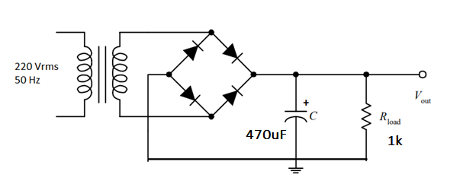Filtering of the signal can be done by the help of a large capacitor between the input voltage and the input terminal.

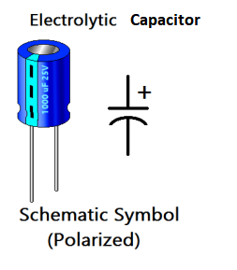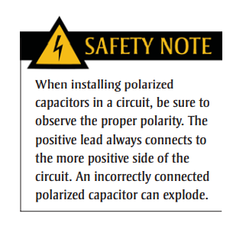

**Fig. 9.1** Capacitor filter circuit.

**1.**

Construct the circuit as shown in Fig.9.1. Put the oscilloscope probes across the resistor and observe the output waveform with / without capacitor on the DSO screen. Then measure the output voltage with your DVM and record here.

**Vo** = ……………….. V

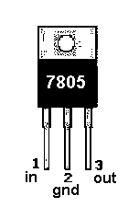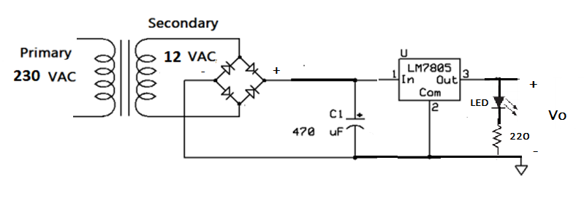**2.**

**Fig. 9.2** +5V Regulated DC power supply

Construct the circuit as shown in Fig.9.2 and then measure and record the followings with your AVO.

**V0** = …………. V **VC1** = ……………. V **V220** = ………………… V **ILED**= ……………. mA

**Experiment 10: Transistor and Application**

**1.**

How to make sure that the NPN and PNP transistors given to you are sound? You can use the test models of the transistor shown in **Fig10.1**



**Fig10.1 Test model of NPN and PNP transistor**

Turn your AVO`s rotary knob to the **diode position** and take the measurements shown in the Table 10.1.

|  |  |  |  |  |  |  |
| --- | --- | --- | --- | --- | --- | --- |
|  | B-E | B-C | C-E | E-B | C-B | E-C |
| NPN |  |  |  |  |  |  |

(a)

|  |  |  |  |  |  |  |
| --- | --- | --- | --- | --- | --- | --- |
|  | B-E | B-C | C-E | E-B | C-B | E-C |
| PNP |  |  |  |  |  |  |

(b)

**Table 10.1** Test results of NPN and PNP transistor

**2.**

Place your transistor in the transistor **gain compartment** on the Digital AVO. Then set the AVO's rotary dial to **hFE**. Record the DC current gains of both transistors (NPN and PNP) after measuring.

NPN β DC = ……………. PNP β DC = …………….

**3.**

Construct the circuit shown in **Fig.10.2** and then measure and record the required parameters in **Table 10.2**

|  |  |  |  |  |  |  |
| --- | --- | --- | --- | --- | --- | --- |
| **Vin** | **0 V** | **2V** | **4v** | **6V** | **8V** | **10V** |
| **IB** |  |  |  |  |  |  |
| **IC** |  |  |  |  |  |  |
| **VRc** |  |  |  |  |  |  |
| **VCE** |  |  |  |  |  |  |

**Fig.10.2**

**Table 10.2**

**4.**

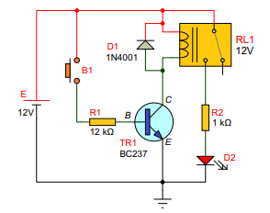

**Fig. 10.3**

The transistors shown in Fig.10.3 is used as a switch. Complete the instructions in **Table 10.3** and then decide about the ON and OFF positions of NPN transistor.

|  |  |  |  |  |  |
| --- | --- | --- | --- | --- | --- |
| **B1 State** | **IB (mA)** | **IC (mA)** | **VCE (V)** | **LED State** | **Tranasistor State** |
| **OFF** |  |  |  |  |  |
| **ON** |  |  |  |  |  |

**Table 10.3**

The transistors shown in **Fig.10.4** is used as a switch. Complete the instructions in **Table 10.4** and then decide about the ON and OFF positions of PNP transistor.

|  |  |  |  |  |  |
| --- | --- | --- | --- | --- | --- |
| **B1 State** | **IB (mA)** | **IE (mA)** | **VEC (V)** | **LED State** | **Tranasistor State** |
| **OFF** |  |  |  |  |  |
| **ON** |  |  |  |  |  |

**Table 10.4**

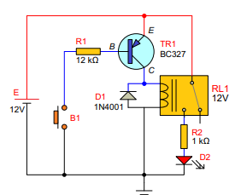

**Fig.10.4**

**5.**

Apply 1 Hz TTL pulses to the base of BC107 shown in **Fig. 10.5** and then observe status the LED .

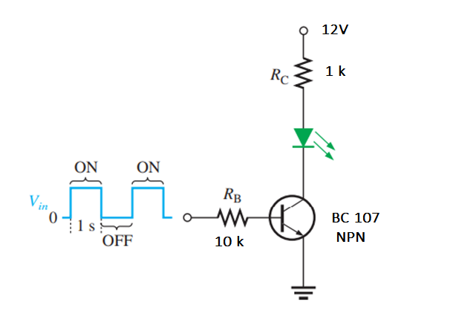

**Fig. 10.5**

**5.**

Apply 1 Hz TTL pulses to the base of BC107 shown in **Fig. 10.5** and then observe status the LED .

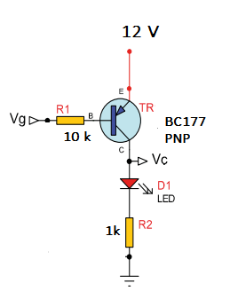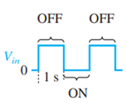

**Fig. 10.6**

**Experiment 11 Non-inverting Amplifier**

Before performing this lab experiment, it is important to learn following concepts:

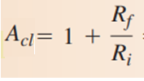An op-amp is a high-gain differential amplifier with very high input impedance. Very high open-loop gain allow for creating amplifiers with stable gain using feedback. In a non-inverting amplifier, the input signal is applied to non-inverting pin of the op-amp and there is no phase inversion between output and input. The amplification factor or gain can be controlled by external components - Resistor in feedback path Rf and input path Ri. Voltage gain of the non-inverting amplifier is given by

While designing op-amp circuits, one has to be careful about output saturation - if the gain or input signal is high enough to drive output beyond the supply voltages (Vcc and Vee ), the amplifier goes into saturation and output is limited to supply voltages.

For non-inverting amplifier, the gain depends on Rf and Ri. The following table shows the estimated (and expected) voltage gain for different combinations of Rf and Ri .

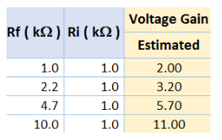

**Table 11.1** Estimated voltage gain for the non-inverting valtage amplifier

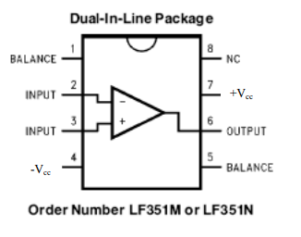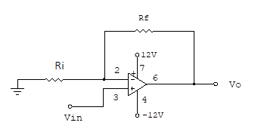

**Fig.11.1** Non-inverting amplifier experimental set-up

**DC Applications:**

**Table 11.2** Estimated voltage gain for the non-inverting valtage amplifier

Complete Table 11.2 experimentally for DC applications and record your results. Then compare your results with Table 11.1.

**AC Applications:**

|  |  |  |  |  |
| --- | --- | --- | --- | --- |
| **Ri**  **(kΩ)** | **Rf**  **(kΩ)** | **Vin**  **(Vp-p = 1V)**  **1kHz** | **Vo**  **(Vp-p)** | **ACL =** |
| **1** | **1** | **+1.5** |  |  |
| **1** | **2.2** | **+1.5** |  |  |
| **1** | **4.7** | **+1.5** |  |  |
| **1** | **10** | **+1.5** |  |  |
| **1** | **1** | **-1.5** |  |  |
| **1** | **2.2** | **-1.5** |  |  |
| **1** | **4.7** | **-1.5** |  |  |
| **1** | **10** | **-1.5** |  |  |

|  |  |  |  |  |
| --- | --- | --- | --- | --- |
| **Ri**  **(kΩ)** | **Rf**  **(kΩ)** | **Vin**  **DC** | **Vo**  **DC** | **ACL =** |
| **1** | **1** | **+1.5** |  |  |
| **1** | **2.2** | **+1.5** |  |  |
| **1** | **4.7** | **+1.5** |  |  |
| **1** | **10** | **+1.5** |  |  |
| **1** | **1** | **-1.5** |  |  |
| **1** | **2.2** | **-1.5** |  |  |
| **1** | **4.7** | **-1.5** |  |  |
| **1** | **10** | **-1.5** |  |  |

**Table 11.3** Estimated voltage gain for the non-inverting valtage amplifier

Complete Table 11.3 experimentally for DC applications and record your results. Then compare your results with Table 11.1.

**Experiment 12 Inverting Amplifier**

Before performing this lab experiment, it is important to learn following concepts:

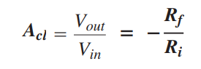An op-amp is a high-gain differential amplifier with very high input impedance. Very high open-loop gain allow for creating amplifiers with stable gain using feedback. In a non-inverting amplifier, the input signal is applied to non-inverting pin of the op-amp and there is no phase inversion between output and input. The amplification factor or gain can be controlled by external components - Resistor in feedback path Rf and input path Ri. Voltage gain of the -inverting amplifier is given by

While designing op-amp circuits, one has to be careful about output saturation - if the gain or input signal is high enough to drive output beyond the supply voltages (Vcc and Vee ), the amplifier goes into saturation and output is limited to supply voltages.

For non-inverting amplifier, the gain depends on Rf and Ri. The following table shows the estimated (and expected) voltage gain for different combinations of Rf and Ri .

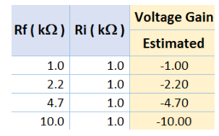

**Table 12.1** Estimated voltage gain for the inverting valtage amplifier

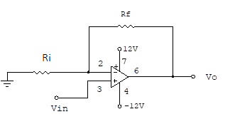

Fig.12.1 Inverting amplifier experimental set-up

|  |  |  |  |  |
| --- | --- | --- | --- | --- |
| **Ri**  **(kΩ)** | **Rf**  **(kΩ)** | **Vin**  **DC** | **Vo**  **DC** | **ACL =** |
| **1** | **1** | **+1.5** |  |  |
| **1** | **2.2** | **+1.5** |  |  |
| **1** | **4.7** | **+1.5** |  |  |
| **1** | **10** | **+1.5** |  |  |
| **1** | **1** | **-1.5** |  |  |
| **1** | **2.2** | **-1.5** |  |  |
| **1** | **4.7** | **-1.5** |  |  |
| **1** | **10** | **-1.5** |  |  |

**DC Applications:**

**Table 12.2** Estimated voltage gain for the inverting valtage amplifier

Complete Table 12.2 experimentally for DC applications and record your results. Then compare your results with Table 12.1.

**AC Applications:**

|  |  |  |  |  |
| --- | --- | --- | --- | --- |
| **Ri**  **(kΩ)** | **Rf**  **(kΩ)** | **Vin**  **(Vp-p = 1V)**  **1kHz** | **Vo**  **(Vp-p)** | **ACL =** |
| **1** | **1** | **+1.5** |  |  |
| **1** | **2.2** | **+1.5** |  |  |
| **1** | **4.7** | **+1.5** |  |  |
| **1** | **10** | **+1.5** |  |  |
| **1** | **1** | **-1.5** |  |  |
| **1** | **2.2** | **-1.5** |  |  |
| **1** | **4.7** | **-1.5** |  |  |
| **1** | **10** | **-1.5** |  |  |

**Table 12.3** Estimated voltage gain for the non-inverting valtage amplifier

Complete Table 12.3 experimentally for DC applications and record your results. Then compare your results with Table 12.1.

**Experiment 12 Summing Amplifier**

As it is known, the adder circuit is the circuit that sums the AC or DC signals applied to its input and transfers it to its output. In the inverting adder circuit, we can obtain a circuit called a mixer or mixer with a multi-input to the inverting input of the op-amp, as seen in Fig 12.1. In this circuit; the signals applied to the inverter input of the op-amp are added and transferred to the output. The input signals applied to the op-amp input are determined by its channel input resistance value and the value of the feedback resistor.

**Fig 12.1**.Adder circuit with two input

The output voltage Vo is given with the following equation;

V0 = - []

1. **Rf = 330 kΩ, R1= 220 kΩ ve R2 = 100 kΩ**

Construct Fig.1 with the above resistances and complete the measurement in Table 12.1

|  |  |  |  |
| --- | --- | --- | --- |
| **V1**  **DC Volt** | **V2**  **DC Volt** | **Vo**  **DC Volt** | **V0 = -[1.5V1+3.3 V2]**  **Theoretical** |
| 2 | -2 |  |  |
| -2 | 2 |  |  |
| 5 | -4 |  |  |
| 0 | 2 |  |  |
| -2 | 0 |  |  |

Table 12.1

1. **Rf = 330 kΩ, R1= 220 kΩ ve R2 = 100 kΩ**

Construct Fig.1 with the above resistances and complete the measurement in Table 12.2

|  |  |  |  |
| --- | --- | --- | --- |
| **V1**  **DC Volt** | **V2**  **DC Volt** | **Vo**  **DC Volt** | **V0 = -[V1+V2]** |
| 4 | -2 |  |  |
| 2 | 2 |  |  |
| 5 | -4 |  |  |
| 0 | 2 |  |  |
| -2 | 0 |  |  |

**Experiment 13 Basic Comparator Circuits**

Operational amplifiers are often used as comparators to compare the amplitude of one voltage with another. In this application, the op-amp is used in the open-loop configuration, with the input voltage on one input and a reference voltage on the other.

1. **Zero level Comparators**

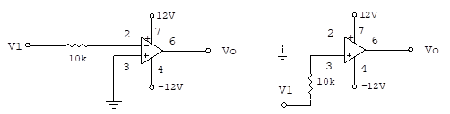

(a) (b)

**Fig 13.1**

**Step 1.**

|  |  |  |  |  |  |
| --- | --- | --- | --- | --- | --- |
| **V1**  **DC Volt** | **Vo**  **DC Volt**  **Theoretical** | **Vo**  **DC Volt**  **Practical** | **V1**  **DC Volt** | **Vo**  **DC Volt**  **Theoretical** | **Vo**  **DC Volt**  **Practical** |
| **2** |  |  | **2** |  |  |
| **3** |  |  | **3** |  |  |
| **-2** |  |  | **-2** |  |  |
| **-3** |  |  | **-3** |  |  |

(a) Table related with Fig 13.1(a) (b) Table related with Fig 13.1(b)

**Table 13.1**

**Step 2.**

Apply 2V peak, 1kHz triangular waveform to the input of Fig.13.1(a). Then sketch the output waveform by using scope to Fig 13.2.



**Fig 13.2**

**Step 3.**

Apply 2V peak, 1kHz triangular waveform to the input of Fig.13.1(b). Then sketch the output waveform by using scope to Fig 13.3.



**Fig 13.3**

1. **Non-Zero level Comparators**



**Fig 13.4**

**Step 1.**

Before constructing the circuit shown in Fig 13.4, calculate and record the theoretical referrence voltage. Then measure and record your circuit practical reference voltage.

Vref (theorical) = ........................ Vref (practical) = ..............................

Apply the voltages shown in Table 13.2 to the Fig 13.4 and then record your practical measurements. Compare your theoretical findings with the practical results.

|  |  |  |
| --- | --- | --- |
| **V1**  **DC Volt** | **Vo**  **DC Volt**  **Practical** | **Vo**  **DC Volt**  **Theoretical** |
| 3 |  |  |
| 4 |  |  |
| 5 |  |  |
| -3 |  |  |
| -4 |  |  |
| -5 |  |  |

**Tablo 13.2**

**Step 2.**

Apply 2V peak, 1kHz triangular waveform to the input of Fig.13.4. Then sketch the output waveform by using scope to Fig 13.5.



**Fig 13.5**

**Fig 13.5**

**Step 3.**

Before constructing the circuit shown in Fig 13.5, calculate and record the theoretical referrence voltage. Then measure and record your circuit practical reference voltage.

Vref (theorical) = ........................ Vref (practical) = ..............................

Apply the voltages shown in Table 13.3 to the Fig 13.5 and then record your practical measurements. Compare your theoretical findings with the practical results.

|  |  |  |
| --- | --- | --- |
| **V1**  **DC Volt** | **Vo**  **DC Volt**  **Practical** | **Vo**  **DC Volt**  **Theoretical** |
| 3 |  |  |
| 4 |  |  |
| 5 |  |  |
| -3 |  |  |
| -4 |  |  |
| -5 |  |  |

**Tablo 13.3**

**Step 4.**

Apply 2V peak, 1kHz triangular waveform to the input of Fig.13.5. Then sketch the output waveform by using scope to Fig 13.6.



**Fig 13.6**