Eastern Mediterranean University
Department of Computer Engineering

CMPE 318 Midterm Exam
2018 – 2019 Fall Semester
27 November 2018

Name, Surname : ________________
Student No : ________________

Instructor: Assoc. Prof. Zeki BAYRAM

Duration: 100 minutes

INSTRUCTIONS:

- Please answer all questions.
- Do not ask any question to the invigilator.
- GSM phones are not allowed in the exam room.
PART I : Short answer questions ( 80 pts)
- Give the internal representation of the Lisp list (A B (C) D)). (5 pts)

- Consider the ‘C’ language definition below.

struct student {
char name[10];
int age;
char gender;
} a[10][10];

Suppose an integer occupies 4 bytes, and the machine can address each byte individually. Assuming row-major addressing, and that &a[0][0] is 5000, what is the address of a[4][1].age? (5 pts)

Ans: _______________

- We are given the following grammar.
E → T T F
T → T a | b
F → c F | d

a) Give a leftmost derivation for the string " b a b d" (5 pts)

b) Give a parse tree for the string "b b a d"" (5 pts)

- We are given the following attribute grammar.

S → E {E.t = 2}
E → a E { E₀.v = 2 + E₁.v, E₁.t=E₀.t+2}
E → E b { E₀.v = 1 + E₁.v, E₁.t=E₀.t+5}
E → E c { E₀.v = 2 + E₁.v, E₁.t=E₀.t}
E → ε {E.v = E.t * 10}

Draw and annotated parse tree for the input "a c b". (10 pts)

- Show that the following grammar is ambiguous (5 pts)

E → E * T | T
T → a | b | E

- Give an equivalent grammar in BNF to the following grammar in EBNF. (10 pts)

S → [b | e | g] {h}

- Eliminate left recursion from the grammar given below (give an equivalent grammar without left recursion) (5 pts)

X→ X d g | t | X a b | X f

- Consider the grammar given below.

A → B c D | f A
B → a B | E
E → g | h
D → d

Assume we are writing a top-down recursive descent parser for this grammar. What is the function written for nonterminal B? (10 pts)

- We are given the following program in the language Gamma that has a syntax similar to C. Print just prints all of its arguments on a single line.

void b(){
int x =3; int y=2; z=10;

void e(){
int x=8;

a();
}

void a(){
int z=14;
d(x);
}

void d(int y){
print("d:", x+y+z);
}

e();
}

What is the output of the program if we call b(), and
i) Gamma uses static scoping? (5 pts)

ii) Gamma uses dynamic scoping? (5 pts)

- We are given a context free grammar, and its LR parsing tables below.

1. E → E + T
2. E → T
3. T → T * F
4. T → F
5. F → ( E )
6. F→ id

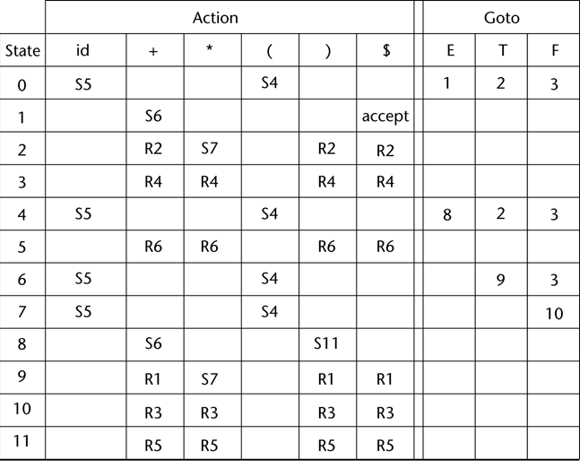

Give the configurations of the LR parser for the input " id + id ) $ ". ONLY THE FIRST 5 CONFIGURATIONS WILL BE GRADED. (10 pts)

Answer to question 10:

PART II: Fill in the blanks (20 pts)

- Haskell is a _____________________ language
- _____________________ is a purely object oriented language.
- Enumeration types are implemented as _____________________
- A binding is ___________________________ if it first occurs during execution or can change during execution of the program
- The ___________________________ of a variable is the time during which it is bound to a particular memory cell
- The _____________________ is used in all phases of the compilation process and stores information about identifiers.
- The part of the compiler that calls generates a tree representation of the input program is called the _____________________ .
- _______________________________ implementation systems initially translate programs to an intermediate language and then compile the intermediate language of the subprograms into machine code when they are called.,
- When a pointer points to a memory location that has been deallocated, it is called a __________________ pointer.
- When an allocated part of memory is inaccessible, this is called a memory ________________.

