Examples of Attribute Grammars

Example 1:
What is an attribute grammar?
• A context-free grammar augmented with a set of semantic rules
• Each symbol in the derivation has a set of values, or attributes
• The semantic rules specify how to compute a value for each attribute
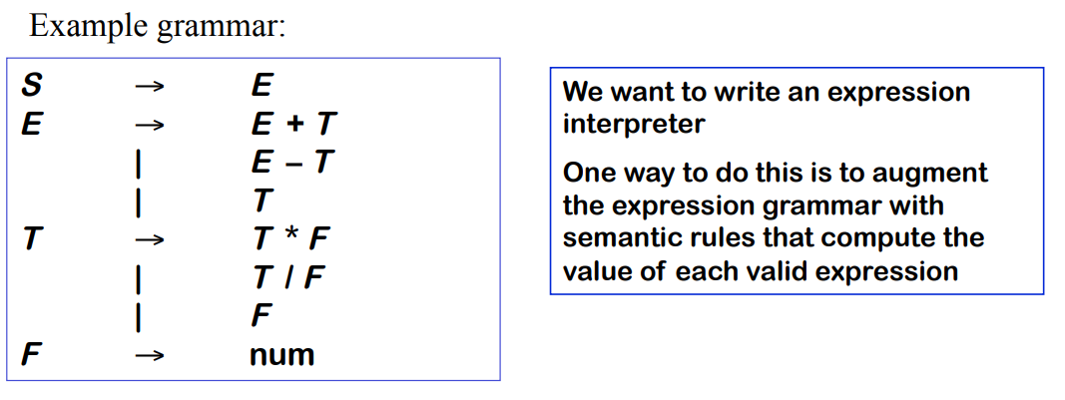
Expression Interpreter:
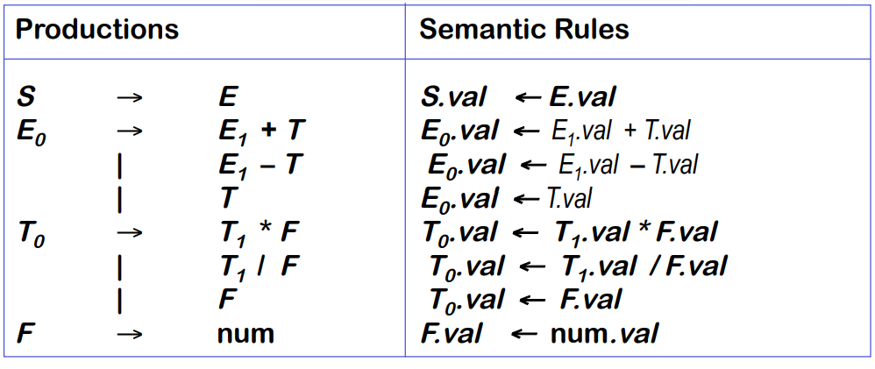
Notice that:
• Semantic rules use context information
• In this attribute grammar, attributes of grammar symbols on the lhs are computed using the attributes of grammar symbols on the rhs (such attributes are called synthesized attributes)

Use of sematic rules for the evaluation of expression : 10-2*3
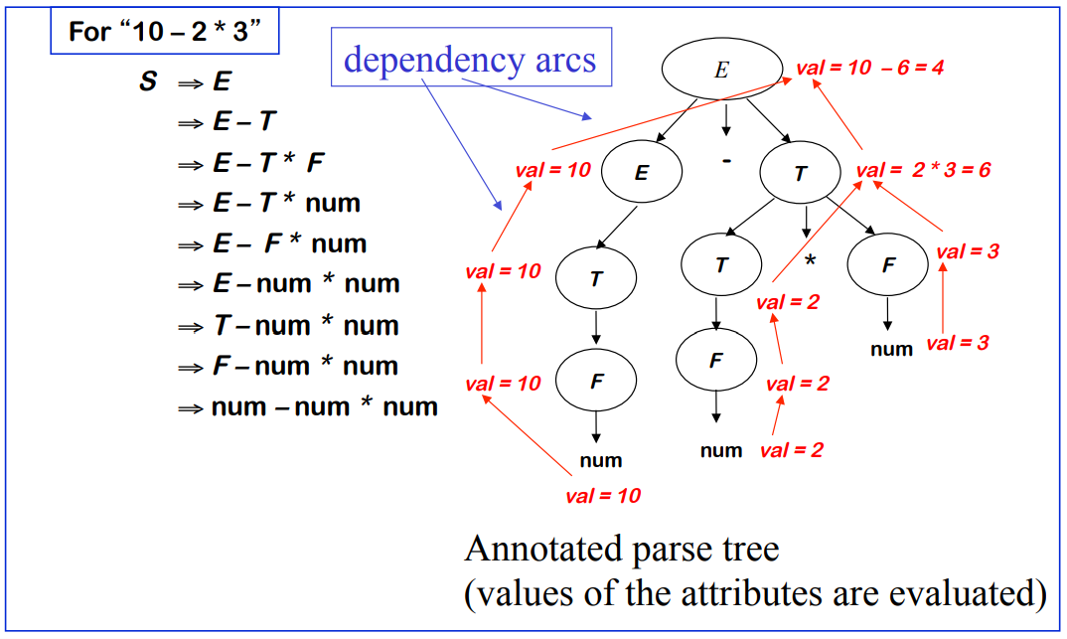

Attribute Grammar Production Rules:

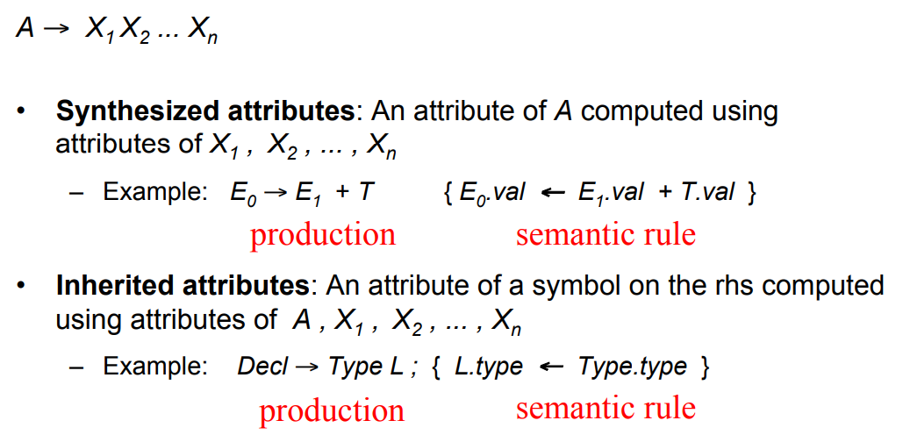
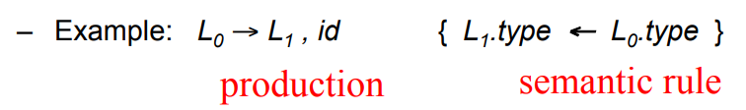

Example 2:
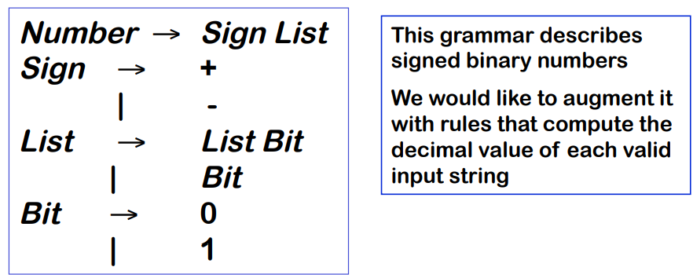
Example Parse Trees:
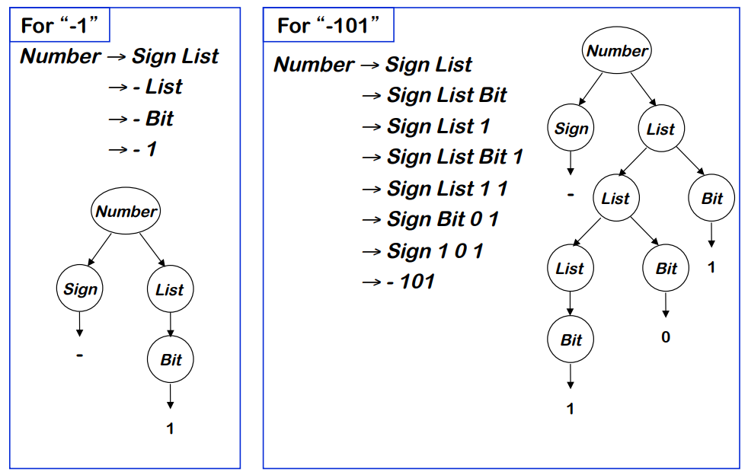

Attribute Grammar:
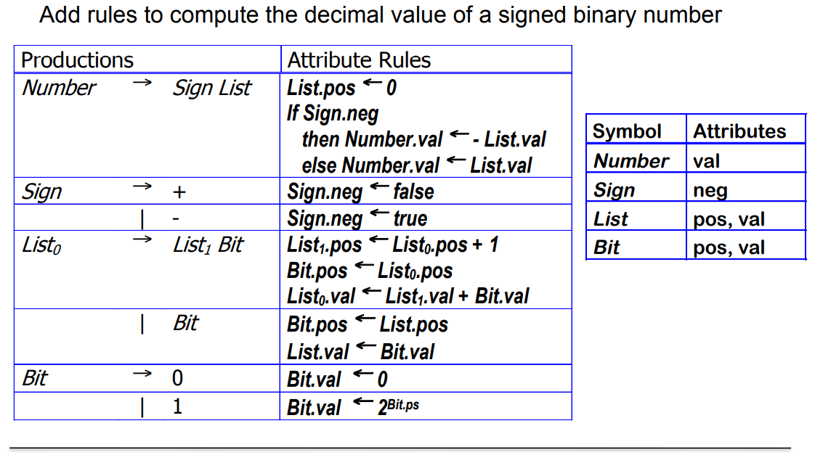
Example 3:
CFG Grammar:
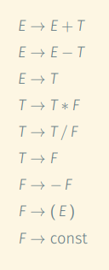

Corresponding Attribute Grammar defining Semantic Rules for evaluation:
