**How to Record Macro in Excel**

Macro recording and VBA Editor is at the “Developer Tab” of the Excel. But, by default this tab is not enabled. If you can already see the developer tab in the ribbon, go to the next section, else follow the below steps:

Right-click on any of the existing tabs in the ribbon and click on ‘Customize the Ribbon’ option. It will open the Excel Options dialogue box.

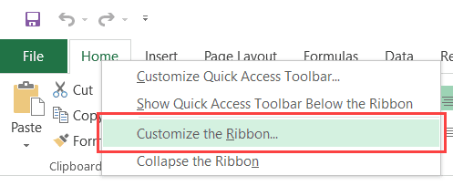

In the Excel Options dialogue box, you will have the Customize the Ribbon options. On the right, within the Main Tabs pane, check the Developer option.

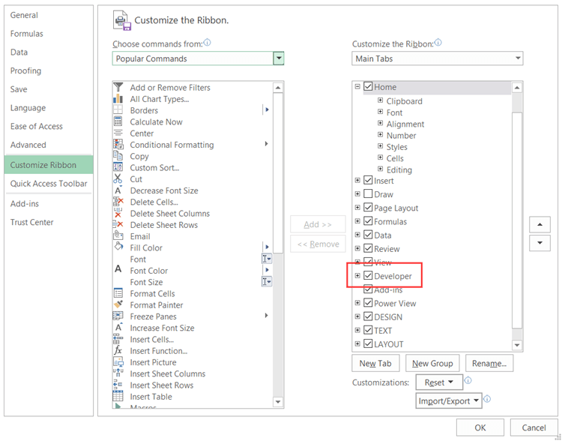

Click OK.

The above steps would make the Developer tab available in the ribbon area.

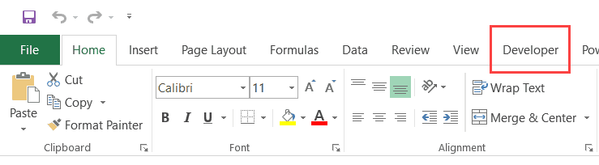

**Recording a Macro in Excel**

Now that we have everything in place, let’s learn how to record a macro in Excel.

Let’s record a very simple macro – one that selects a cell and enters the text ‘Excel’ in it. I am using the text ‘Excel’ while recording this macro, but feel free to enter your name or any other text that you like.

Here are the steps to record this macro:

1. Click the Developer tab.
2. In the Code group, click on the Macro button. This will open the ‘Record Macro’ dialog box.

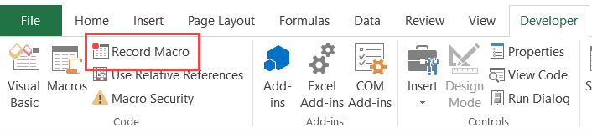

1. In the Record Macro dialog box, enter a name for your macro. I am using the name EnterText. There are some naming conditions that you need to follow when naming a macro. For example, you cannot use spaces in between. I usually prefer to keep my macro names as a single word, with different parts with a capitalized first alphabet. You can also use underscore to separate two words – such as Enter_Text.

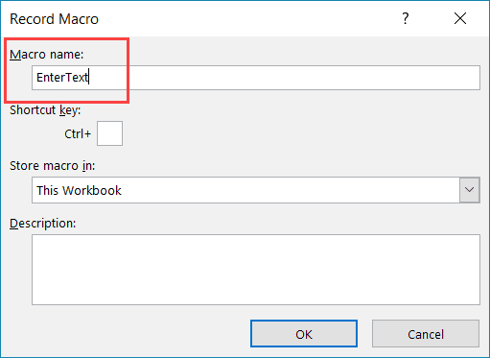

1. (Optional Step) You can assign a keyboard shortcut if you want. In this case, we will use the shortcut Control + Shift + N. Remember that the shortcut you assign here would override any existing shorcuts in your workbook. For example, if you assign the shortcut Control + S, you will not be able to use this for saving the workbook (instead, everytime you use it, it will execute the macro).

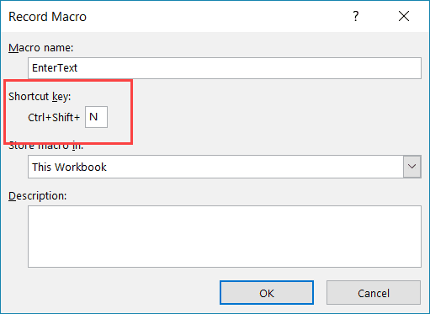

1. In the ‘Store macro in’ option, make sure ‘This Workbook’ is selected. This step ensures that the macro is a part of the workbook. It will be there when you save it and reopen again, or even if you share it with someone.

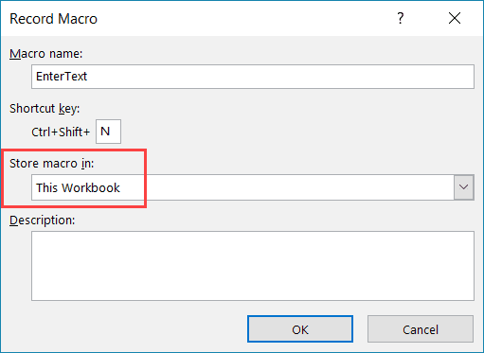

1. Click OK. As soon as you click OK, it starts to record your actions in Excel. You can see the ‘Stop recording’ button in the Developer tab, which indicates that the macro recording is in progress.
2. Do the steps you are wishing to record.

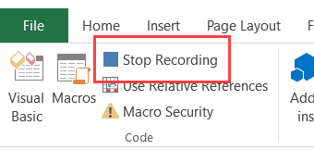

1. Click on the Stop Recording button the Developer tab

Congratulations! You have just recorded your first macro in Excel.

**Example 1:**

Record a macro for generate 10 random numbers as a column and get the average of them. Here, “Use Relative Reference” button has to be enabled before recording. Before starting the recording go to cell A1.

* Start recording
* Go to A2 and write the formula =ROUND(1+RAND()*10-1;0)
* Copy the formula and paste it to the cells A3 to A11
* Go to cell A1 and write the formula =AVERAGE(A2..A11)
* Stop recording
* Go to B1 and run the macro.

**Example 2:**

Before starting the recording go to cell A1.

* Start recording
* Write the formula =ROUND(1+RAND()*10-1;0)
* Copy the formula and paste it to the cells A2 to A10
* Go to cell A1 and press CTRL-A
* Use Conditional Formatting, Color Scale
* Stop recording
* Go to B1 and run the macro.

**Example 3:**

* Open the Developer / VisualBasic Editor (Alt – F11)
* Select the ThisWorkbook on the Project explorer on the left of the screen
* On the code part select and change the (General) to Workbook
* Complete the code as it will be:

***Private Sub Workbook_Open()***

***MsgBox "Hello World"***

***End Sub***

* Save and close the VisualBasic Editor
* Sawe the wokbook as macro enabled mode (.xlsm) and close it
* Re-open the file, see the popup message
* Put comment (‘) infront of the ***MsgBox "Hello World"***
* Save and re-test your program