Eastern Mediterranean University Department of Mechanical Engineering Laboratory Handout

COURSE: Thermal Power Engines (MENG446) –Group1
Semester: Spring (2017-2018)
Name of Experiment: The Heat Engine
Laboratory date: 4-6 th April 2018
Lab Assistant: Gorkem Ozankaya (e-mail: gorkem.ozankaya@cc.emu.edu.tr)

Instructor: Asst. Prof. Dr. Devrim Aydin (e-mail: devrim.aydin@emu.edu.tr)

Submitted by:
Student No:
Group No:
Date of experiment:
Date of submission:

------------------------------------------------------------------------------------------------------------

EVALUATION
Activity During Experiment & Procedure (30%)

Data , Results & Graphs (35%)

Discussion, Conclusion & Answer to Questions (30%)

Neat and tidy report writing (5%)

Overall Mark

Honor Pledge:
By submitting this report I pledge that I have neither given nor received unauthorized assistance on this assignment.
__________ ______________
Date Signature
- Objective and Introduction

The objective of the heat engine experiment is to comprehend the working principles of the heat engines, to plot the P-V diagram for the cycle experienced by the heat engine and to evaluate the work done by the heat engine.
The PASCO TD-8572 Heat Engine/Gas Law Apparatus is employed in this experiment. The equipment allows the amount of work done by thermal energy to be measured. The heart of this apparatus is a nearly friction-free piston/ cylinder system. The graphite piston fits snugly into a precision-ground Pyrex cylinder so that the system produces almost friction-free motion and negligible leakage.

- The Heat Engine/Gas Law Apparatus

The Heat Engine/Gas Law Apparatus is designed with two pressure ports with quick-connect fittings for connecting to the air chamber tubing. The apparatus can be connected to a Low Pressure Sensor for use with PASCO computer interfaces. The apparatus includes the following equipment:
- base apparatus (Figure 1)
  - piston diameter: 32.5 mm ± 0.1
  - mass of piston and platform: 35.0 g ± .06
- air chamber (Figure 2)
- 3 hose configurations: one with one-way check valves and one with a clamp (Figure 2), and one plain piece of tubing (not shown)
- 1 each, one-holed and two-holed rubber stopper:

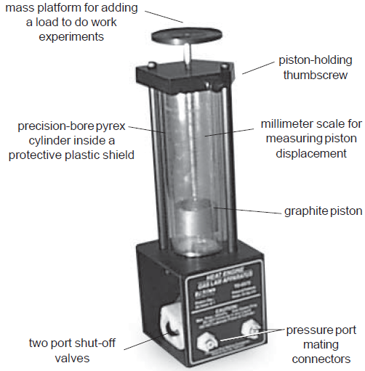

Figure 1: Base apparatus.
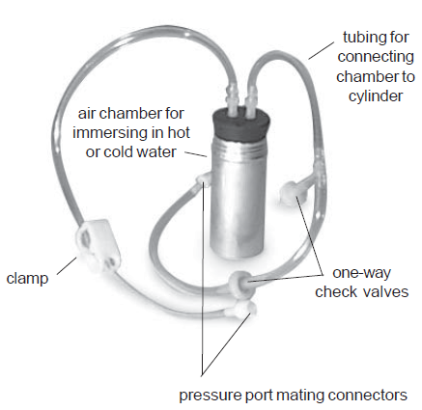
Figure 2: Air chamber and tubing.

- Theory

Your working group has been approached by the Newton Apple Company about testing a heat engine that lifts apples that vary in mass from 100 g to 200 g from a processing conveyer belt to the packing conveyer belt that is 10 cm higher. The engine you are to experiment with is a "real" thermal engine that can be taken through a four-stage expansion and compression cycle and that can do useful mechanical work by lifting small masses from one height to another.
In this experiment we would like you to verify experimentally that the useful mechanical work done in lifting a mass, m, through a vertical distance, y, is equal to the net thermodynamic work done during a cycle as determined by finding the enclosed area on a P-V diagram.
Essentially you are comparing useful mechanical work (see Figure 3):

$$W_{useful}=ma_{g}y$$ | (1)

with the accounting of work in an engine cycle as a function of pressure and volume changes given by the expression (see Figure 4):

$$W_{net}=\oint{PdV}$$ | (2)
Although you can prove mathematically that this relationship holds, the experimental verification will allow you to become familiar with the operation of a real heat engine.
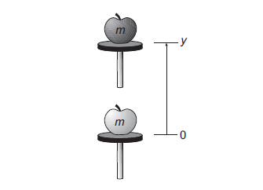
Figure 3: Doing useful mechanical work by lifting a mass, m, through a height, y.
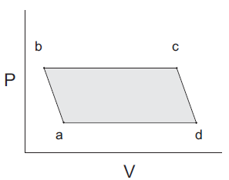
Figure 4: Doing thermodynamic work in a heat engine cycle.

- Procedure and Equipment Required

The heat engine consists of a hollow cylinder with a graphite piston that can move along the axis of the cylinder with very little friction. The piston has a platform attached to it for lifting masses. A short length of flexible tubing attaches the cylinder to an air chamber (consisting of a small can sealed with a rubber stopper that can be placed alternately in the cold reservoir and the hot reservoir. A diagram of this mass lifter is shown in Figure 5.
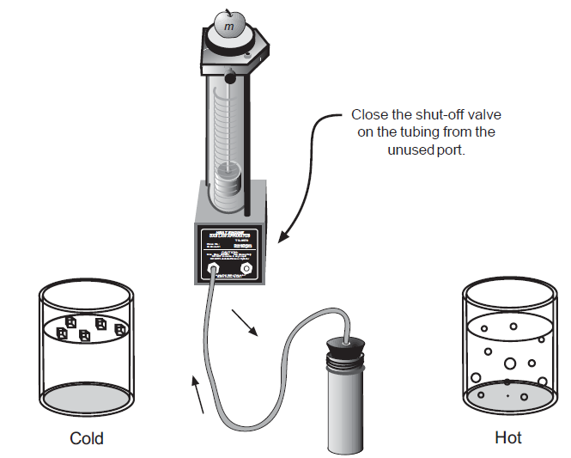
Figure 5: A schematic diagram of the mass lifter heat engine.

If the temperature of the air trapped inside the cylinder, hose, and can is increased, then its volume will increase, causing the platform to rise. Thus, you can increase the volume of the trapped air by moving the can from the cold to the hot reservoir. Then, when the apple has been raised through a distance y, it can be removed from the platform. The platform should then rise a bit more as the pressure on the cylinder of gas decreases a bit. Finally, the volume of the gas will decrease when the air chamber is returned to the cold reservoir. This causes the piston to descend to its original position once again. The various stages of the mass lifter cycle are shown in Figure 6.
Before taking data on the pressure, air volume, and height of lift with the heat engine, you should set it up and run it through a few cycles to get used to its operation. A good way to start is to fill one container with room temperature water and another with hot tap water or preheated water at about 60–70°C. The engine cycle is much easier to describe if you begin with the piston resting above the bottom of the cylinder. Thus, we suggest you raise the piston a few centimeters before inserting the rubber stopper firmly in the can. Also, air does leak out of the cylinder slowly. If a large mass is being lifted, the leakage rate increases, so we suggest that you limit the added mass to something between 100 g and 200 g. After observing a few engine cycles, you should be able to describe each of the points a, b, c, and d of a cycle carefully, indicating which of the transitions between points are approximately adiabatic and which are isobaric. You can observe changes in the volume of the gas directly and you can predict how the pressure exerted on the gas by its surroundings ought to change from point to point by using the definition of pressure as force per unit area.
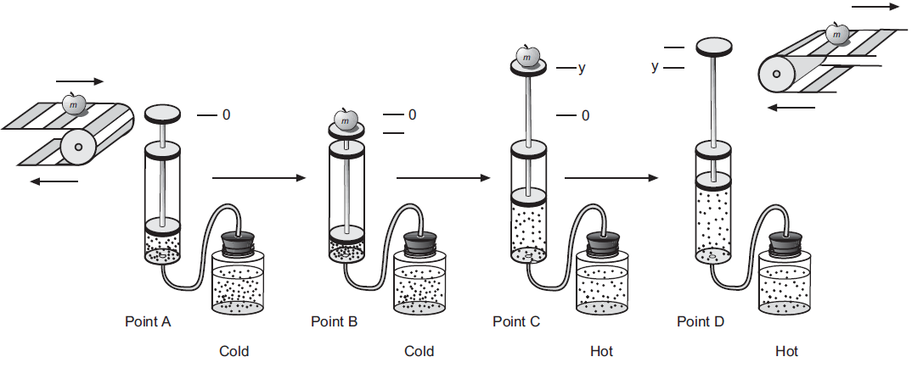
Figure 6: A simplified diagram of the mass lifter heat engine at different stages of its cycle.

The required equipment is as follows:

- Heat Engine/Gas Law Apparatus
- 2 Pyrex beakers (or plastic buckets), 1000 ml (to use as reservoirs)
- 1 ruler
- 1 barometer pressure gauge (optional)
- 1 calipers
- 1 mass set, 20 g, 50 g, 100 g, 200 g
- 1 hot plate
- 1 vat to catch water spills

- Activities

  - Derivation of the Volume and Pressure Equations

- What is the equation for the volume of a cylinder that has an inner diameter of d and a length L?

- Use the definition of pressure to derive the equation for the pressure on a gas being contained by a vertical piston of diameter d if the total mass on the piston including its own mass and any added mass is denoted as M. Hints: (1) What is the definition of pressure? (2) What is the equation needed to calculate the gravitational force on a mass, M, close to the surface of the Earth? (3) Don't forget to add in the atmospheric pressure, P_{atm}, acting on the piston and hence the gas at sea level.

  - Determining Volume and Pressure of Each Point

Now that you have derived the basic equations you need, you should be able to take your
engine through another cycle and make the measurements necessary for calculating both the volume and the pressure of the air and determining a P-V diagram for your heat engine. Instead of calculating the pressures, if you have the optional equipment available, you might want to measure the pressures with a barometer or a barometer sensor attached to a computer based laboratory system.

- Take any measurements needed to determine the volume and pressure of air in the system at all four points in the engine cycle. You should do this rapidly to avoid air leakages around the piston and summarize the measurements with units in the space below.

- Next you can use your measurements to calculate the pressure and volume of the system at point a, b, c and d. Show your equations and calculations in the space below and summarize your results with units.

P_{a}=

V_{a}=

P_{b}=

V_{b}=

P_{c}=

V_{c}=

P_{d}=

V_{d}=

  - Plotting and Interpreting a P-V Diagram

In the next activity you should draw a P- V diagram for your cycle and determine the thermodynamic work for your engine. Fill in the appropriate numbers on the graph frame and plot the P-V diagram for your engine cycle.

On the graph, label each of the points on the cycle (a, b, c, and d). Indicate on the graph which of the transitions (a➔b, b➔c, etc.) are adiabatic and which are isobaric.

Next you need to find a way to determine the area enclosed by the P- V diagram. The enclosed area doesn't change very much if you assume that P is approximately a linear function of V for the adiabatic transitions. By making this approximation, the figure is almost a parallelogram so you can evaluate the enclosed area.

Compare the thermodynamic work and the useful mechanical work.

