Eastern Mediterrenean University
Department of Mechanical Engineering Laboratory Handout
Lab Manual: Handout 1

MENG 446 -Thermal Power Engines

Experiment Name: Determinig The Instant Electrical Capacity of the PVT(photovoltaic thermal panel)
Date:
Instructor:Assist. Prof .Dr. Devrim Aydın Assistant: Görkem Ozankaya

Objectives:The objective of this experiment;
- To calculate the electrical capacity of the PVT system by measuring the voltage and current values

GENERAL EXPLANATION
In solar cells, the surface temperature is higher than 80 °C, yield decreases. It is possible to solve this problem by placing a hot water panel on the cell bottom surface. In this way both efficiency increase and hot water need are met.
TECHNICAL SPECIFICATION
PVT means 'photovoltaic thermal'. PVT, which is an integrated solar energy system, meets both electric and hot water needs. In photovoltaic panels, it is necessary to remove the excessive heat load generated by solar radiation which can not be converted to electricity. For this reason, photovoltaic thermal (PVT) systems are designed. With PVT systems, both the excess heat load can be removed from the photovoltaic material and this energy can be utilized as heat.
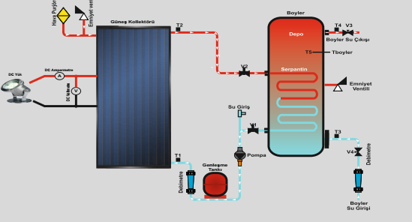

Necessary Equipments
Connection Cables
Operating Instructions and Procedure
- Adjust the tilt angle so that the sun lights come with a 90° angle
- Connect the cables as shown in the figure below
- Measure the current and voltage of the PVT and record them to table given below
- Calculate the generated power using necessary equation

Report Content
Experiment’s data will be defined by determining the power using the measured values,drawing an angle-power curve.

Calculations
Power=V*I (W) Heat Q=mc ∆t (kW)
For Different Angles ;1)15 ⁰ 2)30⁰ 3)45⁰ 4)60 ⁰
Measurement No | 1.(15 ⁰ )  m_{w}=400 L/h | 2. (30 °C)  m_{w}=600 L/h | 3.(45⁰)  m_{w}=750 L/h | 4.(60 ⁰)  m_{w}=800 L/h
Voltage(v)
Current I_{c}(A)
Power,P,(W)
Q_{collector}(Heat),

Plot the graph P-V / V-I

Plot the graph Collector angle - Q_{collector}

