CMPE112 - EXPERIMENT 1 MICROSOFT VISUAL STUDIO AND C PROGRAMMING

Aims
- Learning primary functions of Microsoft Visual Studio 2008*
- Introduction to C Programming
- Running C programs using Microsoft Visual Studio

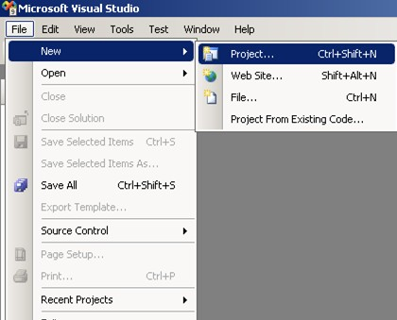
Creating a New Project

Figure 1: File menu
To create a new project, start Visual Studio 2008 (Start → Programs → Microsoft Visual Studio 2008 → Microsoft Visual Studio 2008). Select Project from the New list contained in the File menu, as shown in Figure 1. This operation will display a dialog screen shown in Figure 2. Select “Visual C++” from the “Project types” list shown on the left. Select “Empty project” from the right list and give a name to your project. (Note that you may need your

project later on; therefore, choose a suitable name that you can remember). These steps will create an empty project for you to work on.

* Translated by Cem Kalyoncu and Yıltan Bitirim from BLGM101 laboratory sheets.

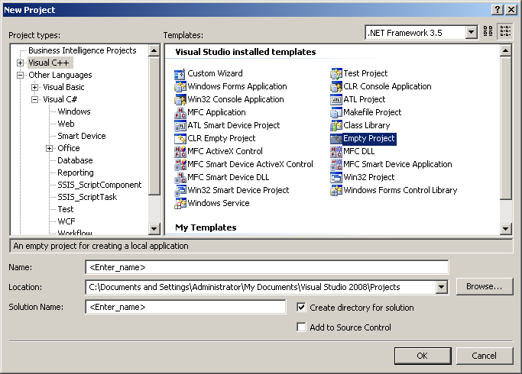
Figure 2: New project window

The first step to do in a new project is to create a file that we can write our codes into. Firstly, find “Project explorer” window. If it is hidden, you can open it from “View” menu. Right click on empty part of Project explorer and choose “New item” from “Add” menu as shown in Figure 3. This operation will open the window shown in Figure 4. From this window, choose “C++ file” and supply its name to create your file.

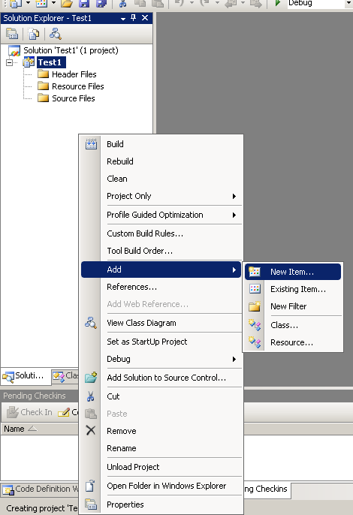
Figure 3: Add file menu

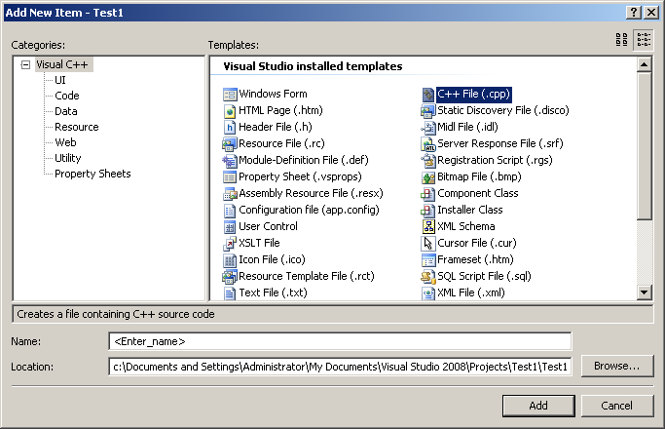
Figure 4: New item dialog

Running C++ Programs

To run your program you can press the button shown in Figure 5 or “F5” key. After issuing run command, the window shown in Figure 5 will be displayed. This dialog window asks if we want to compile our program. Since we want to run the codes we typed we have to compile our program. Therefore, the answer should be “Yes”. If there are no errors in your program, a console screen will be displayed. If your program requires input, you can enter it through this screen. Also your program output will be shown in here.

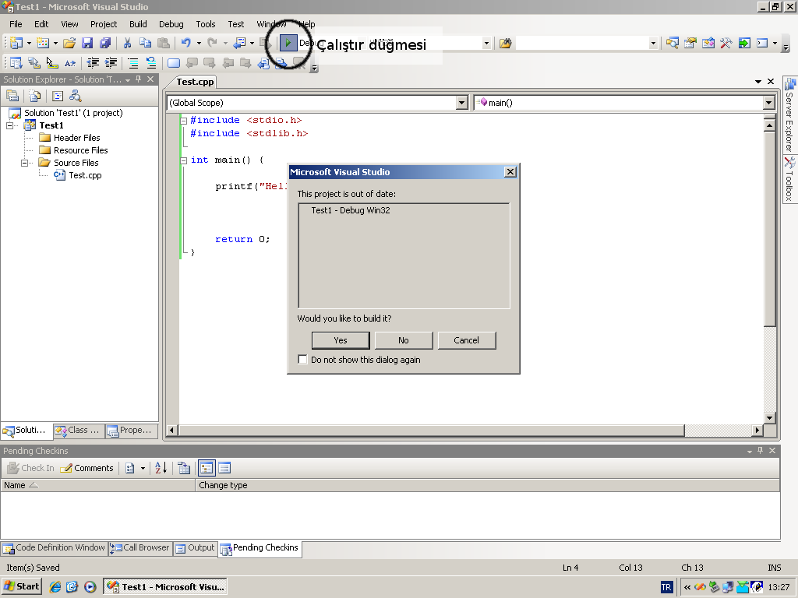
Run button
Figure 5: Running your program

Fixing Problems

If there is an error in your program while compiling, Visual studio will ask if you want to run last working version of your program. Since we need to fix the problems we will answer “No” to this question and abort the running our program. After closing this dialog, a list of errors will be displayed. This window is shown in Figure 6. If you cannot see this window in your screen, you can open it using “View” menu. On the top of this list you will find “Errors”, “Warnings” and “Messages” buttons. These buttons control the visibility of these types of items. We are mostly interested in “Errors” and “Warnings”, so make sure that these two will be displayed. If you double click on an error or warning in this list, Visual Studio will take you to the line that is causing the error or warning. Some errors are caused by the general settings of your program; therefore, the line number information might not be available.

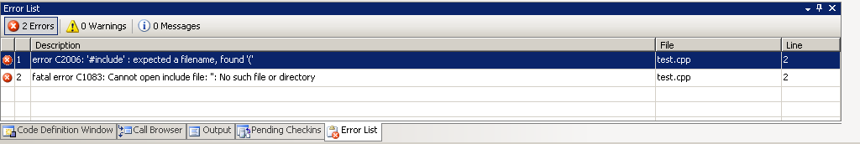
Figure 6: Error list

It is important to know that an error might be caused by previous line. If you are getting too many errors or if you are sure that the line displayed in the error list does not contain any problems, remember to check quotes, parentheses or semicolons (“;”) in the previous line. Most of the time missing semicolon error is given to the next line.
There are errors that cause your program to generate unexpected results. These are called logic errors and will not be handled by compiler. If you have such an error, examine your program carefully. These types of errors will be explained later.
The following is the list of most common errors. There might be errors that cannot be detected while your program is being compiled. Also common errors falling to this category is listed here.

Invalid symbol at include command
Error: Expected Filename...
After “include” preprocessor command, the file name should be written in angled brackets (< >).

Quotation errors
Error: unterminated string literal
In C programming language string literals should be surrounded by straight double quotes and each string should be written in a single line. Word processors replaces straight double quotes with opening and closing quotes, so be careful while copying from text documents.

main function is missing or defined multiple times
Error: undefined symbol main or symbol main is already defined
All C programs must have a main function. Check the name of it. In C language a function can be defined only once (there are exceptions to this rule) per project, therefore, you cannot add a second file and write another main function in there.

WinMain function is required
Error: undefined symbol WinMain
You can write Windows applications in Visual Studio 2008. If you open such a project, the steps you should follow are different from what are shown in this lecture. Therefore, if you have this

error, it means that you have chosen wrong project type. Create a new project and move your code to it.

Semicolon, coma or parenthesis missing
Error: Unexpected ... expecting ...
This error states that you have forgotten the specified symbol. Do not forget that this error is actually exist in somewhere before the error. Therefore, check the previous statements and even previous lines.

Unassigned variable
Warning: Variable ... is used without initializing
This occurs if the given variable is not initialized before it is used. In C programming language the initial value of variables are undefined. Therefore, you have to assign a value to it before you use. This problem causes a warning to be issued and you can tell it to continue. However, your program might have problems in run time.

Address Error
Error: System error or access denied

Experiments
Edit and execute the following codes and perform the given tasks:
#include<stdio.h> #include<stdlib.h>

int main() {
printf("Hello\n"); printf("My name is Ali\n");

system("pause"); return 0;
}

How can you modify the code produce the following output on the computer monitor?
Hello, ”My name is Ali”

- The following code reads two integer numbers (x, y) from the keyboard and finds their sum, i.e., x+y.

#include<stdio.h> #include<stdlib.h>

int main() {
int x,y;
printf("Enter two numbers: "); scanf("%d %d", &x, &y);
printf("%d + %d = %d \n", x, y, x+y);

system("pause"); return 0;
}

  - Execute this code using the following input entered from the keyboard: 5 12
  - How can you modify this code to read three integer numbers (x, y, z) and compute their product, i.e., x*y*z. Use the following input for execution: 5 12 2

