

CMPE353/CMSE354

Database Management Systems

Design a Hotel Reservation Database

In this project you are asked to design a relational database according to the given schema diagram below using Oracle Live SQL software. The project has several subtasks and each of them are described below. Lab hours will be used to check your progress on the project, so each subtask must be completed weekly in accordance with the set lab dates.

The following schema diagram is designed to keep the data of a Hotel. In our hypothetical Hotel schema, doctors visit patients. Each patient has an insurance type. At each visit, some drugs and or comments are ordered by the doctor.

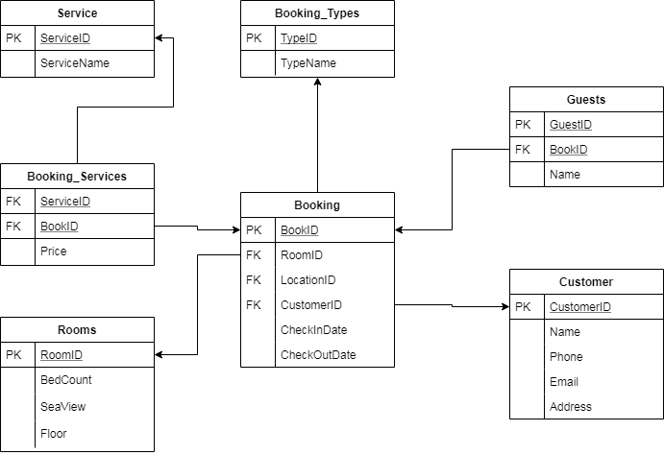

**Task 1:** Fill following information tables: (For your guide some of them are filed)

Table Name : Service

|  |  |  |  |  |  |  |  |
| --- | --- | --- | --- | --- | --- | --- | --- |
| Column Name | Primary key | Foreign key | Data type | Nullable | Check | Default | Sample Data |
| ServiceID | * | - | number | No | No | No | 25 |
| ServiceName | - | - | Varchar2(200) | - | - | - | Food |

Table Name : Booking_Types

|  |  |  |  |  |  |  |  |
| --- | --- | --- | --- | --- | --- | --- | --- |
| Column Name | Primary key | Foreign key | Data type | Nullable | Check | Default | Sample Data |
| TypeID |  |  |  |  |  |  | 107 |
| TypeName |  |  |  |  |  |  | Internet |

Service type can be Internet, Telephone, Agency and Presence.

Table Name : Guests

|  |  |  |  |  |  |  |  |
| --- | --- | --- | --- | --- | --- | --- | --- |
| Column Name | Primary key | Foreign key | Data type | Nullable | Check | Default | Sample Data |
| GuestID |  |  |  |  |  |  |  |
| BookID |  |  |  |  |  |  |  |
| Name |  |  |  |  |  |  |  |

Table Name : Customer

|  |  |  |  |  |  |  |  |
| --- | --- | --- | --- | --- | --- | --- | --- |
| Column Name | Primary key | Foreign key | Data type | Nullable | Check | Default | Sample Data |
| CustomerID |  |  |  |  |  |  |  |
| Name |  |  |  |  |  |  |  |
| Phone |  |  |  |  |  |  |  |
| Email |  |  |  |  |  |  |  |
| Address |  |  |  |  |  |  |  |

Table Name : Booking

|  |  |  |  |  |  |  |  |
| --- | --- | --- | --- | --- | --- | --- | --- |
| Column Name | Primary key | Foreign key | Data type | Nullable | Check | Default | Sample Data |
| BookID |  |  |  |  |  |  |  |
| AlbumID |  | * |  |  |  |  |  |
| TypeID |  |  |  |  |  |  |  |
| CustomerID |  |  |  |  |  |  |  |
| Date |  |  |  |  |  |  |  |
| Description |  |  |  |  |  |  |  |
| Imagepath |  |  |  |  |  |  | C:\MyPhotos |

Table Name : Rooms

|  |  |  |  |  |  |  |  |
| --- | --- | --- | --- | --- | --- | --- | --- |
| Column Name | Primary key | Foreign key | Data type | Nullable | Check | Default | Sample Data |
| RoomID |  |  |  |  |  |  |  |
| BedCount |  |  |  |  |  |  |  |
| SeaView |  |  |  |  | Yes - No |  | Yes |
| Floor |  |  |  |  |  |  | 3 |

Table Name : Booking_Services

|  |  |  |  |  |  |  |  |
| --- | --- | --- | --- | --- | --- | --- | --- |
| Column Name | Primary key | Foreign key | Data type | Nullable | Check | Default | Sample Data |
| BookID |  |  |  |  |  |  |  |
| ServiceID |  |  |  |  |  |  |  |
| Price |  |  |  |  |  |  |  |

**Task 2:** Table Design with your account according to above tables.

**Task 3:** Build the relation

**Task 4:** Insert some sample data.(At least 10 records for each table)

**Task 5:** write query for the following question :

Q1 : How many booking are saved in the database?

Q2 : Which room has more booking?

Q3 : List the booking for the first customer?

Q4 : List the booking which have more than 2 guests?

Q5 : List the Services with the number of booking?

Q6 : List the customers with the number of their bookings?

Q7 : List all booking with customer, type and room information?

Q8 : List the booking which have at least one service as ‘Laundry’?

**Task 6:** write some functions.

Tentative Lab Schedule (subject to change-please check every week)**:**

|  |  |  |
| --- | --- | --- |
| # | Date | Description |
| Lab1 | 24 March 2023 | Task description and Introduction to Oracle Live SQL (in lab) |
| Lab2 | 31 March 2023 | Table Design and construction for Term Project  Complete subtasks in Lab2 |
| Lab3 | 7 April 2023 | Table Design and construction for Term Project  Complete subtasks in Lab3 |
| Lab4 | 14 April 2023 | Table Design and construction for Term Project  Complete subtasks in Lab4 |
| Lab5 | 12 May 2020 | Writing some queries  Complete subtasks in Lab5 |
| Lab6 | 26 May 2020 | Functions |
| Lab7 | 2 June 2020 | Finalization of the Term Project |

**Grading:** Computation of Lab grade: Lab grade is computed as preliminary work, attendance in lab sessions, participation in lab sessions (15%) and completion of the final lab task at the end of semester (5%).

**Cheating and Plagiarism:** Any attempt to cheat, copy report or source codes will be considered as cheating and will result in ZERO grade for the project and will be sent to the disciplinary committee at the discretion of the instructor.