 | EASTERN MEDITERRANEAN UNIVERSITY  SCHOOL OF COMPUTING AND TECHNOLOGY  DEPARTMENT OF INFORMATION TECHNOLOGY  COURSE POLICY SHEET | 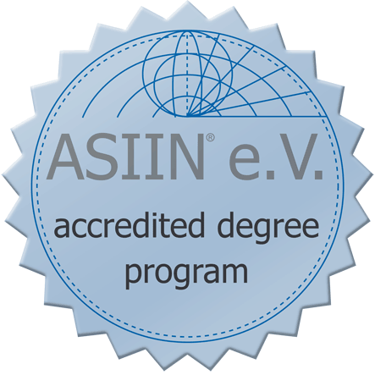

Course Title | Managing Systems Development Project
Course Code | ITEC422
Type | Full Time
Semester | Fall/Spring
Category | AC (Area Core)
Workload | 180 Hours
EMU Credit | (3,1,0) 3
Prerequisite | -
Language | English
Level | Fourth Year
Teaching Format | 3 Hours Lecture and 1 Hour Lab per week
ECTS Credit | 6
Course Web Site | http:// staff.emu.edu.tr/halidesaricizmeli

Instructor(s) | Halide Sarıçizmeli | Office Tel | +90 392 6301661
E-mail | halide.saricizmeli@emu.edu.tr | Office No | CT111

Course Description
This course is about information systems project management covering the processes for delivering quality software on time and on budget using a systematic approach to software project management, project evaluation, estimation, scheduling and resourcing, monitoring and controlling. Various software engineering methodologies and their impact on project management are discussed involving management people, quality, risk and change. The course emphasizes five focal areas of 21st century project management approach: process focus, team focus, global focus, technology focus, and Project Management Body of Knowledge focus. The learning environment is created via networked, collaborative, problem‐based learning‐centered instructional methods.

General Learning Outcomes
- Understand and practice the process of project management and its application in delivering successful IT
projects
- Understand and use risk management analysis techniques that identify the factors that put a project at risk and to quantify the likely effect of risk on project timescales
- Evaluate a project to develop the scope of work, provide accurate cost estimates and to plan the various activities
- Identify the resources required for a project and to produce a work plan and resource schedule
- Practice Microsoft Project Tool.
- Monitor the progress of a project and to assess the risk of slippage, revising targets or counteract scheduling
- Distinguish between the different types of projects and follow the stages needed to negotiate an appropriate contract.
- Project management via team collaboration to prepare a project plan interpersonal relations with people having diverse cultures and skills.

Teaching Methodology / Classroom Procedures
- The course has 2 hours of lectures in a week mainly held in the form of a seminar.
- The practical aspect of the course is made-up of 1 hours/pw in order to provide the students with an experience of using Case Tools(Microsoft project)
- Lecture notes and lab exercises are posted on the course web site.
- There are two written quizzes which are held one week before the midterm and final exam periods.
- There is a practical exam from Microsoft Project tools.
- There is a written midterm exam.
- There is a written final exam.
- There is one term project.
- Class attendance is compulsory.
- The student is responsible to check the course web site regularly and view the latest announcements.

Course Materials / Main References
Effective Project Management , James P. Clements, Jack Gido ısbn no: 10: 1-111-82405-3

Weekly Schedule / Summary of Topics
Week 1 | Overview of projects and emphasizing management.
Week 2 | Project Management Concepts: Project attributes, Balancing Project Constraints, Project Life Cycle, Project Management Process
Week 3 | Identifying and Selecting Project: Project Identification, Project Selection, Project Charter, Preparing request for proposal
Week 4 | Developing Project Proposal : Building relationship with customers and partners, Pre- Request For Proposal(RFP), proposal preparation
Week 5 | Defining scope, Quality, Responsibility, and Activity Sequence : Establish project objectives, Define project scope, Plan for quality, Define activities
Week6 | Developing the schedule : Estimates activity resources, estimates activity durations, establish project start and finish times, develop project schedule, project control process
Week 7-8 | Midterm Examinations Week
Week 9 | Resource Utilization: Resource constrained planning, resource requirements plan, resource levelling
Week 10 | Determining Cost, Budget, and Earned Value: Estimates activity costs, determine project budget, determine actual cost, control cost, and analyze cost.
Week 11 | Managing Risk: Identify risk, assess risk, plan risk responses, monitor risks, managing risks for IS.
Week 12 | Closing the Project: Project closing actions, customer feedback.
Week 13 | The Project Manager: Project manager responsibilities, project manager skills
Week14-15 | Project Presentations
Week 16-18 | Final Examinations Week
Requirements
- Each student can have only one make-up exam.
- One who misses an exam should provide a medical report or a valid excuse within 3 days after the missed exam.
- The make-up exam is done at the end of the term and covers all the topics.
- No make-up exam is given for the quizzes.
- Students who fail to attend the lectures regularly may be given NG grade.
- Once the grades are announced, the students have only one week to do objection about their grades.
- It is the students’ responsibility to follow the announcement in the course web site.

Method of Assessment
Evaluation and Grading | Assignments | Project | Class + Lab Quizzes Quizes | Midterm Exam | Final Exam
Percentage | 5 % | 15 % | 20% | 25 % | 35 %

Grading Criteria *
A | A- | B+ | B | B- | C+ | C | C- | D+ | D | D- | F
90 -100 | 85 - 89 | 80 - 84 | 75 - 79 | 70 - 74 | 65 - 69 | 60 - 64 | 56 - 59 | 53 - 55 | 50 - 52 | 40 - 49 | 0 – 39
* Letter grades will be decided upon after calculating the averages at the end of the semester and distribution of the averages will play a significant role in the evaluation of the letter grades.

