Graphs

What is a Graph?
Informal definition:
- A graph is a mathematical abstraction used to represent "connectivity information".
- A graph consists of vertices and edges that connect them, e.g.,
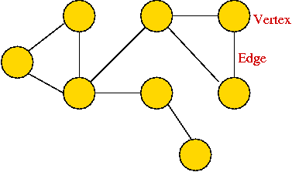
- It shouldn't be confused with the "bar-chart" or "curve" type of graph.
Formally:
- A graph G = (V, E) is:
  - a set of vertices V
  - and a set of edges E = { (u, v): u and v are vertices }.
- Two types of graphs:
  - Undirected graphs: the edges have no direction.
  - Directed graphs: the edges have direction.
- Example: undirected graph
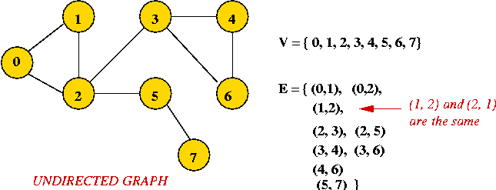
  - Edges have no direction.
  - If an edge connects vertices 1 and 2, either convention can be used:
    - No duplication: only one of (1, 2) or (2, 1) is allowed in E.
    - Full duplication: both (1, 2) and (2, 1) should be in E.
- Example: directed graph
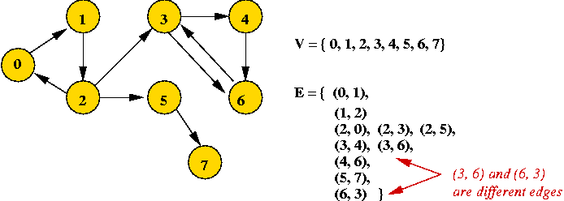
  - Edges have direction (shown by arrows).
  - The edge (3, 6) is not the same as the edge (6, 3) (both exist above).
Depicting a graph:
- The picture with circles (vertices) and lines (edges) is only a depiction
=> a graph is purely a mathematical abstraction.
- Vertex labels:
  - Can use letters, numbers or anything else.
  - Convention: use integers starting from 0.
=> useful in programming, e.g. degree[i] = degree of vertex i.
- Edges can be drawn "straight" or "curved".
- The geometry of drawing has no particular meaning:
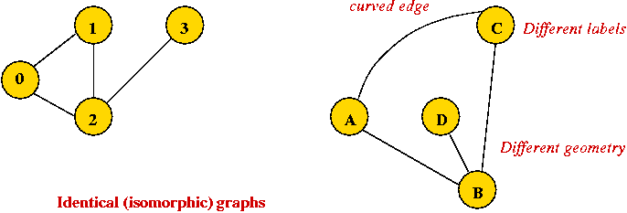
Graph conventions:
- What's allowed (but unusual) in graphs:
  - Self-loops (occasionally used).
  - Multiple edges between a pair of vertices (rare).
  - Disconnected pieces (frequent in some applications).
Example:
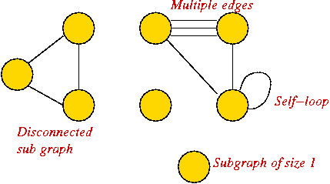
- What's not (conventionally) allowed:
  - Mixing undirected and directed edges.
  - Re-using labels in vertices.
  - Bidirectional arrows.
- Most common:
  - No multiple edges.
  - No self-loops.
- Other terms used:
  - Vertices: nodes, terminals, endpoints.
  - Edges: links, arcs.
Definitions:
- Degrees:
  - Undirected graph: the degree of a vertex is the number of edges incident to it.
  - Directed graph: the out-degree is the number of (directed) edges leading out, and the in-degree is the number of (directed) edges terminating at the vertex.
- Neighbors:
  - Two vertices are neighbors (or are adjacent) if there's an edge between them.
  - Two edges are neighbors (or are adjacent) if they share a vertex as an endpoint.
- Paths:
  - Undirected: a sequence of vertices in which successive vertices are adjacent.
  - Directed: a sequence of vertices in which every pair of successive vertices has this property: there's a directed edge from the first to the second.
  - A simple path does not repeat any vertices (and therefore edges) in the sequence.
  - A cycle is a simple path with the same vertex as the first and last vertex in the sequence.
- Connectivity:
  - Undirected: Two vertices are connected if there is a path that includes them.
  - Directed: Two vertices are strongly-connected if there is a (directed) path from one to the other.
- Components:
  - A subgraph is a subset of vertices together with the edges from the original graph that connects vertices in the subset.
  - Undirected: A connected component is a subgraph in which every pair of vertices is connected.
  - Directed: A strongly-connected component is a subgraph in which every pair of vertices is strongly-connected.
  - A maximal component is a connected component that is not a proper subset of another connected component.
- Digraph: another name for a directed graph.
Example:
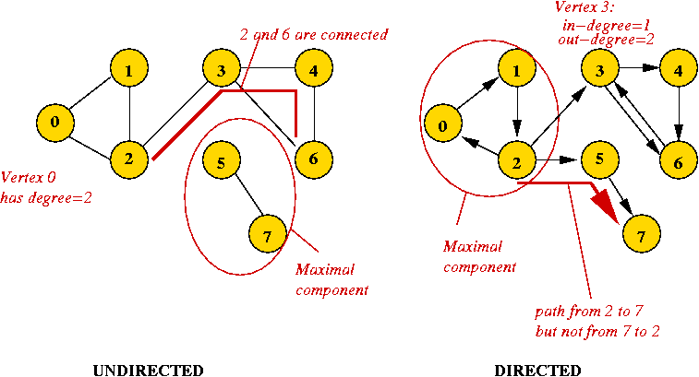
More definitions:
- Euler tour: A cycle that traverses all edges exactly once (but may repeat vertices).
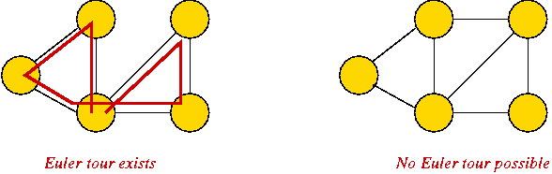
Known result: Euler tour exists if and only if all vertices have even degree.
- Hamiltonian tour: A cycle that traverses all vertices exactly once.
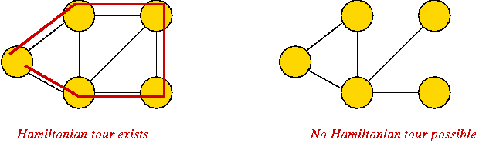
Known result: testing existence of a Hamiltonian tour is (very) difficult.
- Euler path: A path that traverses all edges exactly once.
- Hamiltonian path: A path that traverses all vertices exactly once.
- Trees:
  - A tree is a connected graph with no cycles.
  - A spanning tree of a graph is a connected subgraph that is a tree.
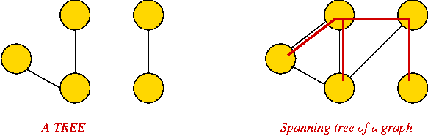

- Weighted graphs:
  - Sometimes, we include a "weight" (number) with each edge.
  - Weight can signify length (for a geometric application) or "importance".
  - Example:
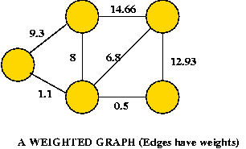

Graph Data Structures
First, an idea that doesn't work:
- We have already represented trees (like binary trees) with node instances and pointers between instances.
- Idea: use a node instance for each vertex, and a pointer from one vertex to another if an edge exists between them.
The two fundamental data structures:
- Adjacency matrix.
  - Key idea: use a 2D matrix.
  - Row i has "neighbor" information about vertex i.
  - Undirected: adjMatrix[i][j] = 1 if and only if there's an edge between vertices i and j.
adjMatrix[i][j] = 0 otherwise.
  - Directed: adjMatrix[i][j] = 1 if and only if there's an edge from i to j.
adjMatrix[i][j] = 0 otherwise.
  - Example: undirected
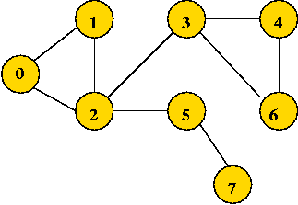

0 1 1 0 0 0 0 0
1 0 1 0 0 0 0 0
1 1 0 1 0 1 0 0
0 0 1 0 1 0 1 0
0 0 0 1 0 0 1 0
0 0 1 0 0 0 1 1
0 0 0 1 1 0 0 0
0 0 0 0 0 1 0 0

Note: adjMatrix[i][j] == adjMatrix[j][i] (convention for undirected graphs).
  - Example: directed
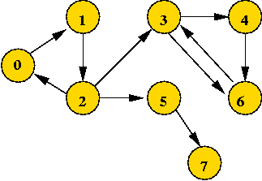

0 1 0 0 0 0 0 0
0 0 1 0 0 0 0 0
1 0 0 1 0 1 0 0
0 0 0 0 1 0 1 0
0 0 0 0 0 0 1 0
0 0 1 0 0 0 0 1
0 0 0 1 0 0 0 0
0 0 0 0 0 0 0 0

- Adjacency list.
  - Key idea: use an array of vertex-lists.
  - Each vertex list is a list of neighbors.
  - Example: undirected
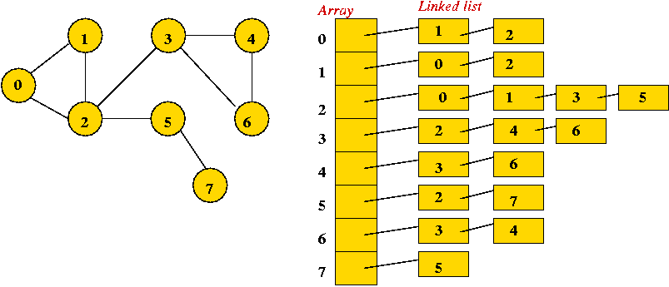
  - Example: directed
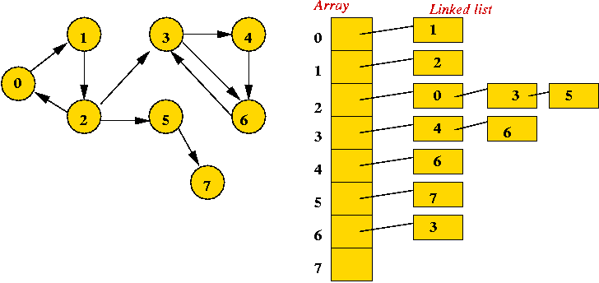
  - Convention: in each list, keep vertices in order of insertion
=> add to rear of list
- Both representations allow complete construction of the graph.
- Advantages of matrix:
  - Simple to program.
  - Some matrix operations (multiplication) are useful in some applications (connectivity).
  - Efficient for dense (lots of edges) graphs.
- Advantages of adjacency list:
  - Less storage for sparse (few edges) graphs.
  - Easy to store additional information in the data structure.
(e.g., vertex degree, edge weight)

Breadth-First Search
About graph search:
- "Searching" here means "exploring" a particular graph.
- Searching will help reveal properties of the graph
e.g., is the graph connected?
- Usually, the input is: vertex set and edges (in no particular order).
Key ideas in breadth-first search: (undirected)
- Mark all vertices as "unvisited".
- Initialize a queue (to empty).
- Find an unvisited vertex and apply breadth-first search to it.
- In breadth-first search, add the vertex's neighbors to the queue.
- Repeat: extract a vertex from the queue, and add its "unvisited" neighbors to the queue.
Example:
- Initially, place vertex 0 in the queue.
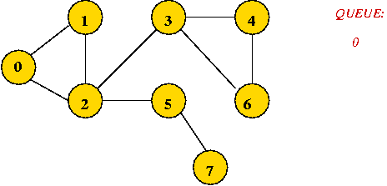
- Dequeue 0
=> mark it as visited, and add its unvisited neighbors to queue:
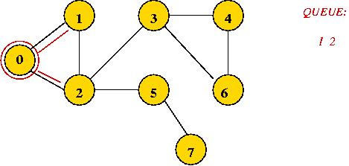
- Dequeue 1
=> mark it as visited, and add its unvisited neighbors to queue:
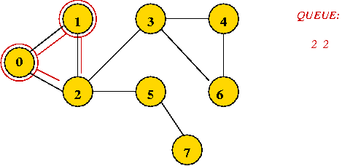
- Dequeue 2
=> mark it as visited, and add its unvisited neighbors to queue:
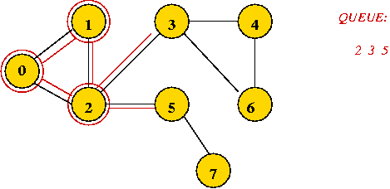
- Dequeue 2
=> it's already visited, so ignore.
- Continuing ...
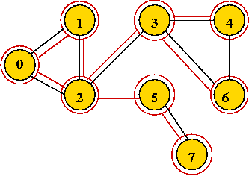
- Breadth-first search tree, and visit order:
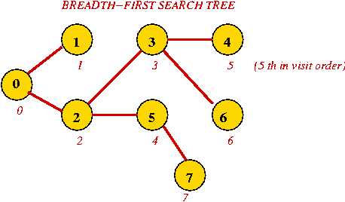
  - Exploring an edge: examining an unvisited neighbor.
  - If an unvisited neighbor gets on the queue for the first time, the edge is called a "tree edge".
  - Putting the tree edges and all vertices together results in: the breadth-first search tree.
  - For a particular graph and its implementation, the tree produced is unique.
  - However, starting from another vertex will result in another tree, that may be just as useful.

Searching an unconnected graph:
- The connected components are explored in order:
- Example:
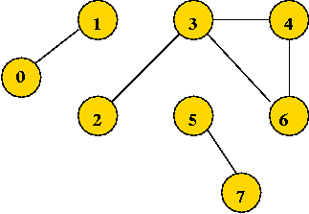
The tree, and visit order:
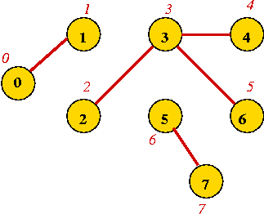
Applications:
- Connectivity:
  - Breadth-first search identifies connected components.
  - However, depth-first search is preferred (required for directed graphs).
- Shortest paths:
  - A path between two vertices in the tree is the shortest path in the graph.
- Optimization algorithms:
  - Various problems result in "graph search space".
  - BFS together with "exploration rules" is often used to search for solutions (e.g., branch-and-bound exploration).
Note: BFS works on a weighted graph by ignoring the weights and only using connectivity information (i.e., is there an edge or not?).

Depth-First Search on Undirected Graphs
Key ideas:
- Mark all vertices as "unvisited".
- Visit first vertex.
- Recursively visit its "unvisited" neighbors.
Example:
- Start with vertex 0 and mark it visited.
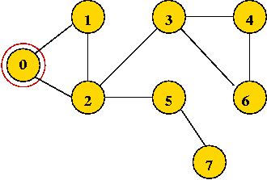
- Visit the first neighbor 1, mark it visited.
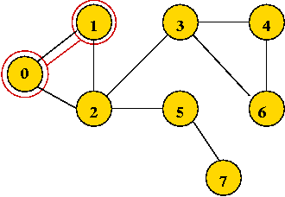
- Explore 1's first neighbor, 2.
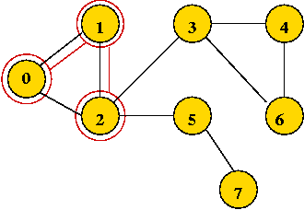
- Continuing until all vertices are visited ...
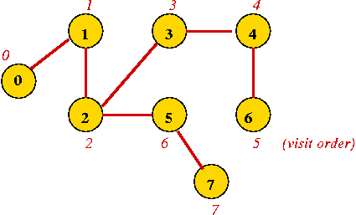
  - Vertices are marked in order of visit.
  - An edge to an unvisited neighbor that gets visited next is in the depth-first search tree.
- Completion order:
  - In breadth-first search, once a vertex is processed, it is never processed again.
  - In depth-first, we also encounter a vertex after returning from the recursive call.
=> we can record a completion order.
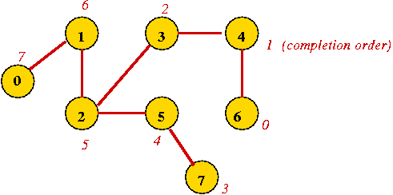

Depth-First Search in Directed Graphs
Key ideas:
- A straightforward depth-first search is similar to the undirected version
=> only explore edges going outward from a vertex in a directed graph.
- In addition to "back" and "down" edges, it is useful to identify "cross" edges.
Example:
- Consider: (slightly different from previous example)
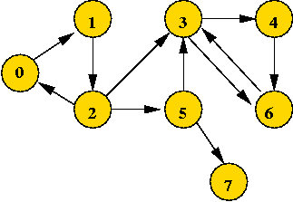
- Applying DFS gives:
