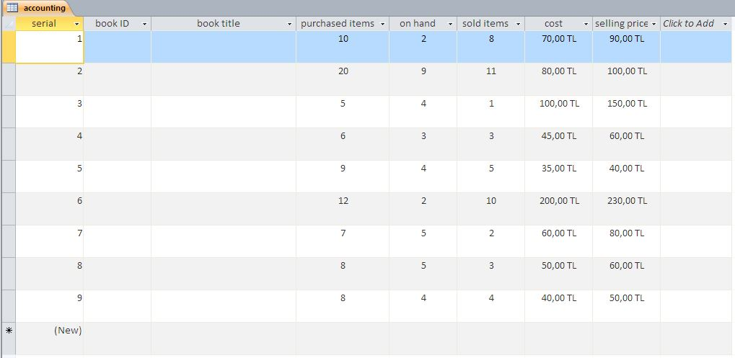

*IEMG/MANE 372 LAB - HW2*

Fill the fields of «accounting» table as shown in the picture , respect the validation rules and the data types.

Your database should contain the first table «book details» as well.