CMSE 423
High-end
Embedded Systems
Design

CMSE428 has been entered to the software engineering curriculum recently on the recommendation of ACM-IEEE for an ABET accredited Electrical, Computer and/or Software Engineering Departments. The course contents is especially structured to introduce the Embedded Systems Design in recently developed approach of Cyber Physical System, modelling, design and analysis. The course outline has three main sections: Modelling, Design, and Analysis, all supported on a easy to build design project. The course applies visual programming approach for all sections, and introduces the signal flow, code flow, and event flow diagram techniques to accomplish the design in virtual environments for rapid design and development of the prototypes.
CMSE428, ABET tarafından akredite edilmiş Elektrik, Bilgisayar ve/veya Yazılım Mühendisliği Bölümleri için ACM-IEEE'nin tavsiyesi üzerine yazılım mühendisliği müfredatına son zamanlarda girmiştir. Ders içerikleri özellikle son zamanlarda geliştirilen Siber Fiziksel Sistem, modelleme, tasarım ve analiz yaklaşımında Gömülü Sistem Tasarımını tanıtacak şekilde yapılandırılmıştır. Kurs taslağının üç ana bölümü vardır: Modelleme, Tasarım ve Analiz, tümü inşa edilmesi kolay bir tasarım projesinde desteklenir. Ders, tüm bölümler için görsel programlama yaklaşımını uygular ve prototiplerin hızlı tasarımı ve geliştirilmesi için tasarımı sanal ortamlarda gerçekleştirmek için sinyal akışı, kod akışı ve olay akış diyagramı tekniklerini tanıtır.
In the course outline, the theory and practice is merged to a team design project, which requires visual signal, code, and event flow techniques. The first two labs cover the analysis of cyber physical systems by coding a simulation of system through a signal flow diagram. The third and fourth labs introduce the code flow diagram technique to simulate a low end embedded systems application. And, at the fifth and sixth labs an event flow diagram approach is introduced to build a high-end application on a PC or Raspberry Pi using the NodeRED environment. The course also contains a chapter for the security issues of embedded systems.
Ders içeriğinde, teori ve uygulama, görsel sinyal, kod ve olay akışı teknikleri gerektiren bir ekip tasarım projesiyle birleştirilmiştir. İlk iki laboratuvar, bir sinyal akış diyagramı aracılığıyla bir sistem simülasyonunu kodlayarak siber fiziksel sistemlerin analizini kapsar. Üçüncü ve dördüncü laboratuvarlar, bir alt düzey gömülü sistem uygulamasını simüle etmek için kod akış diyagramı tekniğini tanıtıyor. Ve beşinci ile altıncı laboratuvarlarda, NodeRED ortamını kullanarak bir PC veya Raspberry-Pi üzerinde üst düzey bir uygulama oluşturmak için olay akış diyagramı yaklaşımı tanıtılıyor. Kurs ayrıca gömülü sistemlerin güvenlik sorunları için bir bölüm içeriyor.

Course Outline
The textbook has been selected to follow the most recent approach in Embedded Systems to integrate modelling, design and analysis.
Ders kitabı, modelleme, tasarım ve analizi entegre etmek üzere Gömülü Sistemlerdeki en son yaklaşımı takip edecek biçimde seçilmiştir.

1/ High-end Embedded Systems - Preface

Lee/Seshia

Presentation compiled by: Dr.M.Bodur, (c) 2019-21

2/ About the Book - Definitions

Digital computing power of computers are everywhere.

Number of task or device dedicated computers are much higher than general purpose computers.

Cyber physical systems are physical systems with dedicated computers to improve system behavior.

Example: An engine control system
Engine is the physical system that delivers torque to the wheels of a vehicle depending on the extent of throtle.
Dedicated computer system decides throttle to control the torque and to prevent unexpected engine stall.
Behaviour of the system is improved in many senses: It prevents non-burned fuel discharge from exhoust. It reduces the response time of the engine in delivering higher torques. It checks the ill conditions for running engine, and warns the driver before any damage.
The Embedded System in this example consists of the dedicated computer as well as all the sensors and actuators required.
Örnek: Bir motor kontrol sistemi
Motor, verilen gazın derecesine bağlı olarak bir aracın tekerleklerine tork sağlayan fiziksel sistemdir.
Özel bilgisayar sistemi, torku kontrol etmek ve beklenmeyen motor durmalarını önlemek için gaz miktarına karar verir.
Sistemin davranışı birçok yönden iyileştirilmiştir: Egzozdan yanmamış yakıt boşalmasını engeller. Daha yüksek tork sağlamada motorun tepki süresini azaltır. Motora zarar verecek kötü koşulları kontrol eder ve herhangi bir hasar oluşmadan önce sürücüyü uyarır.
Bu örnekteki Gömülü Sistemi, özel bilgisayar ile yanısıra gereken tüm sensörler ve aktüatörler oluşturur.

3/ Challenges in Cyber Physical System design

An embedded system is a
- dedicated computing system and its
- interfacing units
that enhances the behavior of a cyber physical system.

4/ Challenges in Cyber Physical System design

Principal challenges in embedded systems raise from their interaction with physical processes,
and not from their limited resources.

The interaction between the cyber and the physical parts of the system is mainly a result of the software, or more fundamentally depends on the coded algorithms rather than the resources such as the execution speed, or the memory capacity of the computer,
Sistemin Siber ve Fiziksel parçaları arasındaki etkileşim, esas olarak yazılımın bir sonucudur veya daha temelde, bilgisayarın yürütme hızı veya bellek kapasitesi gibi kaynaklardan ziyade kodlanan algoritmalara bağlıdır.

5/ History of Cyber Physical Systems

The term cyber-physical systems (CPS) was coined by Helen Gill at the National Science Foundation in the U.S. to refer to the integration of computation with physical processes.

The term appeared first at 2006, and NSF started to fund the development of Embedded System education by many projects.
Today, many frontier universities give at their engineering programs the embedded system courses in this contemporary approach.
Terim ilk olarak 2006'da ortaya çıktı ve NSF, Gömülü Sistem eğitiminin gelişimini birçok projeyle finanse etmeye başladı.
Bugün birçok öncü üniversite, mühendislik programlarında gömülü sistem derslerini bu çağdaş yaklaşımla vermektedir.

6/ Cyber - Physical Interaction

In CPS, embedded computers and networks monitor and control the physical processes, usually with feedback loops where physical processes affect computations and vice versa.

Due to this interaction, information processing and physical system cannot be handled independently.

This means that the conditions detected in the physical system affect the actions of the embedded computer, while at the same time the actions of the computer affect the operation of the physical part, creating a feedback loop. This feedback changes the behavior of the cyber-physical system. Therefore, the behavior of the CPS cannot be understood by examining the physical and cyber parts alone.
Bu, fiziksel sistemde algılanan koşulların gömülü bilgisayarın eylemlerini etkilediği, aynı zamanda bilgisayarın eylemlerinin fiziksel parçanın çalışmasını etkileyerek bir geri besleme döngüsü oluşturduğu anlamına gelir. Bu geri bildirim, siber-fiziksel sistemin davranışını değiştirir. Bu nedenle, CPS'nin davranışı yalnızca fiziksel ve siber kısımlar incelenerek anlaşılamaz.

7/ Challenges of CPS design

The design of such systems, therefore, requires understanding the joint dynamics of computers, software, networks, and physical processes.

It is this study of joint dynamics that sets this discipline apart.

Generally, CPS is a complex system to develop a detailed mathematical model. What we do is just to eliminate all unnecessary details, and to keep only the major effects of physical and cyber parts in our model.
The overall behavior of the system is mostly too complicated to be solved analitically even with the simplified dynamics of cyber and physical parts.

If we can not solve the overall behaviour analitically, we simulate the simplified model on computers to evaluate its behaviour on the possible operation conditions.

Genellikle, CPS, ayrıntılı bir matematiksel model geliştirmek için karmaşık bir sistemdir. Yaptığımız şey sadece gereksiz tüm detayları ortadan kaldırmak ve sadece fiziksel ve siber parçaların ana etkilerini modelimizde tutmaktır.
Sistemin genel davranışı, siber ve fiziksel parçaların basitleştirilmiş dinamikleriyle bile analitik olarak çözülemeyecek kadar karmaşıktır.

Genel davranışı analitik olarak çözemezsek, olası çalışma koşullarında davranışını değerlendirmek için basitleştirilmiş modeli bilgisayarlarda simüle ederiz.

8/ Contents of the Course

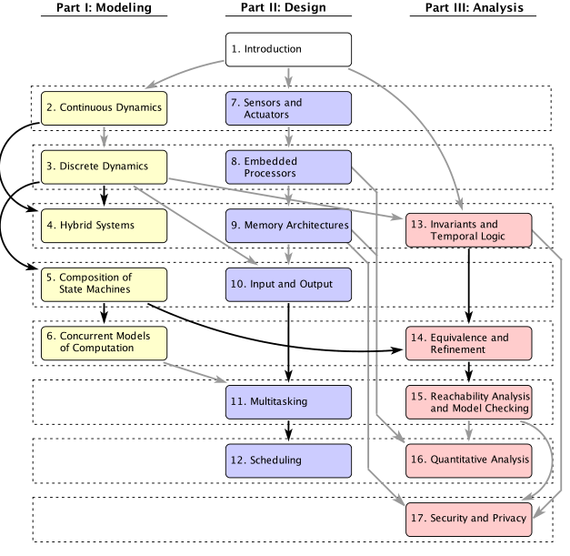

As seen in the diagram we start with Introduction. Next we plan to introduce the continuous, discrete, and hybrid systems focusing on how to simulate them by a computer in a practical manner. Along with the simulation phase, we start to study sensors and actuators, input and output, processors, and memory subsystems of the embedded system design. Finally we need to see the security and privacy issues of a typical embedded system.
Şemada görüldüğü gibi Giriş ile başlıyoruz. Daha sonra, sürekli, ayrık ve hibrit sistemleri, bir bilgisayar tarafından pratik bir şekilde nasıl simüle edileceğine odaklanarak tanıtmayı planlıyoruz. Simülasyon aşamasının yanı sıra gömülü sistem tasarımının sensörleri ve aktüatörleri, giriş ve çıkışları, işlemcileri ve bellek alt sistemlerini incelemeye başlıyoruz. Son olarak, tipik bir gömülü sistemin güvenlik ve gizlilik sorunlarını görmemiz gerekiyor.

9/ Contents of the Course

We need to support all these topics on a design application. Our design application will contain a Low-end Controller (practiced on Arduino-Uno) and a High-end Controller (practiced on Raspberry Pi).
Tüm bu konuları bir tasarım uygulaması üzerinde desteklememiz gerekiyor. Tasarım uygulamamız (Arduino-Uno üzerinde uygulanmış) bir alt-düzey denetçi ve (Raspberry Pi üzerinde uygulanmış) bir üst-düzey denetçi içerecektir.
10/ Audience of the Course

This course targets
undergraduate or
introductory graduate
engineering and computer science students
to introduce
engineering principles of embedded systems

Author expects that the audience shall not only be interested to computer hardware and coding, but also shall be interested sufficiently on the physical and cyber interaction of the two sides in a CPS.
Yazar, izleyicinin yalnızca bilgisayar donanımı ve kodlama ile ilgilenmesini değil, aynı zamanda bir CPS'de iki tarafın fiziksel ve siber etkileşimine de yeterince ilgi göstermesini bekler.
11/ Prerequisites of the Course

Knowing the following items may be helpful to understand the contents easily:
- machine structures (i.e., ALU, CPU, register, datapath),
- computer programming (C, JS),
- basic discrete mathematics and algorithms, and
- signals and systems (mainly for sampling a continuous time signal).

Among the prerequisite topics, ALU, CPU, register and similar architectural structures are necessary for chapters 7-8-9-10. Programming concepts are necessary for design application practice. Discrete math and algorithms are necessary for discrete and hybrid modeling. Signals and Systems may be necessary to understand the Shannon-Nyquist law at Chapter 7.
Ön koşul konuları arasında ALU, CPU, register ve benzeri mimari yapılar 7-8-9-10. bölümler için gereklidir. Tasarım uygulama pratiği için programlama kavramları gereklidir. Ayrık ve hibrit modelleme için ayrık matematik ve algoritmalar gereklidir. Bölüm 7'deki Shannon-Nyquist yasasını anlamak için Sinyaller ve Sistemler gerekli olabilir.

12/ Access of the Course Textbook

main web page: http://leeseshia.org

e- mail: authors@leeseshia.org

You can access the PDF copy of the textbook from this link.
Ders kitabının PDF kopyasına bu bağlantıdan erişebilirsiniz.

Facts of Embedded Systems Industry

13/ Market Study, Introduction
2017 Embedded Markets Study on
Integrating IoT and
Advanced Technology Designs,
Application Development & Processing Environments
ASPENCORE - EETimes Embedded

We are going to see some important properties of the developing Embedded Systems Industry through a series of market study surveys. These surveys are carried by ASPENCORE, which owns the printed and web media EETimes Embedded Incorporation.

14/ Market Study, Respondents and Confidence

Data over 1100 respondents,
Repeated every year to discover trends.
Confidence
+-2.8 for 2017
+-2.3 for 2015
+-3 for 2014
2016 is missing (company changed hand)

The surveys are carried almost yearly, with almost 70% common questions to determine the dynamic change in the Embedded Systems Industry. The number of respondents are especially chosen large to get meaningful confidence margins for such a study of dynamics.

15/ Market Study, Respondents

In which region of the world do you reside?

56% US & Canada
24% Europe
10% Asia (except China)
4% South America
2% Africa & Near East
2% Australia

Almost proportional to GNI PC (Gross National Income per Capita)

16/ Market Study, Company Size

How many employees does your company have at
all locations?

47 % Under 100
14 % 100-499
7 % 500-999
10 % 1,000-4,999
6 % 5,000-9,999
3 % 10,000-19,999
11 % 20,000 or more
3 % Don't know

Most employees are in small size design companies. They carry design for giant companies.

16/ Market Study, Job Requirements

Job Functions?

2017 2014
62% 54% Debugging firmware/software
60% 55% Writing firmware/software for ES
59% 50% Hardware/software integration
59% 55% Architecture selection/specification
51% 44% Firmware/software design or analysis
50% 42% Debugging hardware
48% 43% Project management
44% 33% Prototype testing
42% 36% Device programming
41% 35% Firmware/software testing
40% 30% System design
38% 34% Designing hardware for E.S.
30% 25% Hardware/software co-design
27% 21% Board layout/design
18% 16% Hardware/software co-verification
12% 11% Connected device design
8% 8% SoC (system-on-chip) design
4% 3% Other (please specify)

17/ Market Study, Projects

Application Areas?

36% Industrial control/automation
25% Consumer electronics
24% Internet of Things (IoT)
20% Communication/netwrkg/wireless
17% Electronic instruments
16% Automotive
15% Medical
14% Military/Aerospace
10% Computers and peripherals
9% Audio
9% Video/ imaging
8% Security
8% Transportation
6% Power generation and utilities
6% Government/municipal

Some possible comments:
>Industrial control/automation is the largest employing field among all.
>Consumer electronics, Internet of Things, and Communication networks follow industrial control by huge volumes.
>Instrumentation, Automotive, Medical, Military etc. are the other important fields for employment.

18/ Market Study, Projects - IoT

How important will IoT development be to you and your organization in the next 12 months?

7 % Critically important
18 % Very important
25 % İmportant
-------50%
19 % Not very important
20 % Not at all important
11 % Not sure. Don't know

By looking these percentages we may say that IoT is in raising trend.

19/ Market Study, Projects - IoT

If you are developing Internet of Things (IoT) applications, please indicate the type of application.

42 % Industrial
39 % Sensor-driven
29 % IP connected cloud/router
26 % Smartphone/mobile connected
19 % Smart buildings
17 % Medical
13 % Wearable
13 % Connected vehicles
7 % Non-IP connected hub/gateway
7 % Other

Again, IoT is raising trend in Industrial applications.

20/ Market Study, Projects - IoT

Will have one or more projects devoted to IoT.

Yes 64%
No 36%

18% of all projects will be primarily devoted to IoT.

21/ Market Study, Projects - IoT

Considering all applications of which you are aware, what do you regard as the most interesting use of the IoT? (Selected write-in responses).

• Automatic traffic control.
• Connected automated houses/buildings.
• Connected/autonomous vehicles.
• Detecting location: by screen, audio, phone.
• Distributed sensing for diagnostics and control.
• Environment monitoring energy cons. reduction.
• Intelligent industrial machines,
• Medical information/diagnostic
• Real-time sensing
• Earthquake/seismic monitoring.
• Drones; remote control and monitoring.
• Security within IOT -
• Smart cities, smart factories, agriculture
• Brain waves to control wheelchair movement
• Wireless monitor for underground water.

22/ Market Study, Emerging Technologies 2014

Gartner Hype Cycle for Emerging Technologies 2014

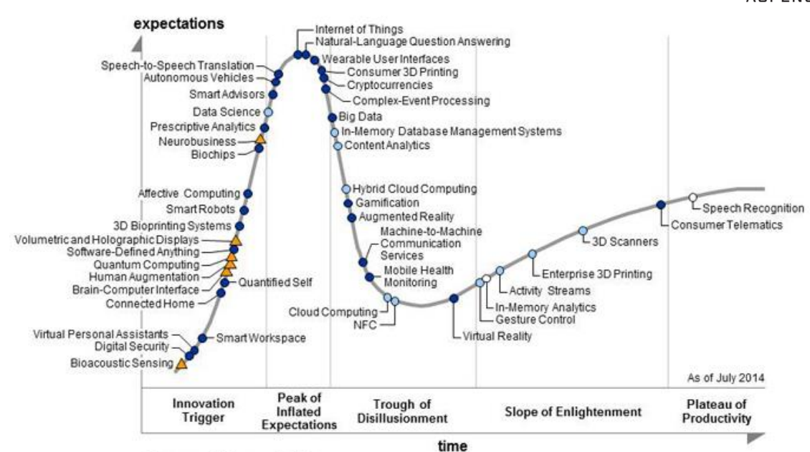

Gartner Hype Cycle is typical behaviour of an emerging technology. Innovation stage starts with many unbelievable expectations.
By the accomplished innovations some of them turn credible, and many other expectations are considered credible without full evidence.
Many early development investments fail during the distillation period.
Once the technology is refined, technology is applied at proper purpose and generates safer expectations in time.
23/ Market Study, Emerging Technologies 2017

Gartner Hype Cycle for Emerging Technologies 2017
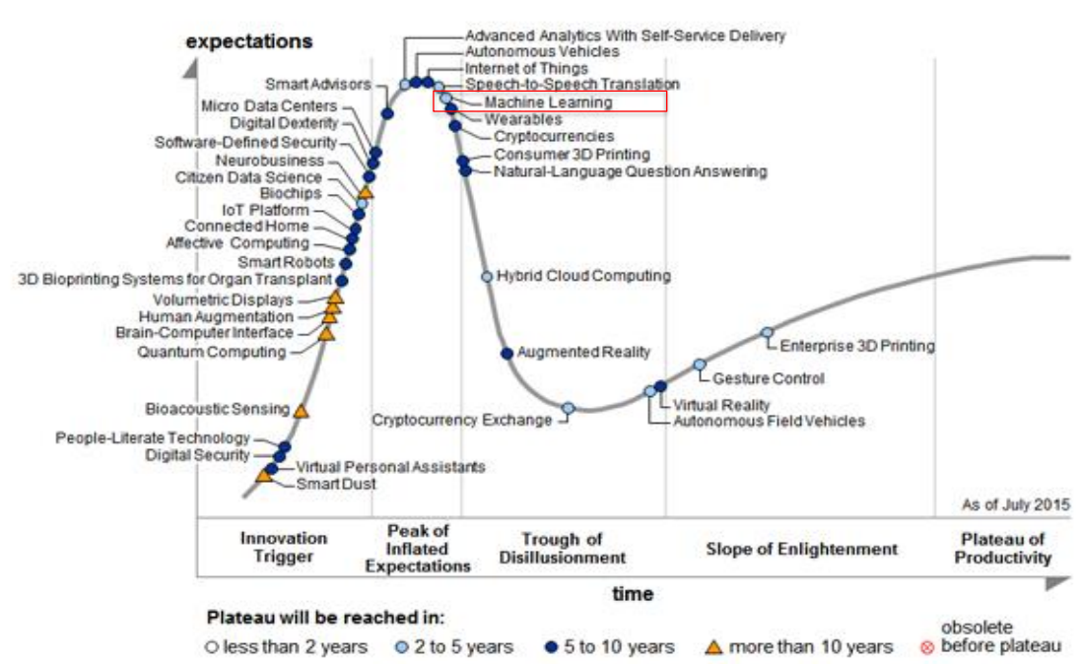

In these charts we notice digital security is at innovation point. There was an expectation to solve the security problems in widespread communication device protocols such as IoTs.
24/ Market Study, Emerging Technologies 2020

Gartner Hype Cycle for Emerging Technologies 2020
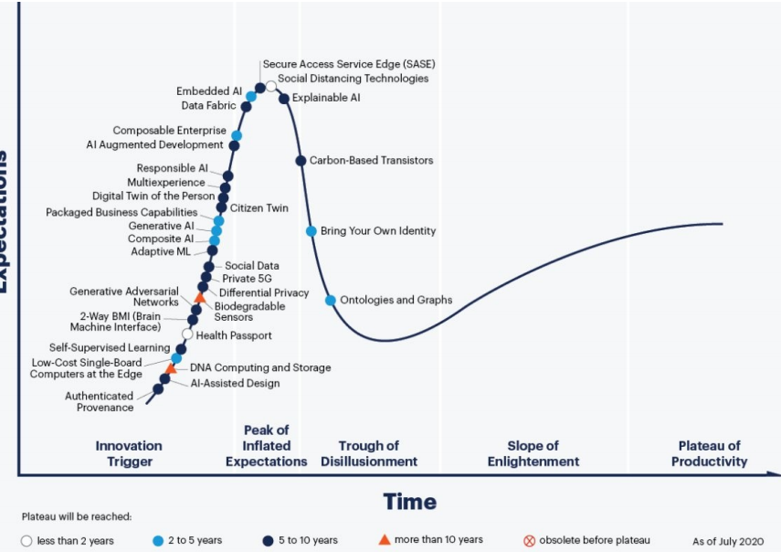

Gartner Hype 2020 shows that security issue is solved by Secure Access Service Edge (SASE) development, which naturally boosted the expectations on using SASE technology in ES.

25/ Market Study, Emerging Technologies

Overall Background
• Focus – IoT and Advanced Technologies were given some focus.
• World Regions – In this data, US/Canada (56%) are the predominantly represented region, Europe /ENEA (25%) is next, and Asia (11%) is less than in 2015.
• Company Size – Average of 3,452 employees is slightly down from 2015.
• Job functions – Debugging (62%), writing firmware/software (60%),hardware/software integration (62%), and architecture selection (59%) are the top four job functions.
• Number of Years Out of School: Average years out of school for the 2017 is 24.
• Applications – Industrial controls (36%) has led applications for many years. Consumer electronics (25%) is holding steady at second. Internet of Things (24%) upticks by leaps and bounds from fourth in 2015 to third place in 2017
• IoT Usage/Advanced Technologies – Sensor-driven (42%) and industrial (39%) applications led the IoT field. Half of all users felt IoT designs will be important in the next 12 months. Among advanced technologies used embedded vision technology was used most. Machine learning has greatest potential.
• 54% are creating IoT edge of the internet devices.
• 64% will have one or more projects devoted to IoT.

26/ Market Study, projects

My current embedded project is…

57% An upgrade or improvement to an earlier or existing project

43% New to the world; a new project from scratch

What does the upgrade or improvement include?

50% New or different software features
38% New or different processor
24% New or different connectivity capabilities
17% Mandatory changes/discontinued hdwr/sftwr
14% New or different peripherals
11% New or different analog components

27/ Market Study, Wireless technology

If wireless, what wireless interfaces does your current embedded project include?

65% Wi-Fi
59% Bluetooth
25% Cellular (LTE, 3G, 2G)
14% IEEE802.15.4
10% NFC
7% LoRA
5% IEEE802.15.4g
5% Z-Wave

28/ Market Study, Project Team

How many people are on your embedded project team?

14 Total team size
3 Firmware engineers
3 Nonfirmware engineers
3 Hardware engineers
2.4 Quality Assurance Engr.
1.5 System Integrator
1 Others

What is your development team’s ratio of total resources (including time/dollars/manpower) spent on software vs. hardware for your embedded projects?

61% Average total resources devoted to software
39% Average total resources devoted to hardware

29/ Market Study, Controller Boards

Do you primarily design or subcontract the design of custom circuit boards, or do you purchase off-the shelf boards?

81% Primarily build/subcontract our own boards
19% Primarily purchase off-the-shelf boards

29/b
Did you start your current embedded design with a development board?
50-50 Yes-No
ST Microelectronics 11.%
TI (LaunchPad=5) 11.%
Xilinx 8.1%
NXP 7.3%
Microchip 5.9%
Arduino 5.6%
Rasberry Pi 4.2%
BeagleBoard Bone Black 3.4%
Atmel 2.8%
Freescale (NXP) 2.8%

30/ Market Study, Controller Boards

Which form factor boards are you currently using, and considering using ?

Custom design 26%
Proprietary 23%
Arduino 17%
Raspberry Pi 16%
Beagle Board/Bone 10%
3.5" 8%
PCI Express 7%
5.25" PCI 7%

31/ Market Study, Project completion time

Thinking now about the last embedded project you completed (no longer in development), how many months did that project take to finish?...

6 months or less 37%
7 – 12 months 36%
13 – 18 months 11%
19 – 24 months 9%
25 months or more 6%
75% completed within one Year

32/ Market Study, Project coding

My current embedded project is programmed mostly in:
C 56%
C++ 22%
Assembly language 4%
Python 3%
Java 2%
LabVIEW 2%
C# 2%
MATLAB 2%
JavaScript 1%
78% is written in C and C++

33/ Market Study, Project code reuse

Does your current project reuse code from a previous embedded project?
No, all new s/w 15%
Yes, reused in house code 81%
Yes, reused opensource 25%
Yes, reused purchased code 11%

Most reused code is in-house code.

34/ Market Study, Improvement possibility

If you could improve one thing about your embedded design activities, what would it be?
Debugging tools 19%
Schedule 17%
Engineering team skill level 15%
Firmware itself 8%
Microprocessor 6%
Programming tools 7%
Interfaces 6%
Other hardware 6 %
IDE 5%
Operating system 4%
The Compiler 2%
Other (Mgt, budget, legacy, etc) 5%

35/ Market Study, Operating System

Does your current embedded project use an operating system, RTOS, kernel, software executive, or scheduler of any kind?
Yes 67% No 33%
My current embedded project uses:
Open-source OS/RTOS, without
commercial support 40%
Commercial OS/RTOS 30%
Internally developed or in-house OS/RTOS Commercial 17%
Distribution of an open-source OS/RTOS 12%

36/ Market Study, Operating Systems

Please select ALL of the operating systems you are considering using in the next 12 months.
FreeRTOS 28%
Embedded Linux 27%
In-house/custom 19%
Android 17%
Debian (Linux) 11%
Ubuntu 11%
Micrium (uC/OS-III) 9%
Texas Instruments RTOS 8%
Micrium (uC/OS-II) 6%
MS Windows Embedded 7/Standard 6%
All followings are less than 5%
Express Logic (ThreadX) .
Keil (RTX) .
Texas Instruments (DSP/BIOS) .
Freescale MQX .
Wind River (Linux) .
Microsoft (Windows 7 Compact or earlier) .
Wind River (VxWorks) .
Red Hat (IX Lunix) .
.....

36/ Market Study, About processors
How many processors?
My current embedded project contains:
A single microprocessor/ microcontroller
(can be multicore) 56%
2 processors/ microcontrollers 22%
3 – 5 processors/ microcontrollers 15%
6 – 10 processors/ microcontrollers 4%
>10 processors/ microcontrollers 3%
Processor bus size
My current emb. project's main processor is:
8-bit 16-bit 32-bit 64-bit don't know
12% 15% 65% 10% 3% .
Choosing a microprocessor
Most important factor is?
Echosystem (tools and support) 70%
Features of the Chip 24%
Vendor and supplier 6%
Which vendor
has the best ecosystem for your needs?
Microchip NXP- .
Atmel TI STM Freescale Xilinx Intel ARM ...
14 14 11 11 5 5 4 % ...

Software development tools are most important to select a microcontroller.

Exercise Questions

Q1
Write the most requested job function for an Embedded System Engineer:

Q2-
Among the hardware and software development, which one needs more effort and resources?

