1979
EASTERN MEADITERRANEAN UNIVERSTY

DEPARTMENT OF MECHANICAL ENGINEERING

LABORATORY HANDOUT

COURSE Materials Science and Manufacturing Processes

Semester: Fall 2018/2019

Laboratory No: 1

Name of Exp: Tensile Test

Instructor: Mohamad Alhijazi

Submitted by: …………………………………………………

Student No: ……………………………………………………

Date: …………………………………………………………..

-------------------------------------------------------------------------------------------------------------

EVALUATION

PROCEDURE

RESULTS & GRAPHS

DISCUSSION

OVERALL MARK

Name and signature (of evaluator): ……………………………………………………………….

1

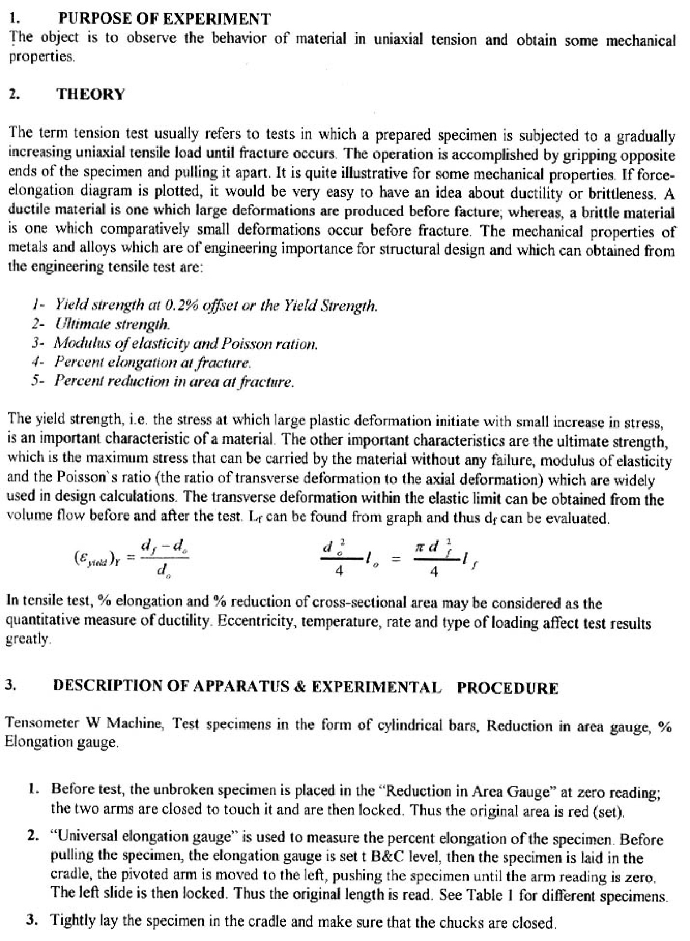

2

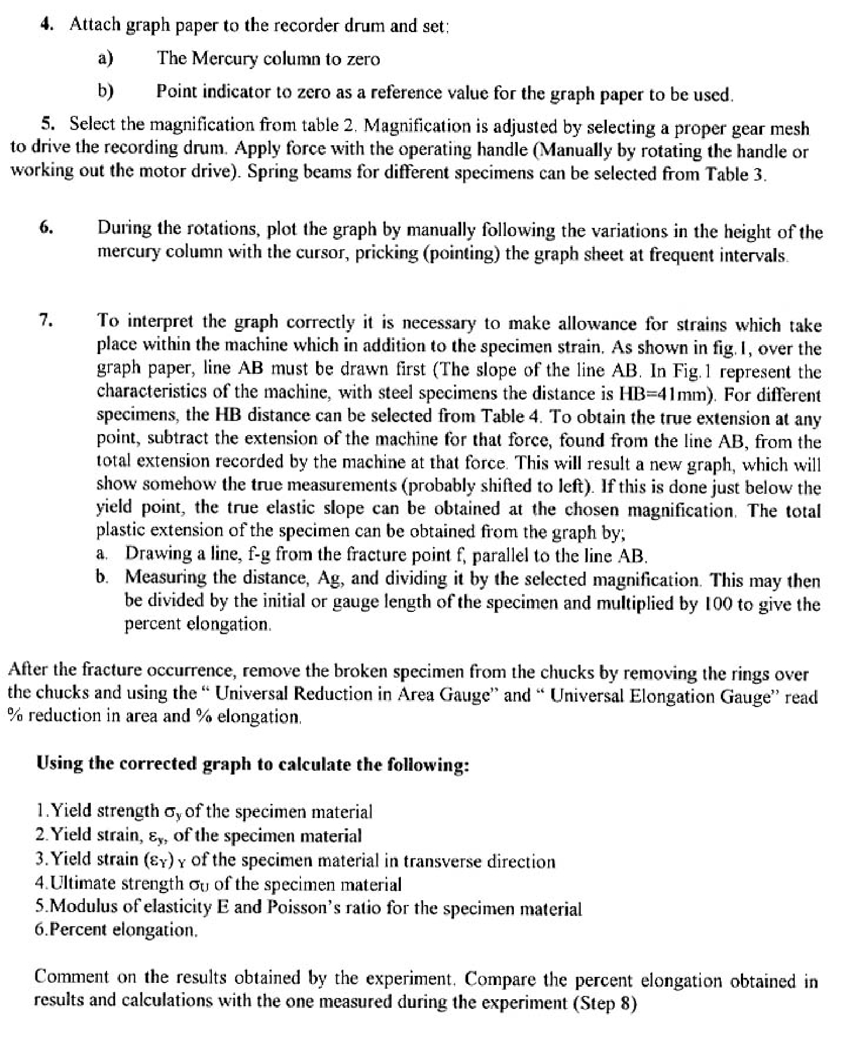

3

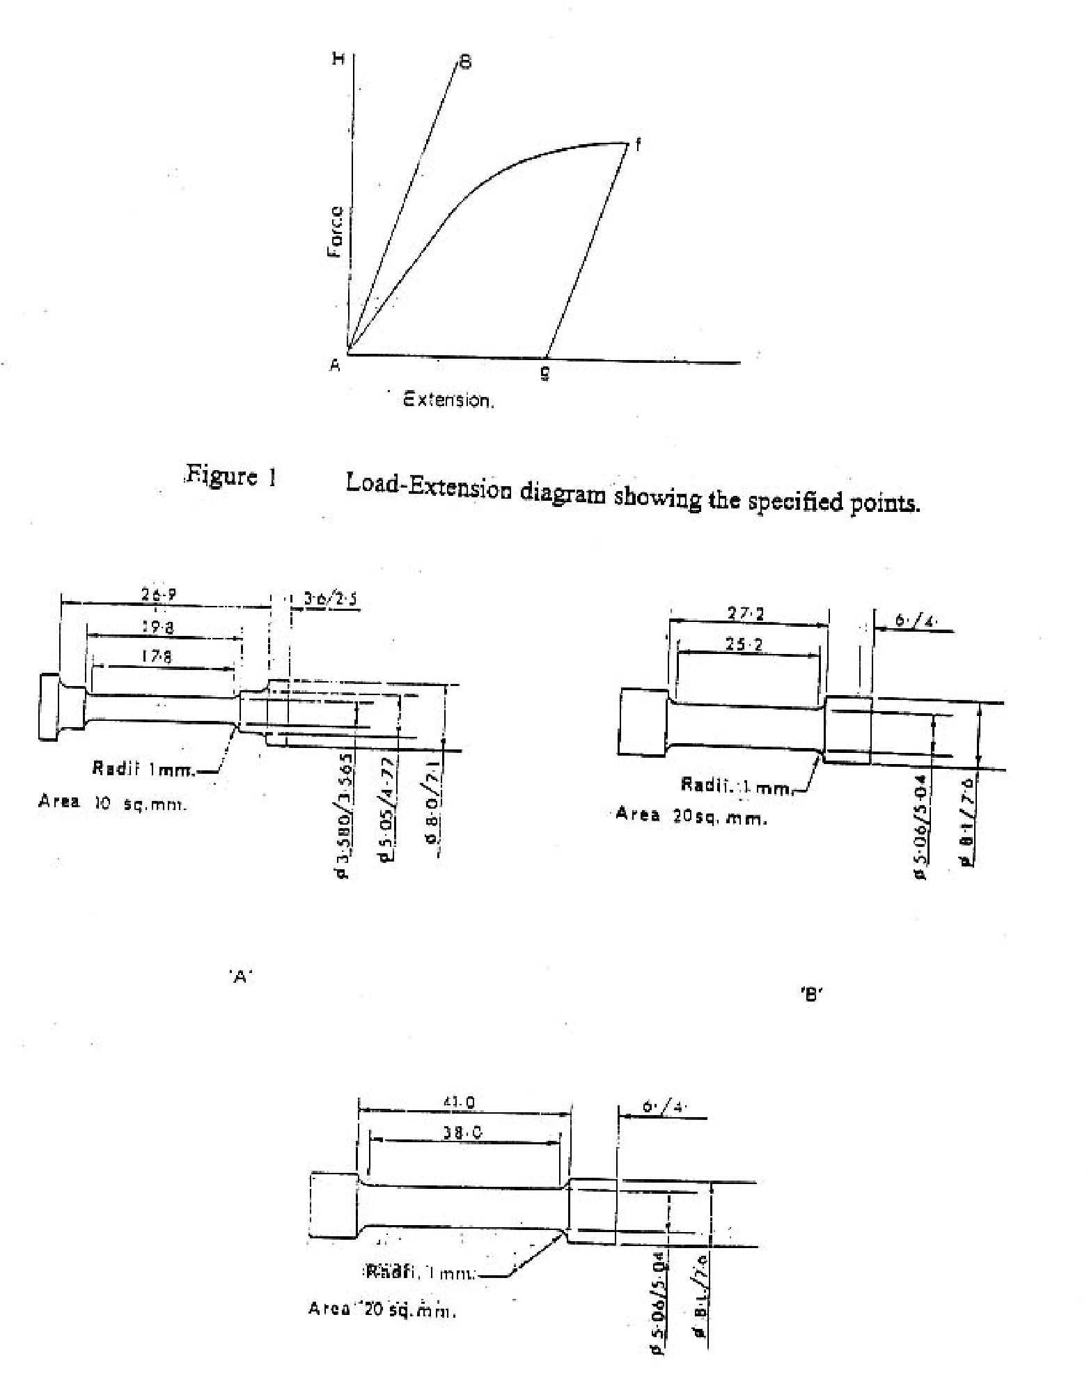

4

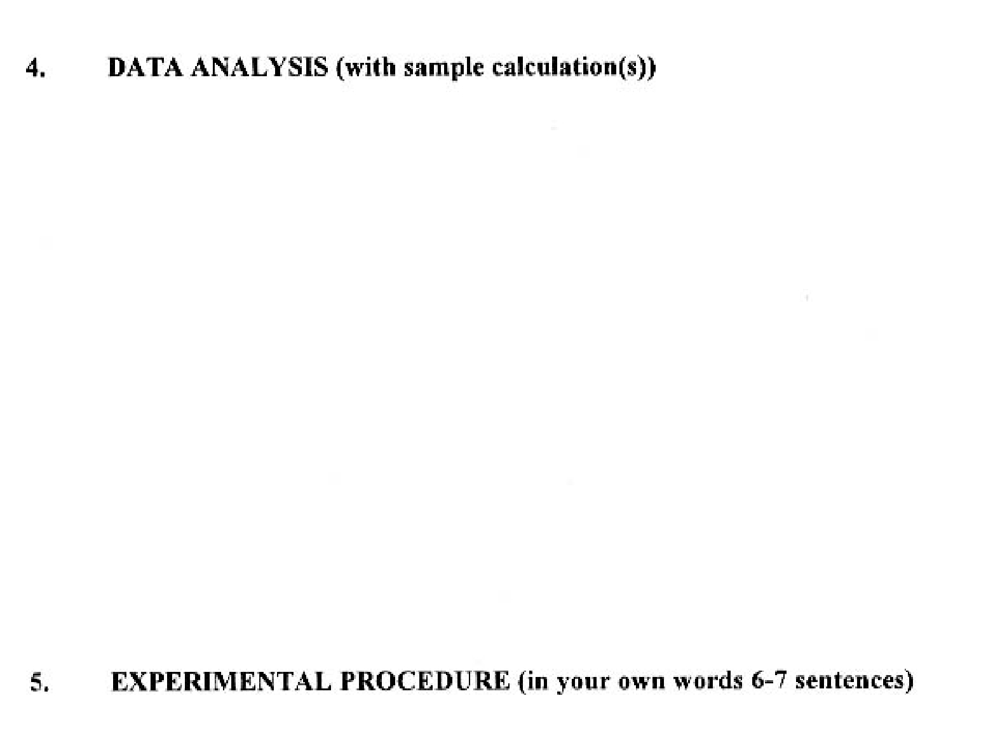

5

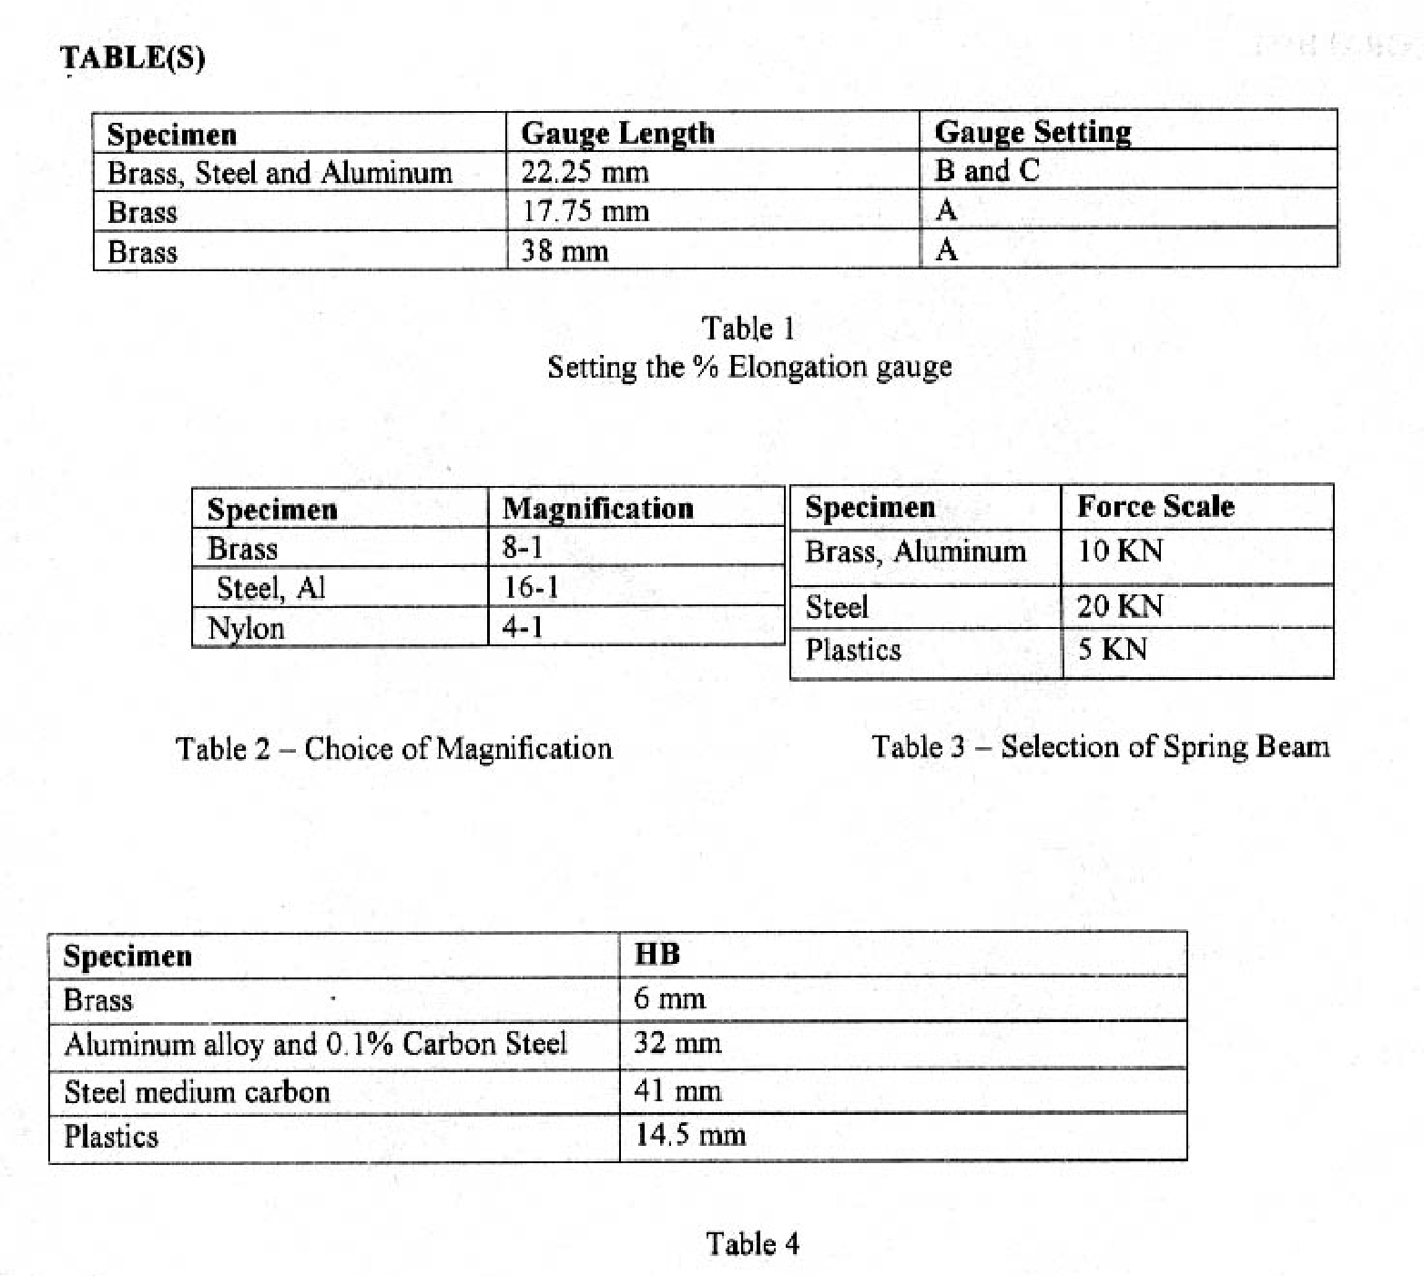

6

7

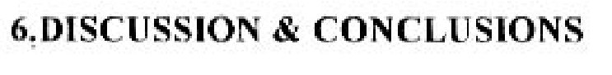

8

