1979
EASTERN MEADITERRANEAN UNIVERSTY

DEPARTMENT OF MECHANICAL ENGINEERING

LABORATORY HANDOUT

COURSE Materials Science and Manufacturing Processes

Semester: Fall 2018/2019

Laboratory No: 2

Name of Exp: Hardness Test

Instructor: Mohamad Alhijazi

Submitted by: …………………………………………………

Student No: ……………………………………………………

Date: …………………………………………………………..

-------------------------------------------------------------------------------------------------------------

EVALUATION

PROCEDURE

RESULTS & GRAPHS

DISCUSSION

OVERALL MARK

Name and signature (of evaluator): ……………………………..……………………………….

1. PURPOSE OF EXPERIMENT

The object is to determine the hardness of a material (steel, aluminum etc.) for different scales.

2. THEORY

The hardness of a material can be defined as “The resistance to permanent plastic deformation”. There are three general types of hardness measurements depending on the manner in which the test is conducted. These are (1) scratch hardness, (2) indentation hardness and (3) rebound or dynamic hardness. Only indentation hardness is of major engineering interest for metals. Scratch hardness is measured according to Mohs’ scale. This consists of ten standard minerals arranged in the order of their ability to be scratched. The softest mineral in this scale is talc (Scratch hardness 1), while diamond has a hardness of 10. A fingernail has a value about 2, annealed copper has a value of 3 and martensite a hardness 7. The hardest metals fall in the Mohs’ hardness range of 4 to 8. In dynamic hardness measurements, the indenter is usually dropped on to the metal surface, and the hardness is expressed as the energy of impact.

In the indentation hardness measurements, the hardness of a metal is measured by forcing an indenter into its surface. The indenter material, which is usually a ball, pyramid or cone, is made of a material much harder than the material being tested. For example hardened steel, tungsten carbide, or diamond is commonly used. In this test, the indenter is forced into the surface of the material under a standard load at right angle (90°). After the indentation has been made, the indenter is withdrawn from the surface. An empirical hardness number is then calculated or read off a dial, which is based on the cross-sectional area or depth of the impression.

Brinell Hardness Testing

In this test, a hardened steel ball is forced into the surface of material under a standard load at right angle. After the indentation has been made, the indenter is withdrawn from the surface and the diameter of spherical indentation is measured. The numerical Brinell Hardness (HB) number is equal to the applied load P, divided by the spherical surface area of the indentation A, expressed in kg/mm².
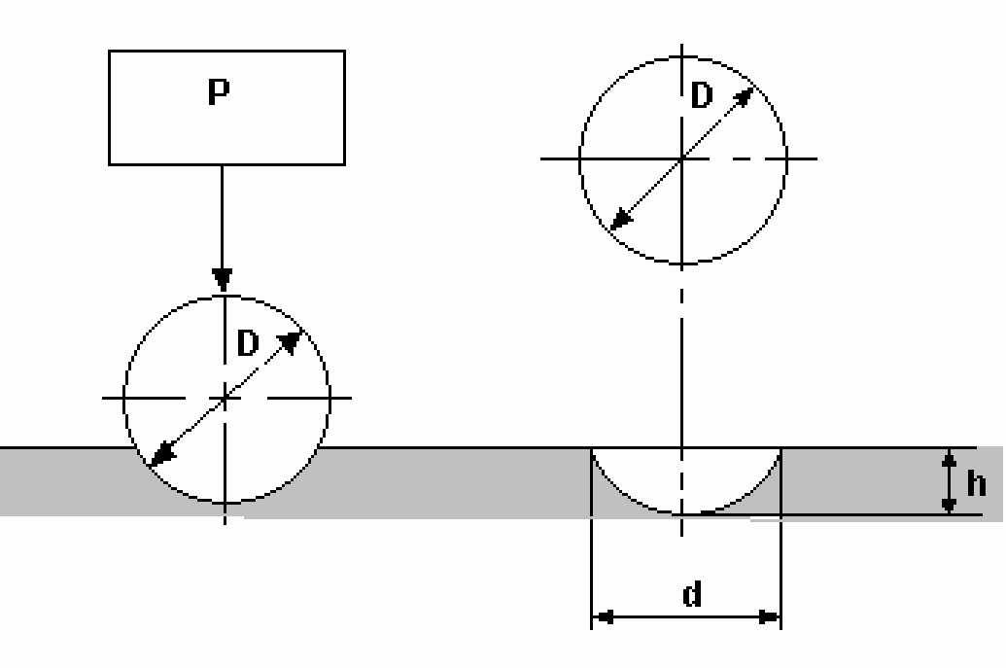

1

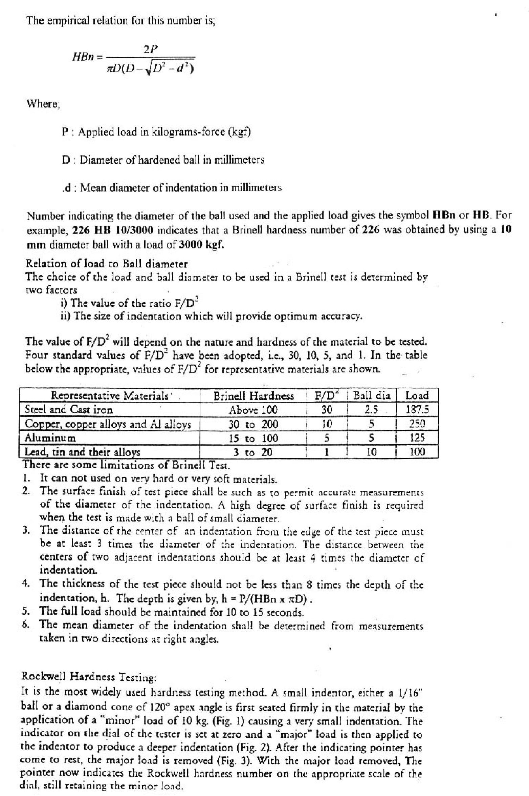

2

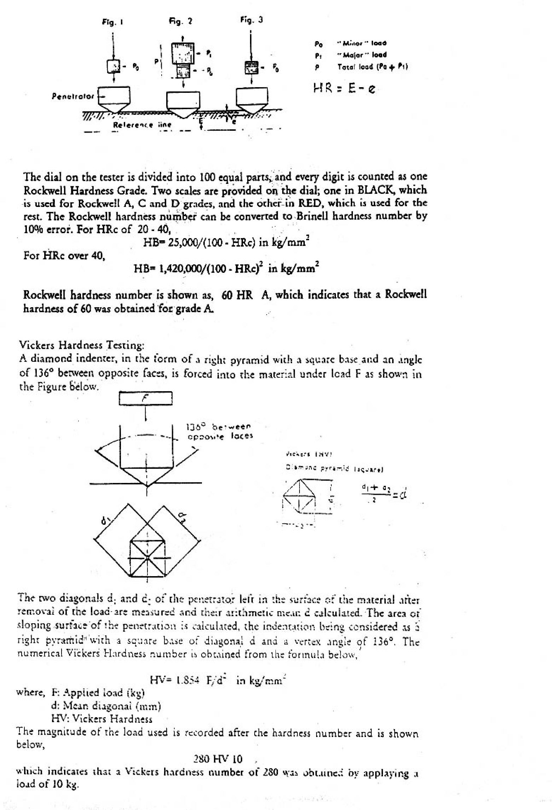

3

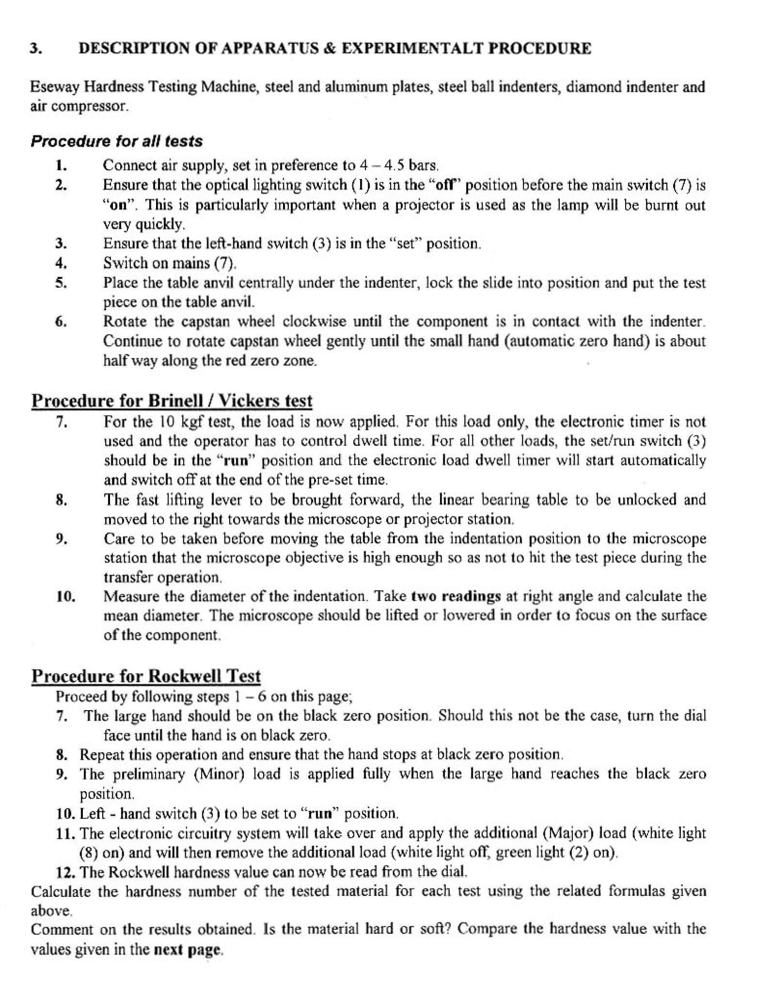

4

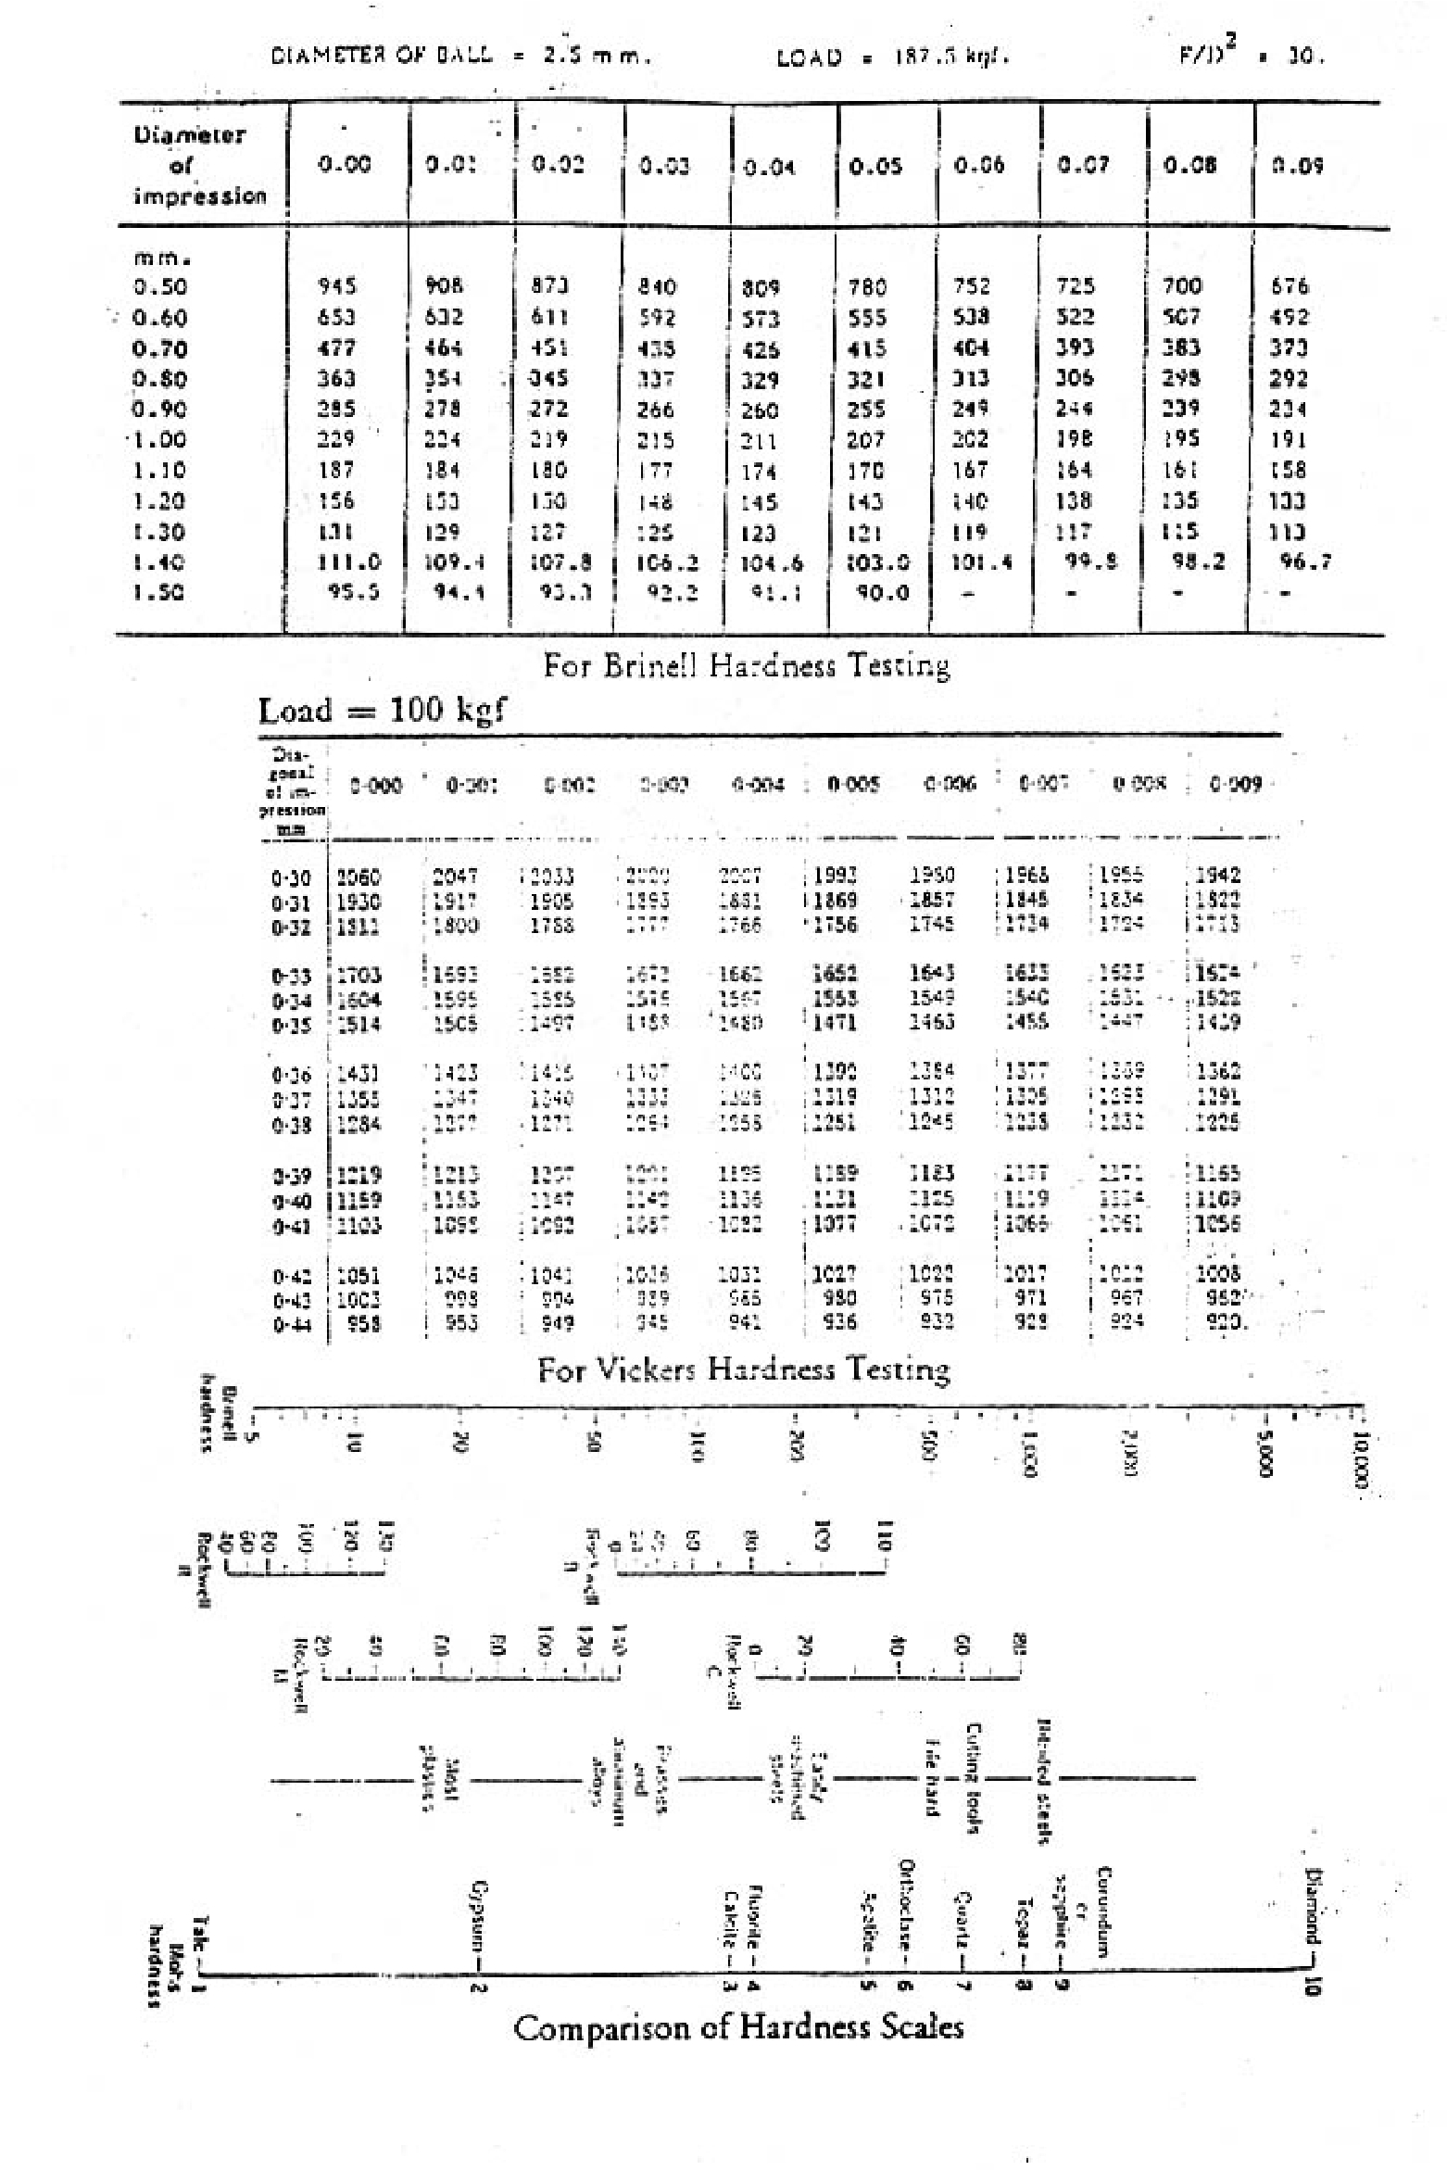

5

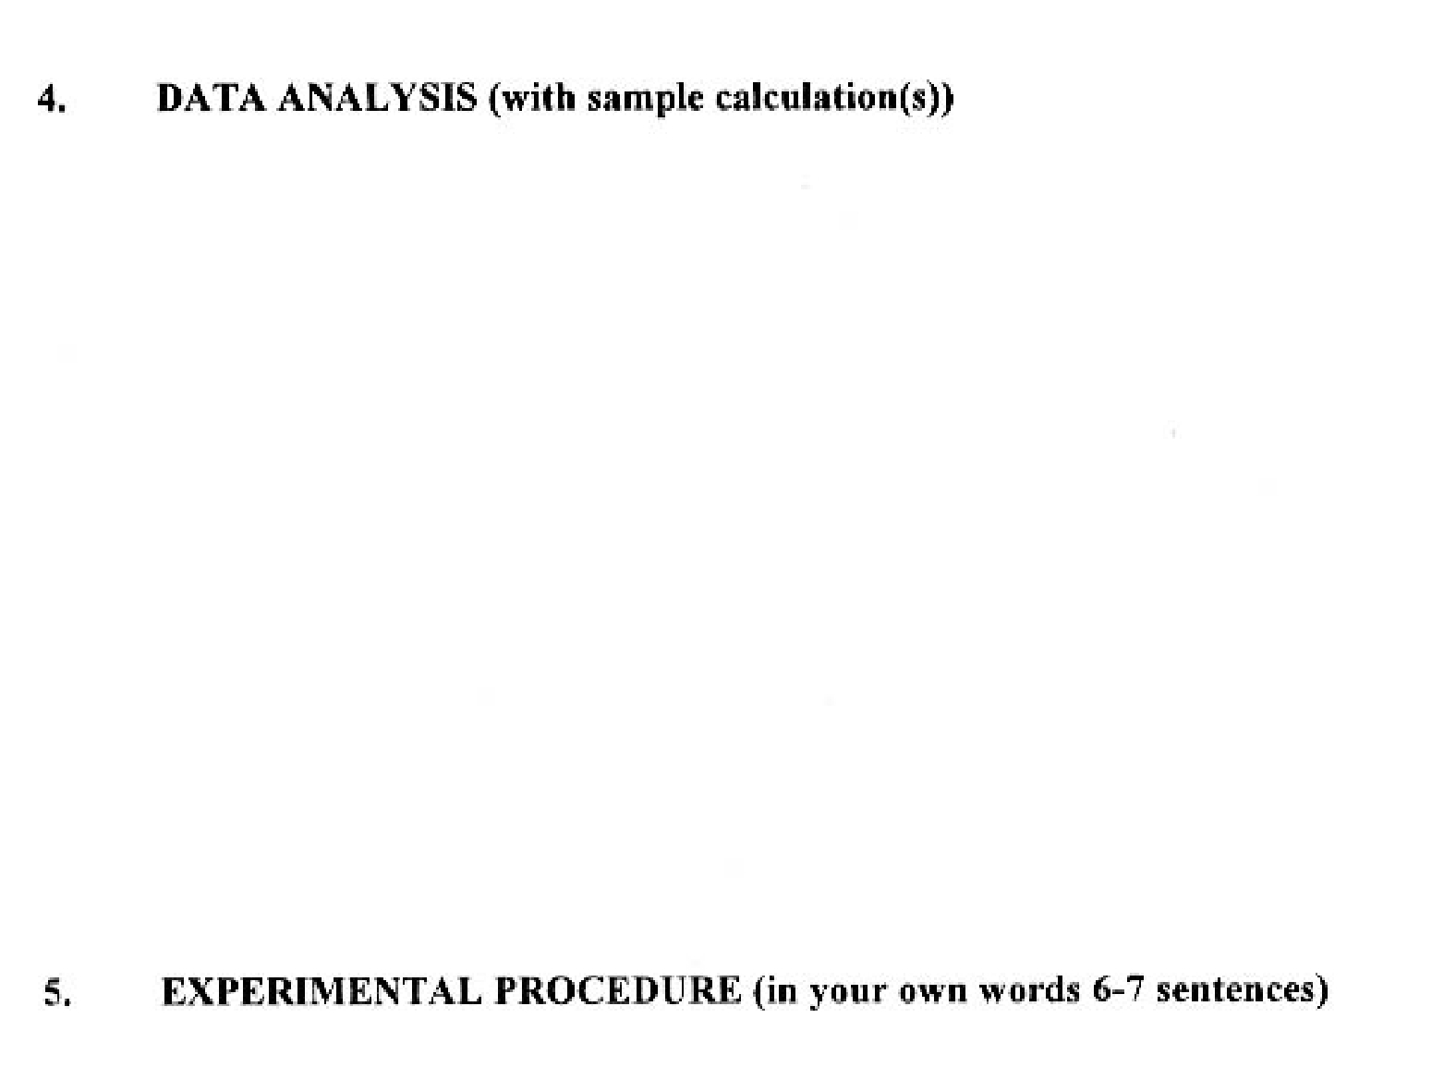

6

7

8

9

