Eastern Mediterranean University
Computer Engineering Department
CMPE344-CMSE346 - Computer Networks– Lab. 2

Title: Switched Local Area Networks Using OPNET Modeler

Overview:

This Lab is designed to demonstrate the need for implementation of switches in the
design of local area networks. In this Lab, the students will design a 16-station LAN using first a simple hub, and then a switch and two hubs. The performance of the local area network in the two scenarios will then be compared.

How to create a new project (Review):

It will happen in these steps as follow:
Step1:

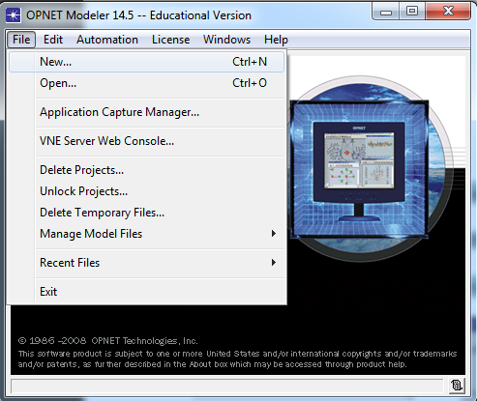

Step 2:
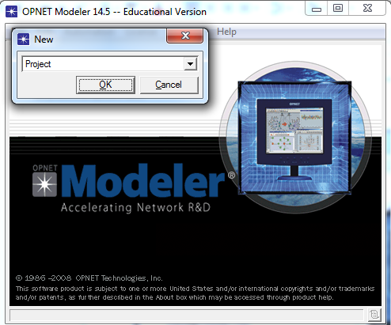

Step 3:

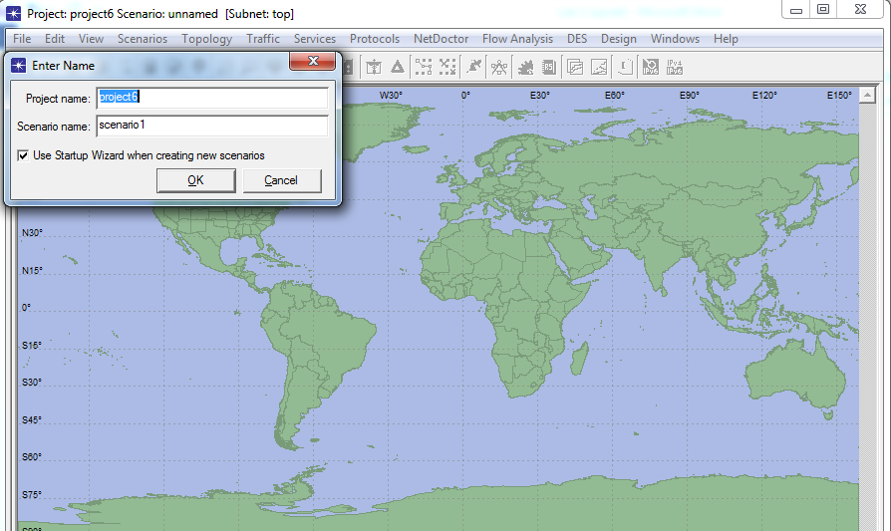

Step 4:

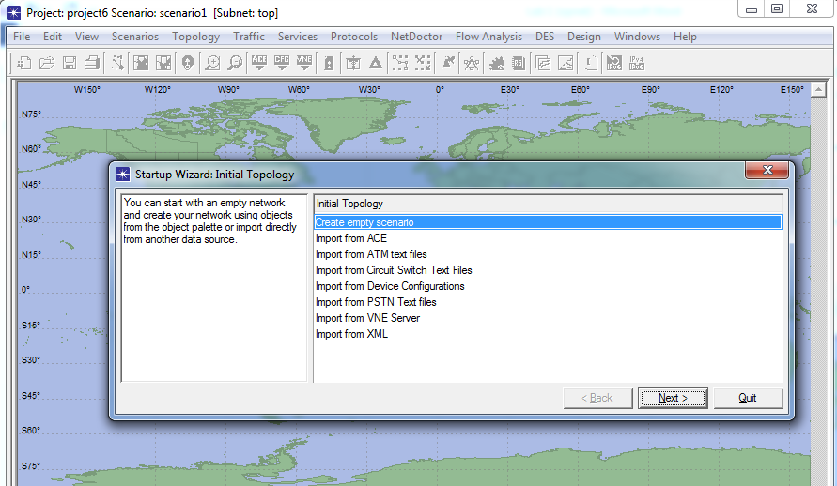

Step 5:

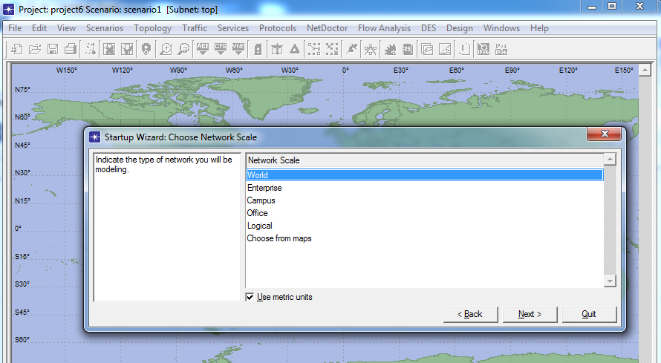

Step 6:

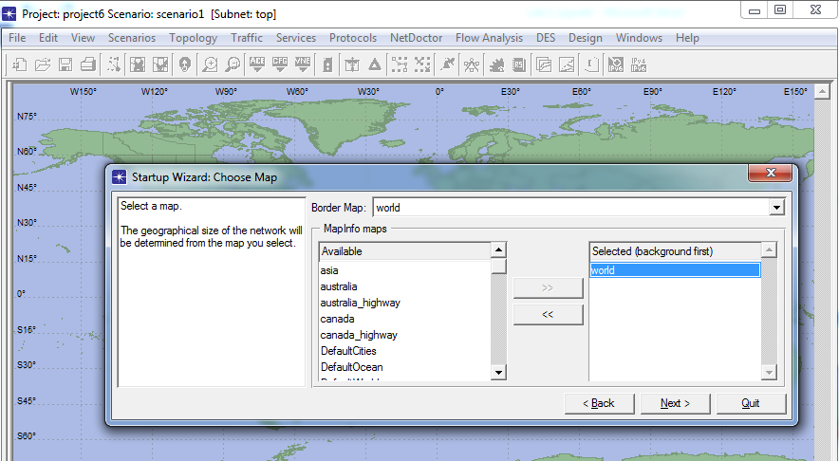

Step 7:

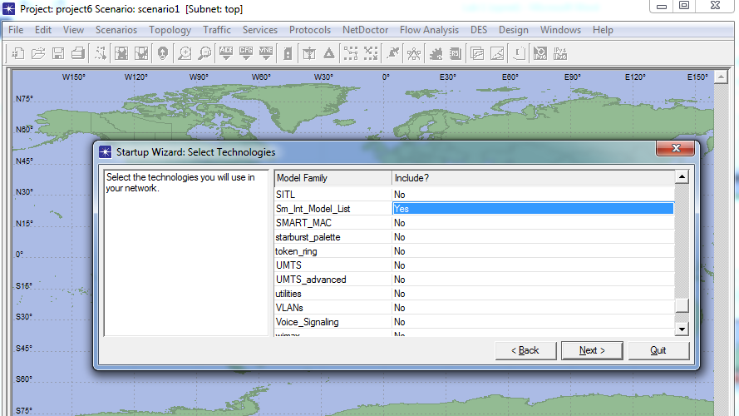

Step 8:

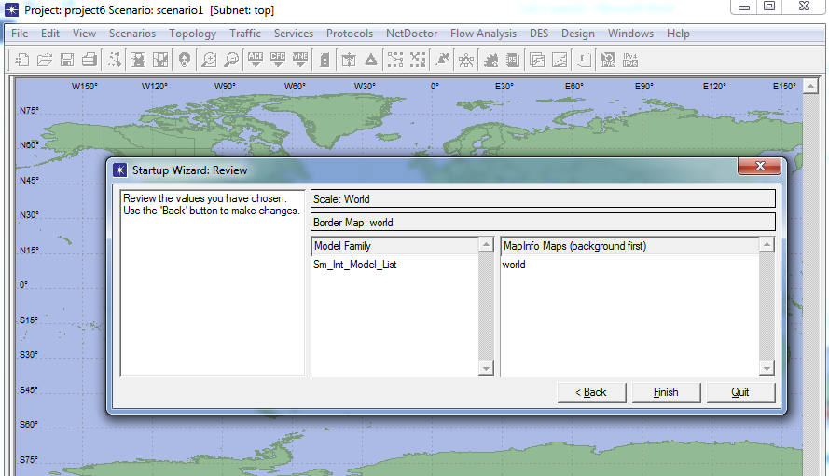
Object palette:

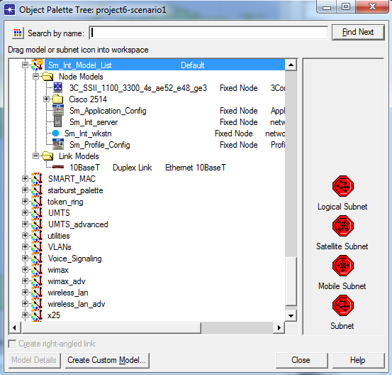
Create a New Project:

In this first phase you will open and name your project and name the first simulation scenario. The first simulation scenario will consist of 16 networked stations (PCs) and one hub. In this first phase you will specify the geographic size of the network.

- Start the OPNET IT Guru Academic Edition → Choose New from the File menu
- Select Project and click OK →; Name the project < Lab2> → Name the scenario OnlyHub; Click OK
- In the Startup Wizard: Initial Topology dialog box, make sure that Create Empty Scenario is selected → Click Next → Choose Office from the Network Scale List → Click Next three times → Click Finish.
- Close the Object Pallete dialog box.

Create the Network:

To create our switched LAN:

- Select Topology → Rapid Configuration. From the drop-down menu choose Star and click OK.
- Click the Select Models button in the Rapid Configuration dialog box. From the Model List drop-down menu choose ethernet and click OK.
- In the Rapid Configuration dialog box, set the following six values: Center Node Model = ethernet16_hub, Periphery Node Model = ethernet_station, Link Model = 10BaseT, Number =16, Y=50, and Radius = 42 → Click OK.

Remember that 10BaseT link represents an Ethernet connection operating at 10Mbps.

- Right-click on node_16, which is the hub → Edit Attributes →Change the name attribute to Hub1 and click OK.
- Now that you have created the network, it should look like the network on Figure below.

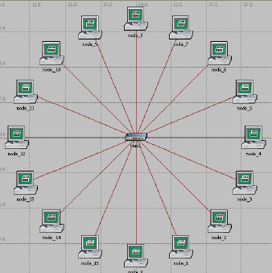

- Make sure to save your project.

Configure the network nodes

- Here you will configure the traffic generated by the stations.
- Right-click on any of the 16 stations (node_0 to node_15) → Select Similar Nodes.
- Now all stations in the network are selected.
- Right-click on any of the 16 stations → Edit Attributes.
- Check the Apply Changes to Selected Objects check box. This is important to avoid reconfiguring each node individually.
- Expand the hierarchies of the Traffic Generation Parameters attribute and the Packet Generation Arguments attribute → Set the following four values: Star timeconstant (0,5) and . . .

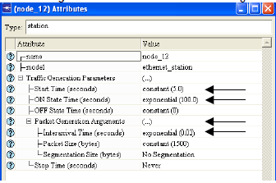

- Click OK to close the attribute editing window. Save your project

Note here that we have introduced a traffic generation at each node. The traffic model follows a well-known ON-OFF model, in which each node switches between On state in which the traffic is generated, and OFF state in which there is no traffic. The duration of ON and OFF states is random, and in this example follows exponential distribution. In this example, the duration of OFF state is 0.

Choose Statistics
To choose the statistics to be collected during the simulation:
- Right-click anywhere in the project workspace and select Choose Individual Statistics DES from the pop-up menu.
- In the Choose Results dialog box, choose the following 4 statistics:
a. Ethernet Delay – this represents the end-to-end delay of all packets received
by all the stations.
b. Traffic Received (in packets/sec) by the traffic sinks across all nodes
c. Traffic Sent (in packets/sec) by the traffic sources across all nodes
d. Collision count is the total number of collisions encountered by the hub during packet transmissions.
- Click OK

Configure the Simulation
Here we need to configure the duration of the simulation:
- Click on the Configure / Run Simulation button.
- Set the duration to be 2.0 minutes
- Click Apply and then Cancel

Duplicate the Scenario
The network we just created utilizes only one hub to connect the 16 stations. We need to create another network that utilizes a switch and see how this will affect the network performance. To do that we will create a duplicate of the current network.

- Select Duplicate Scenario from the Scenarios menu and give it the name
HubAndSwitch → Click OK.
- Open the Object Palette by clicking on Make sure that Ethernet is selected in the pull-down menu on the object palette.
- We need to place a hub and a switch in the new scenario.
- To add the Hub, click its icon in the object palette → Move your mouse to the workspace → Click to drop the hub at a location you select. Right click to indicate you are done deploying hub objects
- Similarly, add the Switch 6. Close the Object Palette
- Right-click on the new hub → Edit Attributes → Change the name attribute to Hub2 and click OK.
- Right-click on the switch → Edit Attributes → Change the name attribute to Switch and click OK
- Reconfigure the network of the HubAndSwitch scenario so that it looks like the following one.

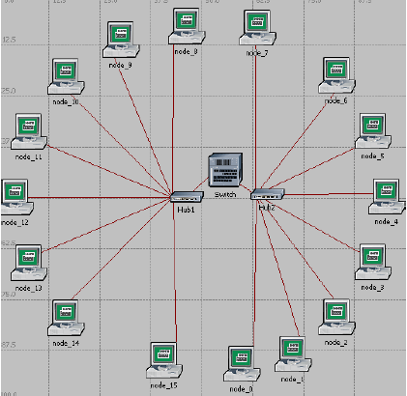

Hints:
• To remove a link, select it and choose Cut from the Eidt menu (or simply hit
the Delete key). You can select multiple links and delete them all at once.
• To add a new link, use the 10BaseT link available in the Object Palette.

- Save the Project

Run the Simulation
To run the simulation for both scenarios simultaneously:
1. Select Manage Scenarios from the Scenarios menu.
2. Change the values under the Results column to <collect> (or <recollect>) for both
scenarios. Compare to the following figure.
3. Click OK to run the two simulations.
4. After the two simulations runs complete, one for each scenario, click Close.
5. Save your project.

View the Results
To view and analyze the results:

1. Select Compare Results from the Results menu. (Or right click in the workspace).
2. Change the drop-down menu in the lower-right part of the Compare Results dialog box from As Is to time_average.
3. Select the Traffic Sent (packets/sec) statistics and click Show.
4. Select the Traffic Received (packets/sec) statistics and click Show.
5. Select the Delay (packets/sec) statistics and click Show.
6. Select the Collision Count (packets/sec) statistics and click Show.
7. On the resulting graph right-click anywhere on the graph area → Choose Add
Statistics → Expand the hierarchies as shown below → Select the Collision Count
statistics for Hub2 → Change as Is to time_average → Click Add.
8. Save your project.

Important warning:
The lab is now completed. Show your result to Lab Assistant.
(In order to grading)

Homework:

- Design a network with 15 workstations with 3 Hubs and one switch

