Eastern Mediterranean University
Computer Engineering Department
CMSE 222 Introduction to Computer Organization– Lab. 5
REGISTERS IN VeriLog HDL

OBJECTIVES:
This laboratory work aims to introduce a practical work on the design of Registers from architectural and behavioral descriptions. The architectural description covers both the schematic and the software implementation of circuits designed through the conventional design procedure. The behavioral descriptions cover the implementation using state transition diagrams.

Important Note: For each of the following experimental tasks (in each phase), open a new project to avoid compilation errors due to multiple use of components within the same project’s files.
Phase 1: Schematic-Entry
Assume that we want to design the following multi-function register that is controlled by two control inputs S1 and S0 as follows:
Mode Control |  | Register  Operation
S1 | S0
0 | 0 | No change
0 | 1 | Shift left
1 | 0 | Shift right
1 | 1 | Parallel Load

The schematic circuit corresponding to this multi-function register is given below:
  - Draw the circuit of this multifunction register, compile and simulate it in VeriLog HDL environment and verify its mode of operations. Adjust and apply appropriate waveforms to observe different function modes easily.

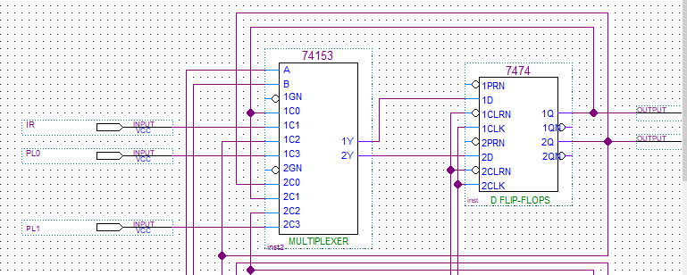

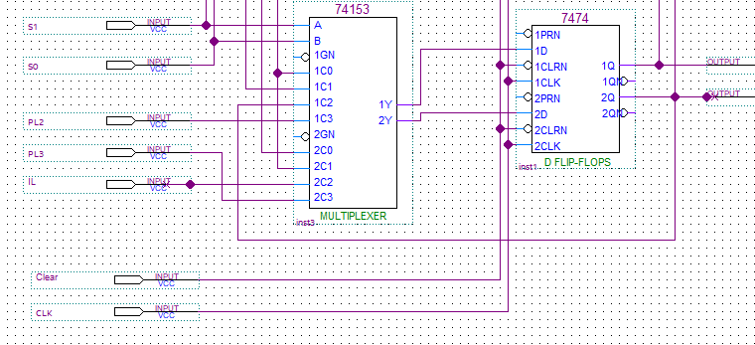

Phase 2: Implementing the Architectural Design of Multi-Function Register in Verilog HDL
Enter the following architectural VeriLog code of multifunction register design into Quartus Lite development suite. Compile and simulate your code to verify its correctness.

/* 4-bit Multifucntion Register controlled by two control inputs S1 and S0 as follws:
s1 s0=00 No change
01 Shift left
10 Shift right
11 Parallel load
*/

module MultiFuncRegister_Arch(Clear,CLK,S,PL,IL,IR,Q);
input CLK;
input Clear;
input IL, IR; // Serial load from left and right
input [1:0] S; // Vector of control inputs S1 and S0
input [3:0] PL; // Parallel load
output [3:0] Q; // Register ouputs Q3, Q2, Q1, Q0
wire [3:0] W; // Internal signals among components

MUX_4_1 m1(W[0],S[1],S[0],PL[0],IL,Q[1],Q[0]);
MUX_4_1 m2(W[1],S[1],S[0],PL[1],Q[0],Q[2],Q[1]);
MUX_4_1 m3(W[2],S[1],S[0],PL[2],Q[1],Q[3],Q[2]);
MUX_4_1 m4(W[3],S[1],S[0],PL[3],Q[2],IR,Q[3]);

D_FF d1(Q[0],W[0],CLK,Clear);
D_FF d2(Q[1],W[1],CLK,Clear);
D_FF d3(Q[2],W[2],CLK,Clear);
D_FF d4(Q[3],W[3],CLK,Clear);

endmodule

module D_FF(Q,D,CLK,CLR);
input D,CLK,CLR;
output reg Q;

always @(posedge CLK)
if (CLR == 1'b1)
Q<= 1'b0;
else
Q<= D;
endmodule

module MUX_4_1(Y,S1,S0,I3,I2,I1,I0);
input S1,S0,I3,I2,I1,I0;
output reg Y;

always @(S1,S0,I3,I2,I1,I0)
begin
if (S1==0 & S0==0)
Y=I0;
else if (S1==0 & S0==1)
Y=I1;
else if (S1==1 & S0==0)
Y=I2;
else if (S1==1 & S0==1)
Y=I3;
end
endmodule

HOMEWORK #3 : (Behavioral Description of a Multi-funtion Regiter)
Behavioral VeriLog code of the above described multifunction register is given below:
/* Behavioral description of a multifunction register in veriLog HDL
s1 s0 =00 Nocahnge
S1 S0 =01 Shift left
S1 S0 =10 Shift right
S1 S0 =11 Parallel load
*/

module MultiFunctRegister_Behav(Clear,CLK,S,PL,IL,IR,Q);
input Clear, CLK;
input [3:0] PL;
input [1:0] S;
input IL,IR;
output [3:0] Q;

reg [3:0] R;

always @(posedge CLK)
begin
if (Clear == 1)
R <= 4'b0000;
else if (S[1]==0 & S[0]==0) // No change
R <= R;
else if (S[1]==0 & S[0]==1) // Shift left
begin
R[0] <= IR; R[1] <= R[0];
R[2] <= R[1]; R[3] <= R[2];
end
else if (S[1]==1 & S[0]==0) // Shift right
begin
R[3] <= IL; R[2] <= R[3];
R[1] <= R[2]; R[0] <= R[1];
end
else if (S[1]==1 & S[0]==1)
begin
R=PL;
end
end

assign Q = R;

endmodule

Modify the above-given behavioral code to design a 4-bit multifunction register that operates as follows:
Enable S1 S0 Operation Mode
0 x x No change
1 0 0 Rotate left
1 0 1 XOR contents with (0101)
1 1 0 Rotate right
1 1 1 Parallel load

Submit your homework at the beginning of the 4-the experimental work.

Prepared by Assoc. Prof. Dr. Adnan ACAN

