 | EASTERN MEDITERRANEAN UNIVERSITY  SCHOOL OF COMPUTING AND TECHNOLOGY  DEPARTMENT OF INFORMATION TECHNOLOGY  COURSE POLICY SHEET | 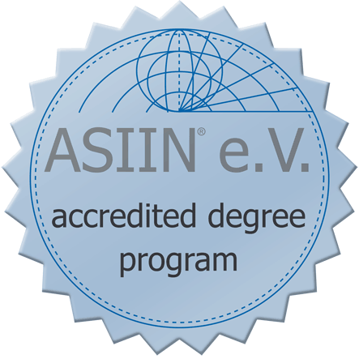

Course Title | Multimedia Development for Web Application
Course Code | ITEC475
Type | Full Time
Semester | Fall/Spring
Category | AE (Area Elective)
Workload | 180 Hours
EMU Credit | (3,1,0) 3
Prerequisite | -
Language | English
Level | Fourth Year
Teaching Format | 3 Hours Lecture, 1 Hour Lab per week
ECTS Credit | 6
Course Web Site | http://courses.sct.emu.edu.tr/it/itec475

Instructor(s) | Pınar Kumyalılı | Office Tel | +90 392 630 1670
E-mail | pinar.sahin@emu.edu.tr | Office No | CT207

Course Description
This course is applicable to anyone who had gained experience on web design concepts, the course aims at introducing students to web design image creation and craftsmanship. In this course students will be introduced to advanced principles of web design graphics, and logos, alongside applications that will enhance their knowledge and skills. It is also designed to provide students with knowledge and analytical skills required for industrial web design, personal websites, and other types of graphics required for web development. The course will use a prevalent imaging tool such as Photoshop or Corel draw.

General Learning Outcomes
On successful completion of this course students should be able to:
- Understand fundamental techniques of Multimedia Development for Web Application.
- Create interactive web site content.
- Create friendly user interface.
- Describe the role and purpose of Multimedia Development easily.
- Design and implement a web interface
- Implement a website and integrate it with other IT applications.
- Understand the needs of industry.

Teaching Methodology / Classroom Procedures
- Each week there are two lecture sessions and one tutorial session.
- Tutorial sessions are organized in parallel to theoretical study given in classrooms. In the laboratory, particular aspects of the Photoshop program are demonstrated and labs tasks are assigned to students and evaluated based on performance.
- Participation in the lab session is graded.
- There is no midterm exam.
- There is a final exam which includes all the chapters.
- The final exam is practical.
- There is an individual project. The project should be submitted as a soft and hard copy.
- The project is assigned to the students in the second week of the semester and submitted at the end of the semester in the presentation day.
- There is no need to take plagiarism test for the project.
- Term project will be assigned to students in order to assess their learning outcome each semester
- Students are also encouraged to use the internet to search for various related topics. Lecture notes, Lab descriptions, and announcements will be posted on the course’s web site.

Course Materials / Main References
Text Book:
- Photoshop® CS5: Top 100 Simplified® Tips & Tricks, 2010 - ISBN: 978-0-470-61265-1
- Mastering Photoshop for Web Designers, 2011 ISBN: 978-3-943075-12-0
Lecture Notes:
All course materials are also available online in Adobe PDF (Portable Document Format).

Weekly Schedule / Summary of Topics
Week 1 | Introduction: installing the software.
Week 2 | Explanation of Adobe Photoshop Tools Palette and assigning individual web based projects.
Week 3 | Layers, selections and masks
Week 4 | Straighten, crop and resize
Week 5 | Retouch images
Week 6 | Enhance colors, tones and sharpness
Week 7 | Applying digital effects
Week 8-9 | Midterm Examinations
Week 10 | Design with text effect, watermark, warp text
Week 11 | Design with text effect, perspective, shadow, weave text and graphics
Week 12 | Creating digital artworks, art projects
Week 13 | Creating Web Photo Gallery, HTML
Week 14 | Project Presentations
Week 15 | Project Presentations
Week 16-18 | Final Examinations

Requirements
- One who misses an exam should provide a medical report or a valid excuse within 3 days after the missed exam.
- The make-up exam is done at the end of the term and covers all the topics.
- Students who fail to attend the lectures regularly may be given NG grade.
- Once the grades are announced, the students have only one week to do objection about their grades.
- It is the students’ responsibility to follow the announcement in the course web site.

Method of Assessment
Evaluation and Grading | Term Project | Activities | Final Exam
Percentage | 35% | 25 % | 40 %

Grading Criteria *
A | A- | B+ | B | B- | C+ | C | C- | D+ | D | D- | F
90 -100 | 85 - 89 | 80 - 84 | 75 - 79 | 70 - 74 | 65 - 69 | 60 - 64 | 56 - 59 | 53 - 55 | 50 - 52 | 40 - 49 | 0 – 39
* Letter grades will be decided upon after calculating the averages at the end of the semester and distribution of the averages will play a significant role in the evaluation of the letter grades.

