**EASTERN MEDITERRANEAN UNIVERSITY**



**Department of Industrial Engineering**

**IENG516 Network Flows**

**HOMEWORK 3 Spring 2016-17**

1. Fine the simplex tableau for the optimal solution of last question in Homework2.
2. Consider the following network. Node 1 has five units available. Node 3 has two units available. Node 2 needs four units. Node 4 needs one unit.

a. Set up the linear program for this problem.

b. Solve the problem by the network simplex method. Is the optimal solution obtained degenerate?

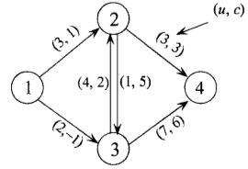

1. Starting with *x12* , *x24* and *x31* as part of a basis where *x14* is nonbasic at its upper bound and where all other *xij* variables are nonbasic at their lower bounds, solve the following network flow problem:

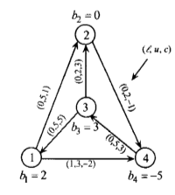

1. Solve the following network flow problem:

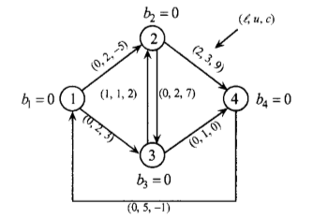

1. Develop a method to solve a linear program of the form



Where *A* is a node-arc incidence matrix. Apply the method to the following problem.

