EASTERN MEDITERRANEAN UNIVERSITY
Department of Industrial Engineering
IENG516 Network Flows
HOMEWORK 6 Spring 2016-17

- Find the shortest path from node 1 to all the nodes in the following network. Identify the shortest path tree obtained.
1
7
3
4
6
56
1
6
2
1
7
2
2
2
5
3
2
c_{ij}

7

4

- Show that at optimality of the shortest path problem w_{i}-w_{m} represent a lower bound on the cost of the shortest path from node i to node m for each i.

- Find the shortest path from node 1 to every other node in the following network. Identify the shortest path tree obtained. Find the optimal solution of dual problem.
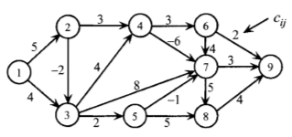

- Find the shortest path from node 1 to all nodes for the following network using Dijkstra's algorithm as well as using the PSP algorithm. Identify the shortest path tree obtained. Now consider arc (6,3) with cost -7 instead of the current arc (3,6) with cost 7. Solve the problem again and find the negative cost circuit.
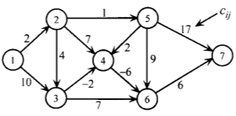

- Suppose that you are to find the shortest simple path from node 1 to node m in a network that may contain negative cost circuits. Furthermore, suppose that you have obtained an optimal solution to the minimum cost flow problem on this network after designating b₁ = 1, b_{m} = -1, and b_{i} = 0 otherwise, and setting bounds on all the arcs (i,j) in the problem. How would you identify the simple path from 1 to m that has a flow of one unit in this solution? Why is this not necessarily the shortest simple path from 1 to m? Provide a mathematical formulation of the problem of determining a shortest simple path.

- Find the minimal spanning tree for the following network. Write the dynamic mathematical linear programming of the problem.

2000
2
7

1100
1300
2200
800
5
1000
4
1
2600
7
1400
780
300
6
3
1300

