**EASTERN MEDITERRANEAN UNIVERSITY**



**Department of Industrial Engineering**

**IENG516 Network Flows**

**HOMEWORK 1 Spring 2016-17**

1. Show that the following three definitions are equivalent for a tree.
2. *T* is connected and also has no cycles.
3. *T* is connected and has *(m-1)* arcs.
4. *T* has *(m-1)* arcs and has no cycles.

1. Show the rank of a technological matrix A, for any minimal cost network flow problem with *m* nods is *(m-1)*.
2. Solve the following problem by the simplex method.



1. Draw a network regarding the following linear programming problem.

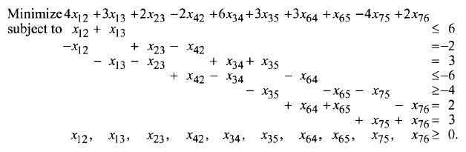

= 6

= -2

= 2

= -6

= -4

= 2

= 2

≥0

1. Suppose that the following figure represents a railroad network. The numbers beside each arc represent the time it takes to traverse the arc. Two locomotives are stationed at point 2 and three locomotives are at point 3. One locomotive is needed at point 5 and 4 locomotives are needed at point 6. Formulate the problem to get the power required to points 6 and 5 with minimum cost.

4

2

2

2

5

3

1

1

3

1

2

3

6

4

4

1. Formulate the following network flows problem.

*bi*

5

1

2

3

4

-2

-2

4

-3

2

2

4

4

5

3

3

1

1

*cij*

Show that *x23=4, x34=7, x41=2, x45=3* and zero for other *xij* is a feasible solution. Show its associated tree. Compute the value of objective function related to the above point.

1. Show that for a Network Flow Problem if the values of *bi* *i=1,2,...m* are integer then all of extreme points for feasible region of this problem have integer components.
2. If *B* be that basis obtain from the node-arc matrix of a Network Flow Problem then *det(B)=-1* or *+1*.

1. Write the following Network Flow Problem as a linear problem. Represent each of nonbasic columns regarding the basic rooted spanning tree given by the doted arcs as follow. Find the correspond BFS.

*bi*

2

-2

-3

*cij*

-2

1

-1

3

3

5

4

0

2

4

5

4

3

2

1