LAB4:Using printf/scanf
Task1: write a program to print hello on screen
Using printf
#include<stdio.h>
#include<conio.h>

void main()
{
printf("hello ");
getchar();
}

Please remember to use open and close paranthesis after the name printf. Every function in C, must have open/close paranthesis.

Task2: Write a program to print numbers 1 to 5 on screen using a loop
Using printf
#include<stdio.h>
#include<conio.h>

void main()
{
for(int i=1;i<=5;i++)
printf("%d",i);
getchar();

}
The output of these programs are: 12345
Print the numbers separated by a single space
#include<stdio.h>
#include<conio.h>

void main()
{
for(int i=1;i<=5;i++)
printf("%d ",i);
getchar();

}
The output of these programs are: 1 2 3 4 5
Print numbers separated by a tab
#include<stdio.h>
#include<conio.h>

void main()
{
for(int i=1;i<=5;i++)
printf("%d\t",i);
getchar();

}
The output of these programs are: 1 2 3 4 5
Print numbers on separate lines
#include<stdio.h>
#include<conio.h>

void main()
{
for(int i=1;i<=5;i++)
printf("%d\n",i);
getchar();

}
The output of these programs are:
1
2
3
4
5

Formatted output
Width specifier: %3d means you want to print an integer and width is at least 3 characters wide
program | output
#include<stdio.h>  #include<conio.h>  void main()  {  for(int i=8;i<=15;i++)  printf("%d\n",i);  getchar();  } | 8  9  10  11  12  13  14  15

program | output
#include<stdio.h>  #include<conio.h>  void main()  {  for(int i=8;i<=15;i++)  printf("%3d\n",i);  getchar();  } | 8  9  10  11  12  13  14  15

program | output
#include<stdio.h>  #include<conio.h>  void main()  {  int a=-4;  int b=4;  printf("%d\n",a);  printf("%d\n",b);  getchar();  } | -4  4

Program | output
#include<stdio.h>  #include<conio.h>  void main()  {  int a=-4;  int b=4;  printf("%12d\n",a);  printf("%12d\n",b);  getchar();  } | -4  4

{
int a=-4;
int b=4;
int c=4444;

printf("%-4d\n",c);
printf("%-4d\n",a);
printf("%-4d\n",b);

getchar();
}

For left justification we use – sign. Normally the numbers are left justified anyway.

If you want to print more than one variable in a single printf statement, you list the format specifiers inside the double quotes and for each format specifier, you provide a comma separated list of variables.
#include<stdio.h>
#include<conio.h>

void main()
void main()
{
int a=-4;
int b=4;
printf("%d %d\n",a,b);
getchar();
}

Exercises:
1-Write a program to print a triangle of integer numbers as shown below using printf:
1
12
123
1234
12345

Answer:

#include<stdio.h>
#include<conio.h>

void main()

void main()
{

for(int i=1;i<=5;i++)
{
for(int j=1;j<=i;j++)
printf("%d",j);
printf("\n");
getchar();
}/*end of for*/

}/*end of main*/

2-Modify the previous program to print the numbers as right justified in a 2-character wide spaces

Answer
#include<stdio.h>
#include<conio.h>

void main()

void main()
{

for(int i=1;i<=5;i++)
{
for(int j=1;j<=i;j++)
printf("%2d",j);
printf("\n");
getchar();
}/*end of for*/

}/*end of main*/
Please notice that since each value printed is a single character, this is as if we left one blank before each number.

Output
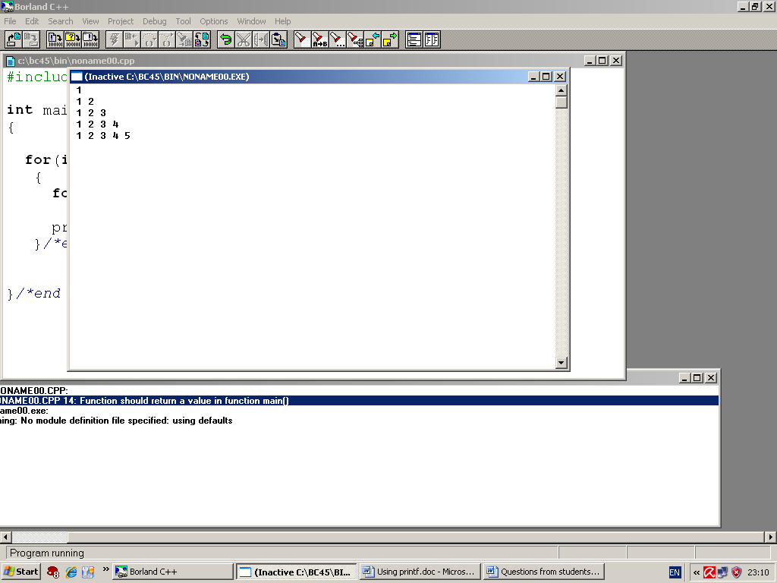

3- Modify the previous program so that the numbers are left justified in 2-character wide spaces.

Answer:
#include<stdio.h>
#include<conio.h>

void main()
{

for(int i=1;i<=5;i++)
{
for(int j=1;j<=i;j++)
printf("%-2d",j);
printf("\n");
getchar();
}/*end of for*/

}/*end of main*/

Output
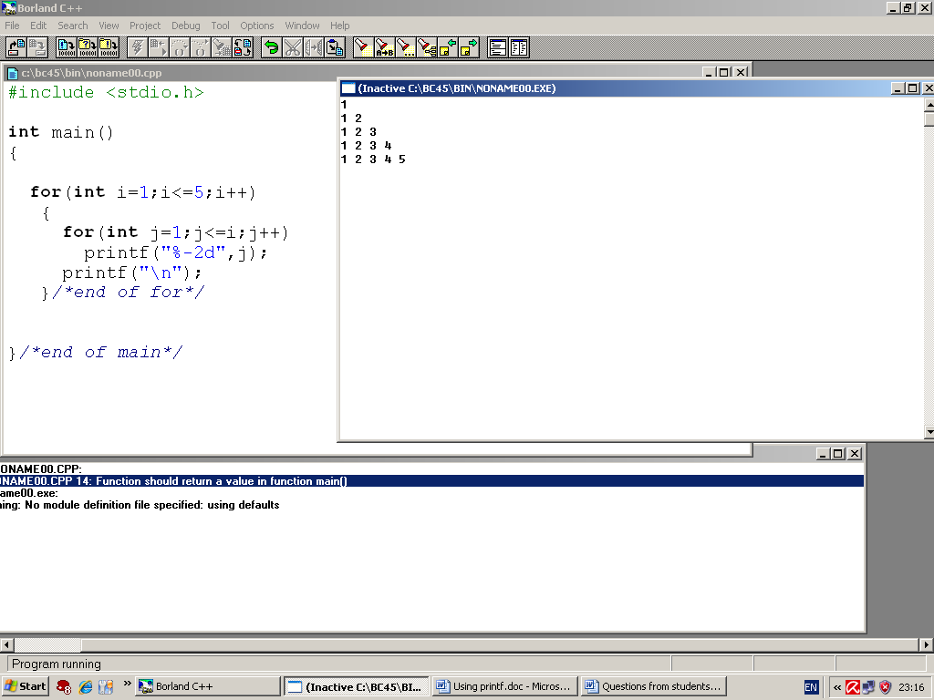
End of session

