An Electronic Assembly and Test System

The following figure represents the operations involved in the production of two different electronic units.
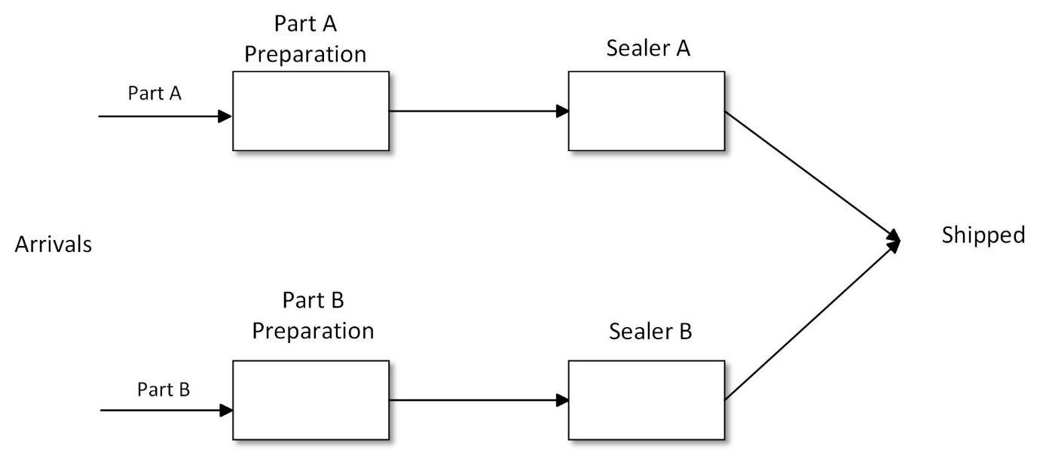

Analyze the 250 random data sets that are attached in an Excel file for each step of the model. After analyzing the data, discuss your findings.
Please note that all files and your output must be submitted.

