CMPE-552 Database and File Security

Problem Session 16.11.2021
Cryptography, both symmetric and asymmetric, widely uses number theory, in particular, relative primality, modular arithmetic, and multiplicative inverses. That’s why we begin with them.
- Primality, Greatest Common Divisor (GCD), Euclidean Algorithm
Prime number is one having no other factors except one and itself, e.g. N=7 is a prime number
Relatively prime are such two numbers that have no common factors except one
Greatest Common Divisor (GCD) is the maximal common factor for two numbers
For example, gcd(12,15)=3
GCD can be obtained by factoring the numbers and comparing them
For example, 12=2x2x3, 15=3x5, hence, gcd(12,15)=3
Euclidean algorithm provides straightforward method of finding gcd without necessity of finding factors
EUCLID(a,b)
- A:=a; B:=b
- if B=0 return A=gcd(a,b)
- R=A mod B
- A:=B
- B:=R
- goto 2

The algorithm has the following progression:
A1=B1xQ1+R1
A2=B2xQ2+R2
A3=B3xQ3+R3
To find gcd(1970,1066)
1970=1x1066+904 gcd(1066,904)
1066=1x904+162 gcd(904,162)
904=5x162+94 gcd(162,94)
162=1x94+68 gcd(94,68)
94=1x68+26 gcd(68,26)
68=2x26+16 gcd(26,16)
26=1x16+10 gcd(16,10)
16=1x10+6 gcd(10,6)
10=1x6+4 gcd(6,4)
6=1x4+2 gcd(4,2)
4=2x2+0 gcd(2,0)
Therefore, gcd(1970,1066)=2
Given any positive integer n and any integer a, if we divide a by n, we get an integer quotient q and an integer remainder r that obey the following relationship:
a=qn+r
where is the largest integer less than or equal to x.
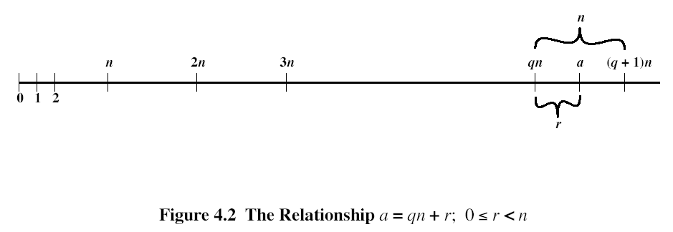
The remainder r is often referred to as a residue. Let Zn ={0,1,..,n-1}.
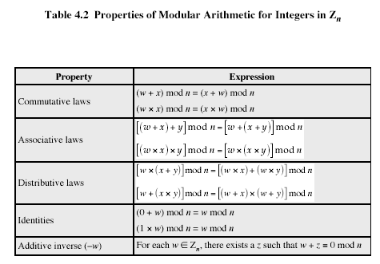
In general, an integer has a multiplicative inverse in Zn, if that integer is relatively prime to n. Table 4.1c shows that the integers 1, 3, 5, and 7 have a multiplicative inverse, but 2, 4, and 6 do not.
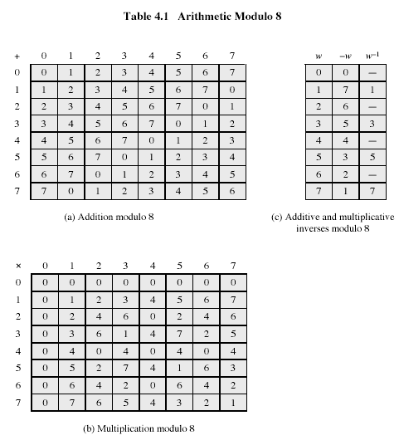
- Multiplicative inverse, Extended Euclid
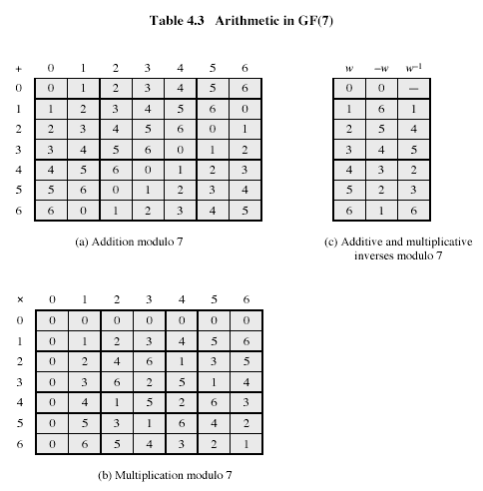
If gcd(m,b)=1, then b has a multiplicative inverse modulo m. That is, for positive integer b<m, there exists a b⁻¹<m such that b b⁻¹=1 mod m. Euclid’s algorithm can be extended so that, in addition to finding gcd(m,b), if the gcd is 1, the algorithm returns the multiplicative inverse of b.
EXTENDED EUCLID(m,b)
- (A1,A2,A3):=(1,0,m); (B1,B2,B3):=(0,1,b);
- if B3=0 return A3=gcd(m,b); no inverse
- if B3=1 return B3 = gcd(m,b); B2= b⁻¹ mod m
- Q=
- (T1,T2,T3):=(A1-QB1, A2-QB2, A3-QB3)
- (A1,A2,A3):= (B1,B2,B3)
- (B1,B2,B3):= (T1,T2,T3)
- goto 2
Throughout the computation, the following relationships hold:
mT1+bT2=T3 mA1+bA2=A3 mB1+bB2=B3
To see that algorithm correctly returns gcd(m,b), note that if we equate A and B in Euclid’s algorithm with A3 and B3 in the extended Euclid’s algorithm, then the treatment of the two variables is identical. Note also that if gcd(m,b)=1, then on the final step we would have B3=0 and A3 =1. Therefore, on the preceding step, B3=1. But if B3=1, then we can say the following:
mB1+bB2=B3
mB1+bB2=1
bB2=1-mB1
bB21 mod m
Hence, B2 is the multiplicative inverse of b.
Table 4.4 is an example of the execution of the algorithm. It shows that gcd(550,1759)=1 and that the multiplicative inverse of 550 is 355; that is, 550x3551 mod 1759.
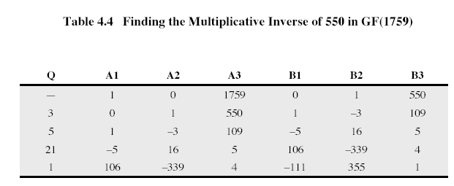

- Types of attacks? What are passive attacks? What are active attacks?
- How does virtual memory support memory protection? How is provided separation of processes?
- What is access control? What types of access control do you know? What is user-oriented access control? What is data oriented access control? What is access matrix? What is access control list? What is capability list (ticket)? How these are related to each other?
- What technique is used for intrusion?
- Why “salt” is kept in clear in Unix password scheme?
- What are password selection strategies and what are their deficiencies?
- How intrusion can be detected?
- What is audit? What information is usually kept in audit file records?
- What is malicious software? What are the main virus types (Parasitic, Memory-resident, Boot sector, Stealth, Polymorphic, Macro)? What are the life steps of virus?
- What is multilevel security? What are no read-up and no write-down rules? What is the use of the reference monitor? How can multilevel security system thwart Trojan horse attack?
- What are the main sources of security vulnerabilities of software?
- What does it mean “data consistency”?
- Explain primary key constraint. How it can be checked?
- Explain foreign key referential integrity constraint. How it can be checked?
- Explain mapping cardinality constraints for binary relations. How mapping cardinality constraints can be checked?
- RSA: key generation, Euler totient function, encryption, decryption
- MD5: Message padding: target size, structure of the last block, padding bits structure, padding bits number
- MD5: Initialization of the registers A, B, C, D
- MD5: General structure using HMD5
- MD5: Structure of HMD5
- MD5: Round function of HMD5 structure
- MD5: Logical functions, array T, array X, permutations $ρ_{i}, i=2..4$, used in HMD5
- MD5: What register is updated in one round function of HMD5?
- MD5: How all for registers, A, B,C, D are updated in HMD5?
- MD5: How many steps are used in a round function of HMD5?
- MD5: What is the formula for a register updating in a round function of HMD5? How values of $k, i, s$ are defined for a particular step of a round function?

