MT Exam CMPE-553 5.12.2014 (90 min, 30 points)
St. Name, Surname______________________________________ St.Id#_____________
Instructor Alexander Chefranov
Task 1. (7.5 points) Use extended Vigenere cipher (26 English letters and 10 decimal digits) to encrypt “CMPE553” using key word “Mediterranean”. Show details of your work
Hint: Use modular arithmetic.

a | b | c | d | e | f | g | h | I | j | k | l | m | n | o | p | q | r | s | t | u | v | w | x | y | z
0 | 1 | 2 | 3 | 4 | 5 | 6 | 7 | 8 | 9 | 10 | 11 | 12 | 13 | 14 | 15 | 16 | 17 | 18 | 19 | 20 | 21 | 22 | 23 | 24 | 25

0 | 1 | 2 | 3 | 4 | 5 | 6 | 7 | 8 | 9
26 | 27 | 28 | 29 | 30 | 31 | 32 | 33 | 34 | 35

CMPE553 is 2 12 15 4 31 31 29
Mediterranean is 12 4 3 8 19 4 17 17 0 13 4 0 13
Encrypt by adding modulo 36
C+M=2+12=14=o
M+e=12+4=16=q
P+d=15+3=18=s
E+i=4+8=12=m
5+t=31+19=50mod36=14=0
5+e=31+4=35=9
3+r=29+17=46mod36=10=k
Ciphertext is OQSMO9K

Task 2. (7.5 points) Find inverse of the matrix below modulo 27 and check its correctness by multiplication if it exists, or show that it does not exist.
A=
7 | 7
1 | 8
Hint: A⁻¹[I,j]=(-1)^{i+j}D_{ji}/det(A)

detA=7*8-1*7=56-7=49mod27=22; gcd(22,27)=1, hence detA⁻¹ exists and equal to 16: 22*16=382=13*27+1
a⁻¹[1,1]=8*16=128mod27=20
a⁻¹[1,2]=-7*16=-112mod27=-4=23
a⁻¹[2,1]=-1*16=-16mod27=11
a⁻¹[2,2]= 7*16=112mod27=4
Check by multiplication

Task 3. (7.5 points) Consider
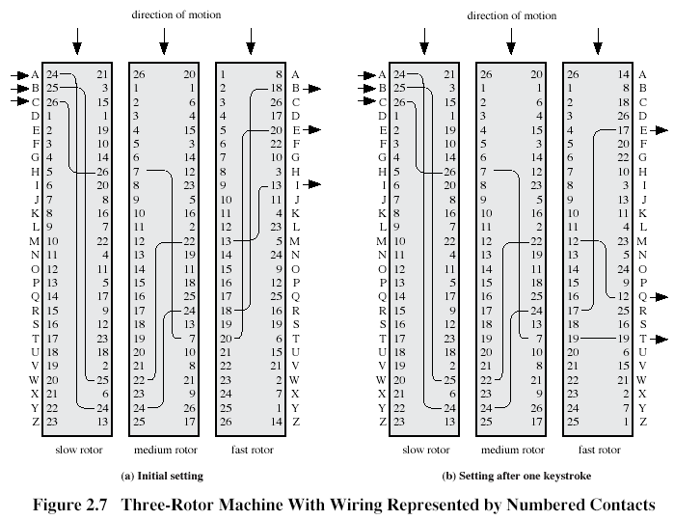
Encrypt “Cipher” assuming initial state as shown on Fig. 2.7,a.
c-26-7-20-e
i-6-23-8-b
p-13-25-15-w
h-5-15-2-z
e-2-21-19-w
r-15-2-7-c
Ciphertext is EBWZWC

Task 4. (7.5 points) Determine what S-boxes in the previous round of DES algorithm affect “middle” bits (bits 3 and 4) of the S-box S4 of the next round. Explain your answer using information below:
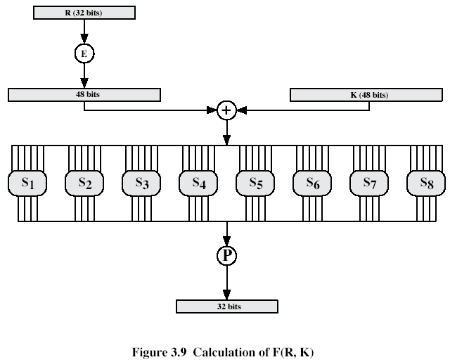
Expansion/Permutation (E table)
32 | 1 2 3 4 | 5
4 | 5 6 7 8 | 9
8 | 9 10 11 12 | 13
12 | 13 14 15 16 | 17
16 | 17 18 19 20 | 21
20 | 21 22 23 24 | 25
24 | 25 26 27 28 | 29
28 | 29 30 31 32 | 1
Permutation function( P )
16 7 20 21 29 12 28 17
1 15 23 26 5 18 31 10
2 8 24 14 32 27 3 9
19 13 30 6 22 11 4 25
Middle bits of S4 are bits 14 and 15 coming from the previous round. Bit 14 is bit 18 output by S-box S5, and bit 15 is bit 31 output by S8. Hence, S5 and S8 in the previous round affect middle bits of S4 in the next round.

