Problem Session CMSE-353 “Security of Software Systems” 18.11.2021
Security requirements, Access control models, RSA, Digital signatures, Certificates, MD5
- What CIA concepts are?
- What Authenticity, Assurance, Anonymity are?
- What are the classes of intruders? What insider is? External intruder?
- How intrusion can be detected?
- What are the types of malware?
- What are the methods of password cracking?
- What are the requirements to strong passwords?
- What social engineering is? What are the methods of SE?
- What is Access Control Matrix? List? Capability list?
- What is Mandatory Access Model? What rules are used in it?
- What RSA method is? How many keys RSA has? How RSA keys are defined? How a private RSA key is defined? Public? How in RSA a message is encrypted? Decrypted?
- RSA: key generation, Euclid GCD algorithm, Extended Euclidean algorithm, finding multiplicative inverse, Euler totient function, encryption/decryption, exponentiation by squaring with in-line reducing
Keys shall be relatively prime to fi(N)=(p-1)(q-1)=fi(p)*fi(q), fi is Euler totient function; N=p*q
Gcd(a,b)=1=>a,b are relatively prime; gcd(a,0)=a
Gcd(103, 24)=gcd(24, 103 mod 24)=gcd(24, 7)=gcd(7, 24 mod 7)=gcd(7,3)=gcd(3,7 mod 3)=gcd(3,1)=gcd(1,0)=1
Gcd(a,b)=gcd(b, a mod b = a-q*b, q=floor(a/b))

For example, 12=2x2x3, 15=3x5, hence, gcd(12,15)=3
Euclidean algorithm provides straightforward method of finding gcd without necessity of finding factors
EUCLID(a,b)
- A:=a; B:=b
- if B=0 return A=gcd(a,b)
- R=A mod B
- A:=B
- B:=R
- goto 2

The algorithm has the following progression:
A1=B1xQ1+R1
A2=B2xQ2+R2
A3=B3xQ3+R3
To find gcd(1970,1066)
1970=1x1066+904 gcd(1066,904)
1066=1x904+162 gcd(904,162)
904=5x162+94 gcd(162,94)
162=1x94+68 gcd(94,68)
94=1x68+26 gcd(68,26)
68=2x26+16 gcd(26,16)
26=1x16+10 gcd(16,10)
16=1x10+6 gcd(10,6)
10=1x6+4 gcd(6,4)
6=1x4+2 gcd(4,2)
4=2x2+0 gcd(2,0)
Therefore, gcd(1970,1066)=2
Given any positive integer n and any integer a, if we divide a by n, we get an integer quotient q and an integer remainder r that obey the following relationship:
a=qn+r
where is the largest integer less than or equal to x.
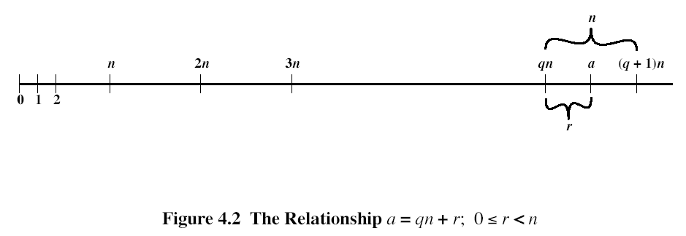
The remainder r is often referred to as a residue. Let Zn ={0,1,..,n-1}.

E*d=1 mod fi(N)
Extended Euclidean algorithm (m,b) b^(-1) mod m

EXTENDED EUCLID(m,b)
- (A1,A2,A3):=(1,0,m); (B1,B2,B3):=(0,1,b);
- if B3=0 return A3=gcd(m,b); no inverse
- if B3=1 return B3 = gcd(m,b); B2= b⁻¹ mod m
- Q=
- (T1,T2,T3):=(A1-QB1, A2-QB2, A3-QB3)
- (A1,A2,A3):= (B1,B2,B3)
- (B1,B2,B3):= (T1,T2,T3)
- goto 2
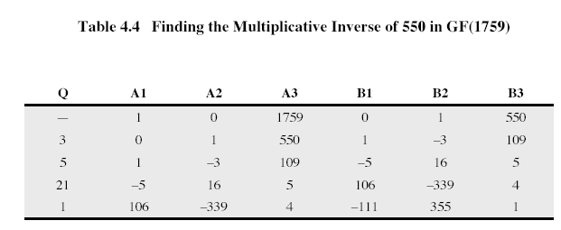
A=(A1,A2,A3)=(1,0,m); B=(B1,B2,B3)=(0,1,b)
Step 1: B3=0=> A3 is gcd(A3,B3)=gcd(m,b)<>1 => inverse does not exist
B3=1=>gcd(m,b)=1=>inverse exists and b^(-1) mod m= B2; B1=m^(-1) mod b
Iteration
Q=floor(A3/B3);
T=A-q*B=(A1-q*B1, A2-q*B2, A3-q*B3 = A3 mod B3)
A=B;
B=T;
Goto Step 1;
C=M^e mod N; M=C^d mod N
Exponentiation use squaring together with reduction
M^(2k) mod N= (M^k mod N)^2 mod N
29=16+8+4+1
M^29 mod N=M^(16+8+4+1) mod N=(M^16 mod N)*(M^8 mod N)*(M^4 mod N)*M
M^2 mod N =M2<N
M^4 mod N = M2^2 mod N =M4
M^8 mod N=M4^2 mod N =M8
M^16 mod N = M8^2 mod N =M16
M^29 mod N=) (M16*M8 mod N)*M4 mod N)*M mod N
- Can RSA be used for secret data transmission? How it can be done?
- What digital signature is? How RSA digital signature can be constructed? What hash function is? Why hashing is used in RSA signature?
- What certificate is? What for certificates are issued? Who issues certificates? What is the main information in a certificate? How a certificate is verified?
- MD5: Message padding: target size, structure of the last block, padding bits structure, padding bits number
- MD5: Initialization of the registers A, B, C, D
- MD5: General structure using HMD5
- MD5: Structure of HMD5
- MD5: Round function of HMD5 structure
- MD5: Logical functions, array T, array X, permutations $ρ_{i}, i=2..4$, used in HMD5
- MD5: What register is updated in one round function of HMD5?
- MD5: How all for registers, A, B,C, D are updated in HMD5?
- MD5: How many steps are used in a round function of HMD5?
- MD5: What is the formula for a register updating in a round function of HMD5? How values of $k, i, s$ are defined for a particular step of a round function?

