IENG112
Notes #6

Work Design and Organizational Performance Measurement

1. Productivity Measurement
1.1 General Idea:
$\frac{output}{input}$ (1)
Examples. (a) Units per Labor Hour, (b) Units per Ton (raw material), (c) Units per Joule/BTU/kWh, (d) Units per Dollar. Units can be thousands, millions, etc. of basic units.
Good for comparison for other organizations in the same industry or different industries. Companies are watching one another.
Aggregate units are units which are suitable for measuring different items. The most frequent aggregate units are time and money.

1.2 Dynamic Version
$$\frac{\frac{{output}_{this time period}}{{input}_{this time period}}}{\frac{{output}_{base time period}}{{input}_{base time period}}}$$
Base time period. Examples: (i) first full year of the company, (ii) first full year after a major reorganization. Base time period is also used in statistics. It can be the first year after a war or any major changes.
Dynamic index shows tendencies.

1.3 How to Find a Proper Index Set for a Company
The method is called: Nominal Group Technique (NGT), the result is Normative Productivity Measurement Model.

NGT
STEP 0: A group of 5 to 12 persons with a head must be nominated. The group must cover all areas of the company.
STEP 1: (Silent Generation) Each person prepare a list of measures.
STEP 2: (Round Robin; special meeting) Each person presents one measure. This continues around the group as many times as necessary to exhaust everyone’s list.
STEP 3: (Group Clarification) All ideas are clarified and duplications are filtered out.
STEP 4: (Voting) In the case of N measures each member of the group gives number from 1 to N to the measures. N is the most important, 1 is the less important. Selection is made based on the result of voting.

Remark. Compare the American style meeting by the Japanese style meeting.

2. Analysis of the Moves of Individual Workers and Methods of Improvement
2.1 Creation of Flow Process Chart

Flow process chart shows the current method.
Example. Textbook Example 6.2, pages 156 to 158, Mr. Café’s spaghetti production. Assaumption: tap water is drinking water.

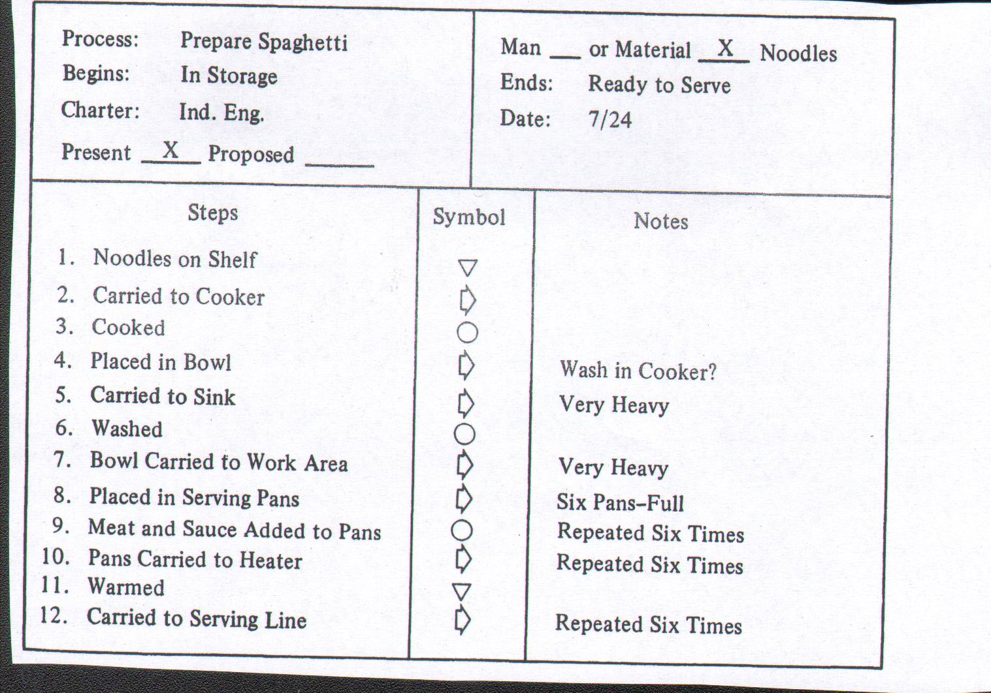

The suggested new method is presented also in flow process chart. Here the suggested new method is that the spaghetti should be washed in the cooker. The method needs a new tap close to the cooker. Advantage: no transportation of heavy item.
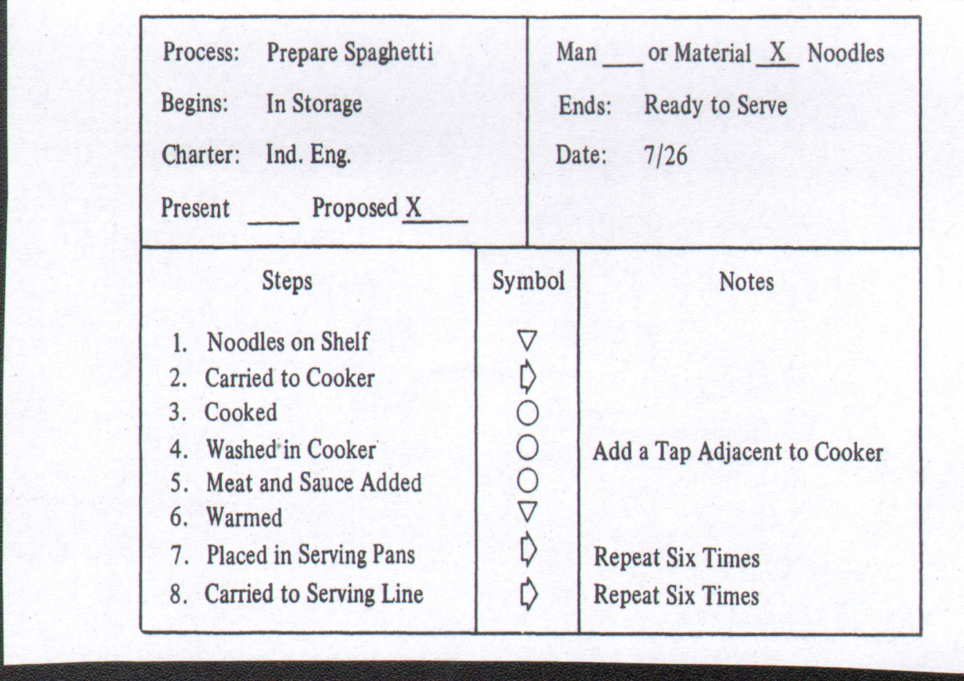

2.2 Application of Left-Hand – Right-Hand Chart

Example. Textbook Example 6.3, pages 158 to 162.

The key notion is burr: it is an undisirable surplus which must be removed. Burr is created at any kind of welding including even plastic. The example is about plastic. The product is pot handle. The machine which is used in the operation is grinder. Grinder can be used for sharpening knives. Transportation of the semi-finished handles is made by a chute. Chute is a transportation equipment which uses gravity as the power which moves the items. Item completed the operation are transported in boxes.
The current arrangement of the workplace:
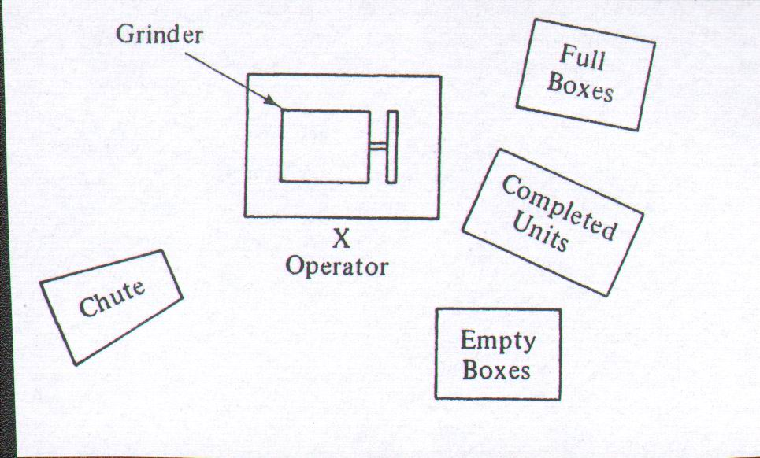

The chart of the current method:
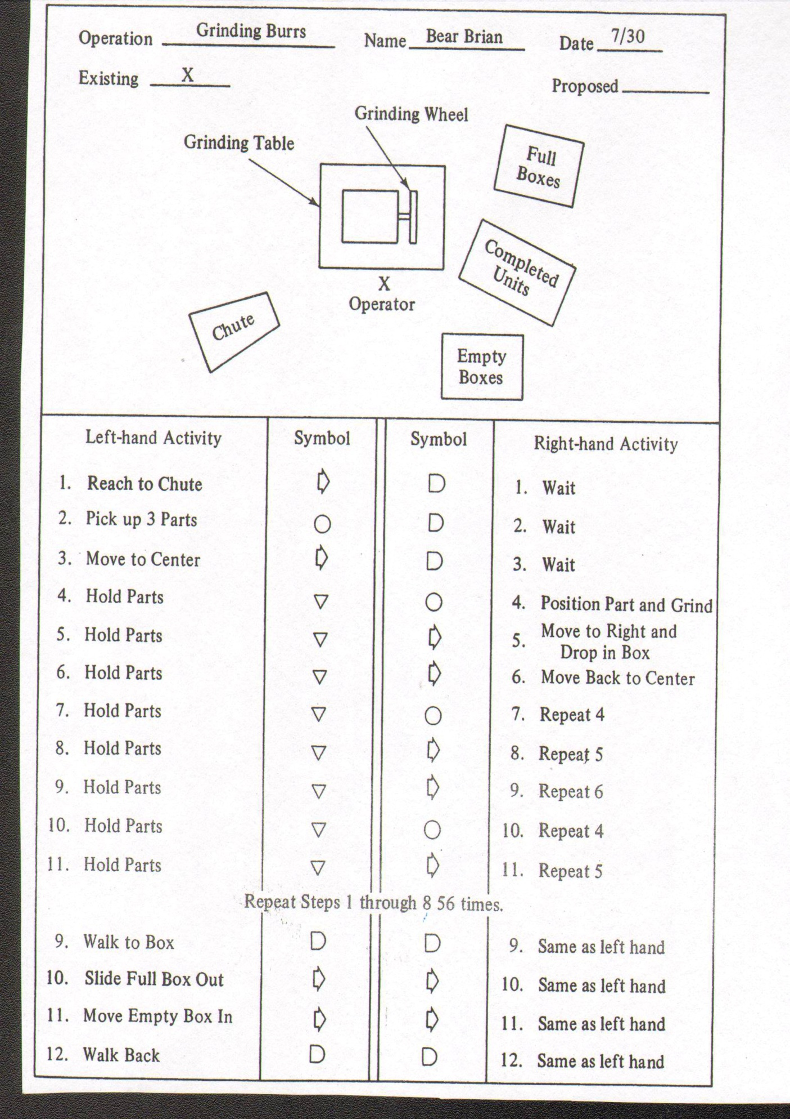
The suggested solution is double-handed operation with a common drop hole.
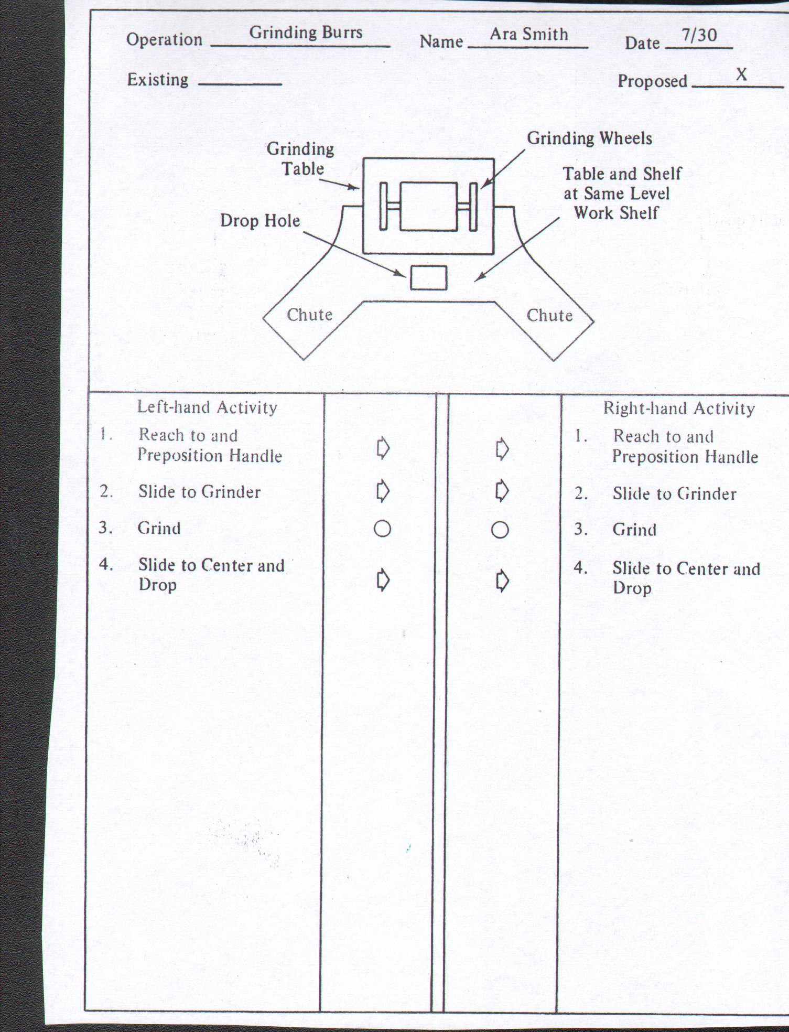

2.3 Analysis of Human Work Areas
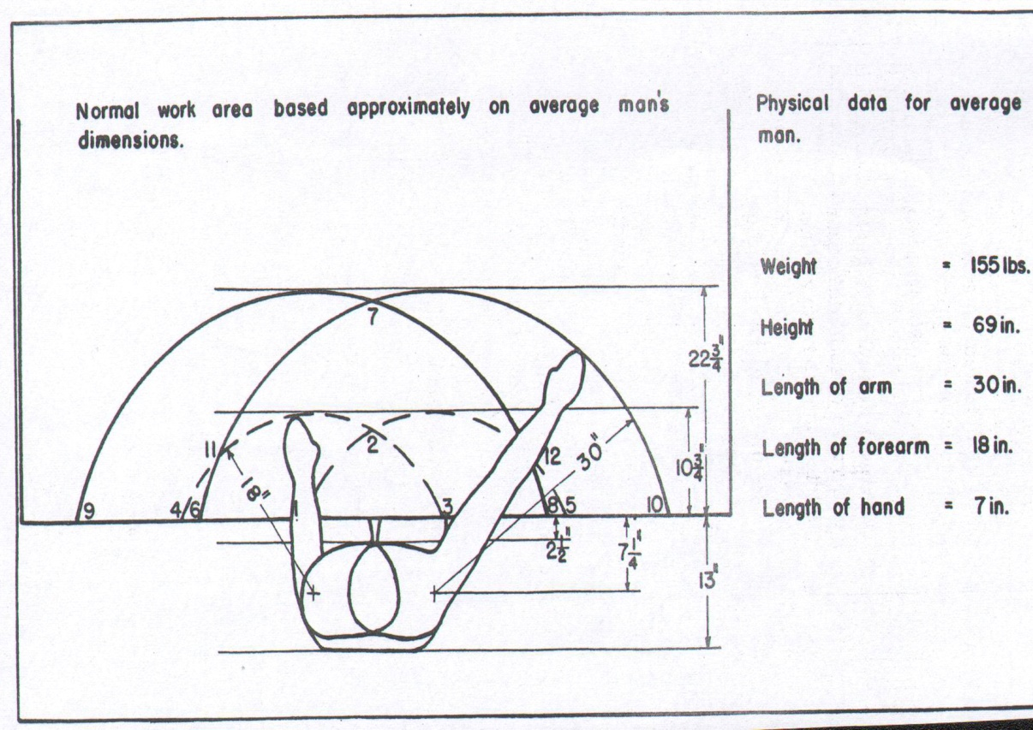

Any tool should be placed in a distance such that it is easy to reach the tool. The method can be used even for designing kitchen.

2.4 Time Study

Basic notions.
Allowance. Any time needed for personal needs (drinking water, WC, etc.) unavoidable delays (e.g. breakdowns), and tiredness (fatigue). Multiplicative factor. Expressed in percentage.
Normal time. The time needed for a trained operator to perform a task without allowances under regular working conditions.
Normal pace. The speed of working of a trained operator in a 8-hour shift.
Standard time. Normal time multiplied by the adjustment of allowances.

How to obtain these times?
- By measuring each movement. Take average as necessary time.
- Use predetermined standard data.
- Take samples in random times.

British Thermal Unit: Approx. 1055 joule = the energy the increase the temperature of 1 pound of water by one degree Fahrenheit.

