

**E**astern **M**editerranean **U**niversity

**D**epartment of **M**echanical **E**ngineering

**L**aboratory **H**andout

### COURSE: Thermodynamics II (MENG246) Group 1

**Semester: Spring 2018-2019**

**Name of Experiment: Wet Cooling Tower**

**Instructor: Assist. Prof. Dr. Devrim Aydin**

**Lab Assistant: Mohamed Alibar**

Submitted by:

Student No:

Group No:

Date of experiment:

Date of submission:

----------------------------------------------------------------------------------------------------------

**EVALUATION**

|  |  |  |
| --- | --- | --- |
| **Activity During Experiment & Procedure 30 %** | |  |
| **Data &Results 35 %** | |  |
| **Discussion, Conclusion & Answer to the Questions 30 %** | |  |
| **Neat and tidy report writing 5 %** | |  |
| **Overall Mark** |  | |

**Name of evaluator:**

**OBJECTIVE:**

To construct an overall energy and mass balances across a water cooling tower.

**THEORY:**

Steam power plants, large air-conditioning systems, and some industries generate large quantities of waste heat that is often rejected to cooling water from nearby lakes or rivers. In some cases, however, the cooling water supply is limited or thermal pollution is a serious concern. In such cases, the waste heat must be rejected to the atmosphere, with cooling water recirculating and serving as a transport medium for heat transfer between the source and the sink (the atmosphere).

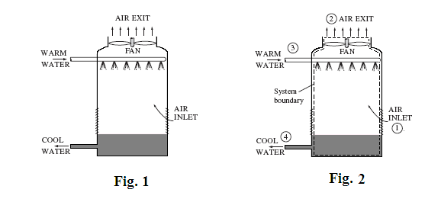

One way of achieving this is through the use of **wet cooling towers**. A simplified schematic of the device is shown in Fig. 1. The warm cooling water is sprayed from the top of the tower and falls downward under gravitational force. Atmospheric air is inducted at the bottom of the tower by a fan and flows upward and in counter-flow to the falling water droplets. The water and air streams are thus brought into intimate contact, and a small fraction of the water stream evaporates into the air stream. The evaporation process requires energy and this energy transfer results in a cooling of the remaining water stream. The cooled water stream is then returned to the power plant to pick up additional waste energy. Since a portion of the cooling water is evaporated into the air stream, an equivalent amount of water must be added as makeup somewhere in the flow cycle.

To make an energy analysis of a wet cooling tower, a control volume is drawn around the entire tower, as shown by the dashed line in Fig 2the process is assumed to be adiabatic, the fan work is negligible.

Consequently, the governing equations are:

The basic energy balance given by:

 (1)

Dry air mass balance:

 (2)

Water mass balance:

 (3)

Theenergy equation may be written as:

 (4)

For atmospheric air, the enthalpy of the water vapor  may be approximate by at the given temperature and for the water stream enthalpy  may be evaluated by  at the given temperature. Also recall that.

Then Eq. (4) becomes:

 (5)

In many uses of cooling towers the value of  is known, as well as the temperature drop needed for the water stream. The above equation is then used to calculate the mass flow rate of air required on a dry basis.

The mass flow rate of dry air may also be calculated directly from Eq. (1) if data from a psychometric chart are to be used. The result is:

 (6)

Where is the total enthalpy of dry air plus water vapor recorded on the psychometric chart .

**PROCEDURE:**

1. According to Fig. 3, set the air blower shutter fully open and adjust the water flow control to obtain maximum water flow rate.
2. Switch on the water heaters to warm up the water at the inlet to the cooling tower. **Never permit the water inlet temperature to exceed approximately 50oC**.
3. Take at least 4 readings of the flowing quantities at 3 minutes intervals.
   1. Water inlet and outlet temperatures(**Tw- 3**&**Tw 4**).
   2. Air inlet and outlet dry bulb temperatures(**Tdb1**&**Tdb2**).
   3. Air inlet and outlet wet bulb temperatures(**Twb1**&**Twb2**).
   4. Air volume flow rate ()
   5. Water flow rate in ()

4. Measure the quantity of water collected in the calibrated water collecting tank and the period of time passed to obtain.

**APPARATUS:**

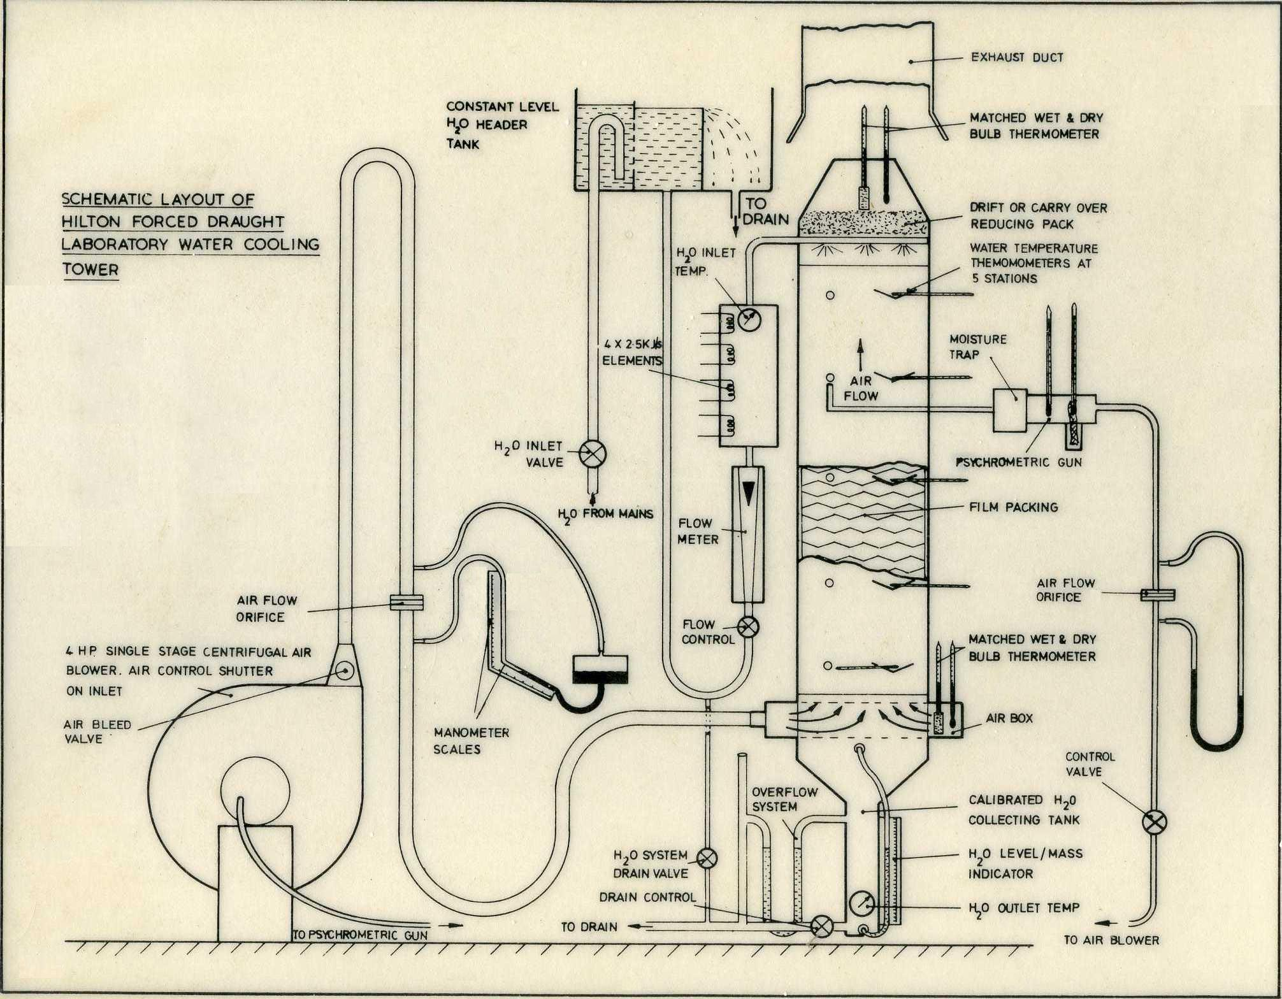

**Fig. 3** *Wet cooling water apparatus*

**RECORDING DATA:**

|  |  |  |  |  |  |  |  |  |  |
| --- | --- | --- | --- | --- | --- | --- | --- | --- | --- |
| **#** | **Twb1** | **Tdb1** | **Twb2** | **Tdb2** | **Tw-3** | **Tw-4** |  |  |  |
| **Case 1** | **16,5** | **33** | **15** | **22,5** | **47** | **15** | **120kg/h** | **47kg/h** | **450m³/h** |
| **Case 2** |  |  |  |  |  |  |  |  |  |

**CALCULATIONS:**

**Part A.**

A-1- Use the equations given in the lecture notes to calculate humidity ratios and enthalpies.

A-2- Calculate  using equation 5 and compare it with the measured value of.

A-3- Calculate mass flow rate of air from equation 5 and compare it with the measured value of.

**Part B.**

B-1- Use psychometric chart to obtain humidity rations and enthalpies.

B-2- Calculate  from equation 6 and compare it with the measure value of.

B-3- Calculate mass flow rate of air  from equation 6 and compare it with the measured value of.

**RESULTS**

|  |  |  |  |  |  |  |  |  |
| --- | --- | --- | --- | --- | --- | --- | --- | --- |
| **#** |  |  | hm1 | hm2 |  |  |  |  |
| Case 1- A |  |  |  |  |  |  |  |  |

**EXPERIMENTAL PROCEDURE (in your own words, 6-7 sentences)**

First of all, we run compressor and heater of water.After that open the valfe of water and water starts to fill to system, from up to the down stage.To take true value of system (Twb,Tdb,rates of water and air etc.), we should wait about five minutes.We take quantities.According to this handout, we never allowed the inlet temperature to rise above 50 $℃$, after all of these happenings, water starts to chill.

**DISCUSSION, QUESTIONS & CONCLUSION**

1. Discuss about the results.
2. Give sample calculation for results.
3. Derive equation 5 and 6.
4. Indicate the error sources in this experiment.
5. Write your own conclusion about this experiment.
6. What suggestions do you have for improving this experiment?