IENG 323 Lab work 01
- Bucknell, Inc. uses the calendar year as its fiscal year. Determine the total net cash flow recorded at the end of the fiscal year and find the following if the Initial investment be
$1,000,000.
- Find the Present value if MARR = 10%
- Find the Interest rate

Month | Receipts, $1000 | Disbursements, $1000
Jan | 300 | 500
Feb | 950 | 500
Mar | 200 | 400
Apr | 120 | 400
May | 600 | 500
June | 900 | 600
Jul | 800 | 300
Aug | 900 | 300
Sept | 900 | 200
Oct | 500 | 400
Nov | 400 | 400
Dec | 1800 | 700

- The net cash flows associated with development and sale of a new product are shown. Determine the beginning of period annual worth (i.e., for years 0 through 5) at an interest rate of 12% peryear. The cash flows are in $1000 units. Find the AW for this product.
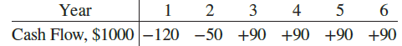

- Calculate the equivalent future cost in year 10 for the following series of disbursements at an interest rate of 10% per year. Also, write a single-cell spreadsheet function that will determine the future worth.

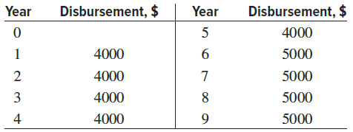

- For the cash flows shown, find the future worth in(a) year 5, and (b) year 4. Assume an i of 10% per year.
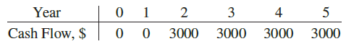
- For the cash flows shown (in $1000 units), calculate the value of x that makes the present worth in year 0 equal to $300,000 at an interest rate of 10% per year.
