IENG323 Lab 02

NOTE: Students should send their work in an excel file to the behzad.sanaei@emu.edu.tr during the lab hour. Submission after 14:30 will not be accepted. Please check your internet connection, Microsoft excel and make sure you save your files regularly. File’s name must start with your student number.
- For the cash flow revenues shown below, find the value of G that makes the equivalent annual worth in years 1 through 7 equal to $500. The interest rate is 10% per year. (20 points)
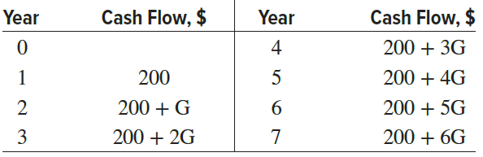

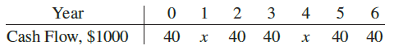
- For the cash flows shown (in $1000 units), calculate the value of x that makes the present worth in year 0 equal to $300,000 at an interest rate of 10% per year. (30 points)

- Alternative R has a first cost of $100,000, annual M&O costs of $50,000, and a $20,000 salvage value after 5 years. Alternative S has a first cost of $175,000 and a $40,000 salvage value after 5 years, but its annual M&O costs are not known. Determine the M&O costs for alternative S that would yield a required incremental rate of return of 20%. Solve using the GoalSeek tool or RATE function on a spreadsheet. (50 points)

