Eastern Mediterranean University
Computer Engineering Department
CMPE344-CMSE346 - Computer Networks– Lab. 1

Title: Introduction to Using OPNET Modeler

OVERVIEW:

OPNET Network simulator is a tool to simulate the behavior and performance of any type of network. The main difference Opnet Network Simulator comparing to other simulators lies in its power and versatility. IT Guru provides pre-built models of protocols and devices. It allows you to create and simulation different network topologies.

Advantages of Opnet Network Simulator:

- Opnet Network Simulator is the open free software
- Large number of project scenarios that are offered information on Opnet Network Simulator
- Can be overlooked using Opnet Network Simulator.

Uses of opnet simulator:

- Operational validation.
- Application troubleshooting.
- Network planning and design.
- Validating hardware architecture.
- Protocol modeling.
- Traffic modeling of telecommunication networks.
- Evaluating performance aspects of complex software systems.

The Project/Scenario Workflow:

- Create project

- Create baseline scenario:
- Import or create topology
- Import or create traffic
- Choose results and reports to be collected
- Run simulation
- View results

- Duplicate scenario:
- Make changes
- Re-run simulation
- Compare results

The Three-Tiered OPNET Hierarchy

- Three domains: network, node, and process
- Node model specifies object in network domain
- Process model specifies object in node domain

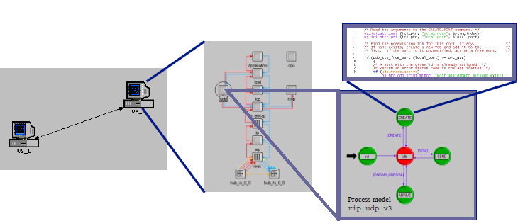

OPNET workspace:

- Title of project and scenario
- Main menu
- Toolbox
- Network editor

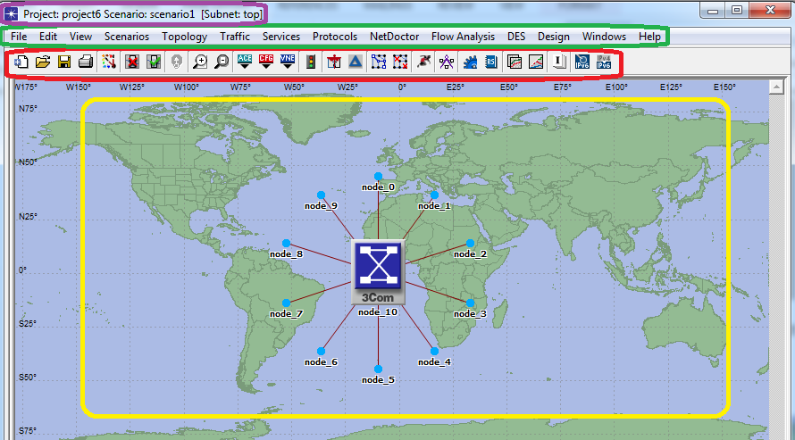

Note: we will describe each menu and its items later.

Network Domain: Network Objects:

Network models consist of nodes, links and subnets
Nodes represent network devices and groups of devices
- Servers, workstations, routers, etc.
- LAN nodes, IP clouds, etc.
Links represent point-to-point and bus links
Icons assist the user in quickly locating the correct nodes and links
Vendor models are distinguished by a specific color and logo for each company

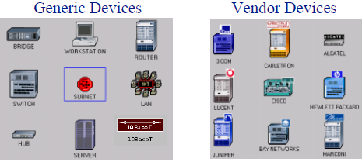

Node Domain

- Basic building blocks (modules) include processors, queues, and transceivers
- Processors are fully programmable via their process model
- Queues also buffer and manage data packets
- Transceivers are node interfaces
- Interfaces between modules
- Packet streams
- Statistic wires

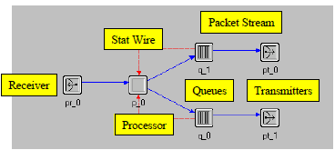

Node Objects: Processors and Queues:

• Processors
– General-purpose building blocks of node models
– Fully programmable
• Queues
– Offer all the functionality of processors
– Can also buffer and manage a collection of data packets

Double click on each node:

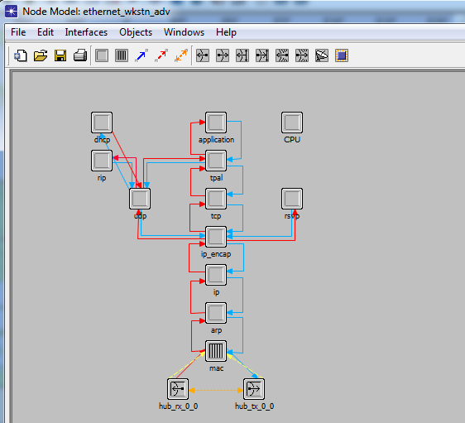

Process Domain:

OPNET process models consist of
- State transition diagrams
- Blocks of C code
- OPNET Kernel Procedures (KPs)
- State variables
- Temporary variables
• A process is an instance of a process model
• Processes can dynamically create child processes
• Processes can respond to interrupts

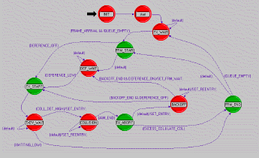

Process models represent algorithms

– Communications protocols and algorithms
– Shared-resource managers
– Queuing disciplines
– Specialized traffic generators
– Statistic-collection mechanisms
– Control Processes
• Process Editor provides the features for creating process models

In this model we will deal with:

- State transition diagrams
- C programming language
- Library of OPNET Kernel Procedures (KPs)
- State variables (private to each process)
- Temporary variables

State Transitions:

• Transitions connect states
– Conditional
– Unconditional
– Transition executive
• Exactly one condition must evaluate to true
• If the condition statement (x == y) is true, the transition executive (Reset_Timers) is invoked

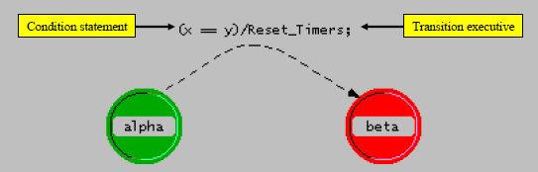

State Executive Blocks: Each state has two executive blocks
– Enter executives are invoked upon entering a state
– Exit executives are invoked before exiting a state

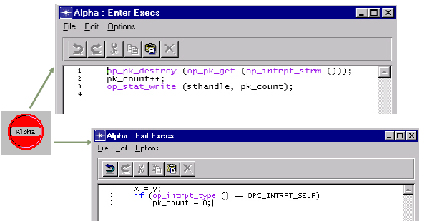

Link Modeling:

Link Types: Link objects model physical layer effects between nodes, such as delays, noise, etc.

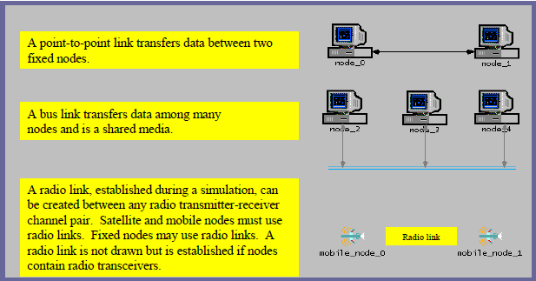

Other LABs are listed as follow:
- Switched Local Area Networks

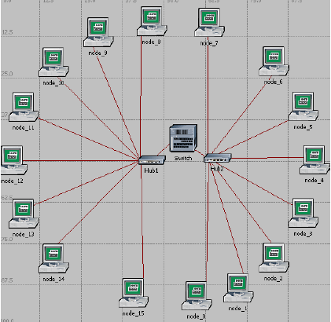

- Create Sub networks

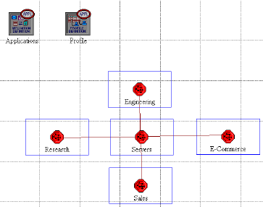

- A WAN Network

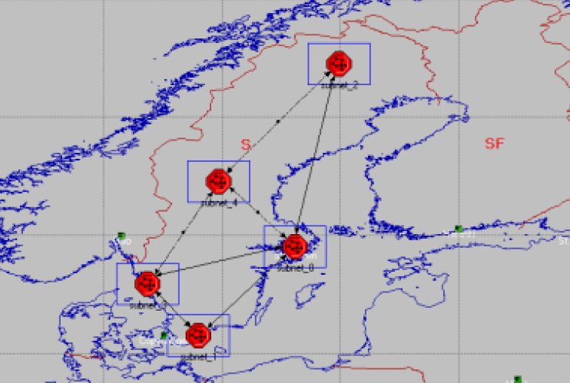
- TCP (Transmission Control Protocol)

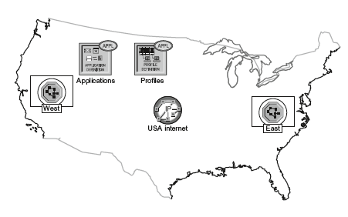

- Wireless Local Area

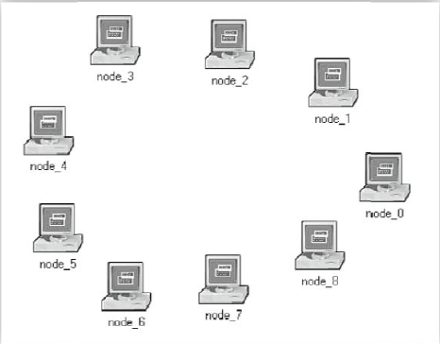

First Project: How to create a new project:

It will happen in 8 steps as follow:
Step1:

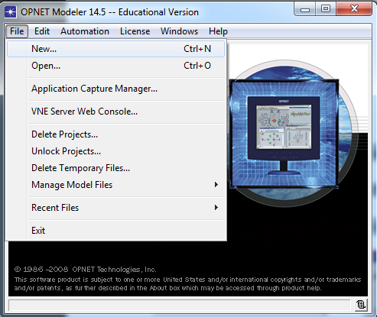

Step 2:
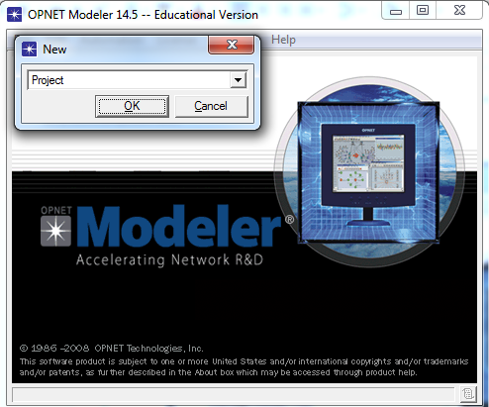

Step 3:

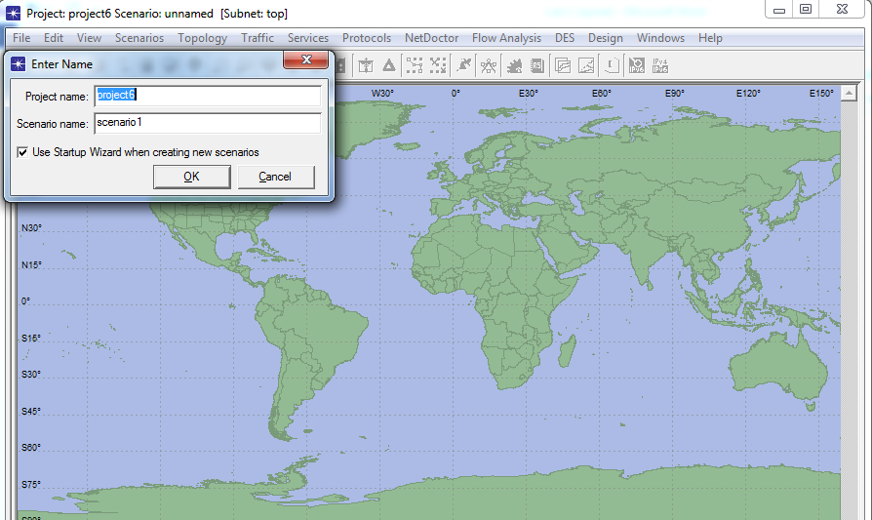

Step 4:

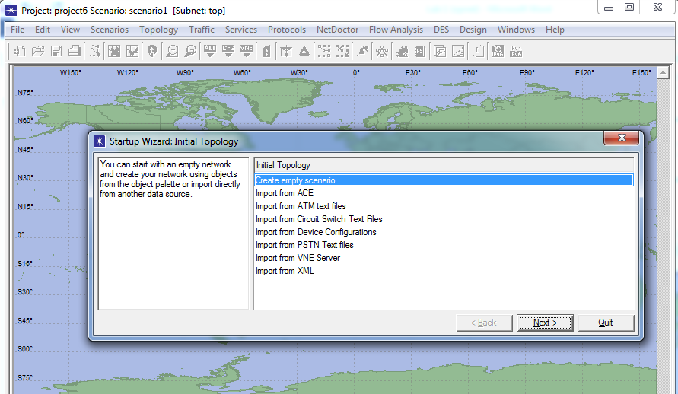

Step 5:

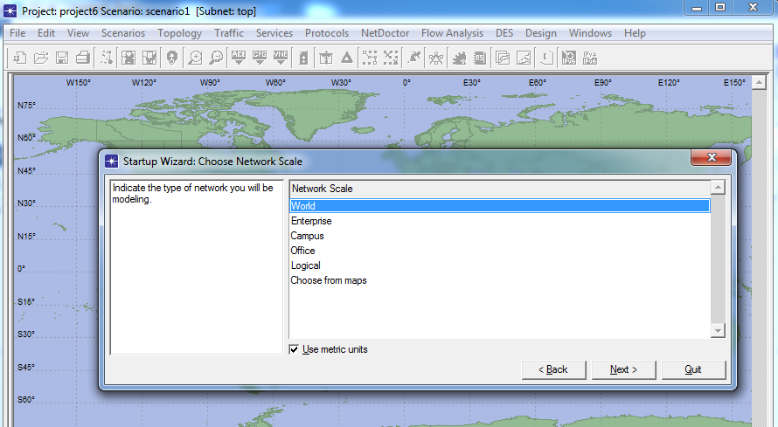

Step 6:

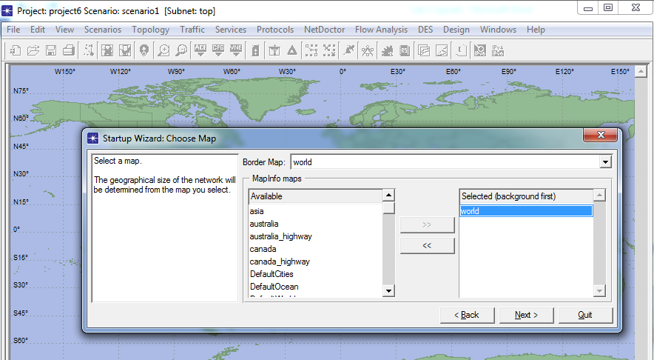

Step 7:

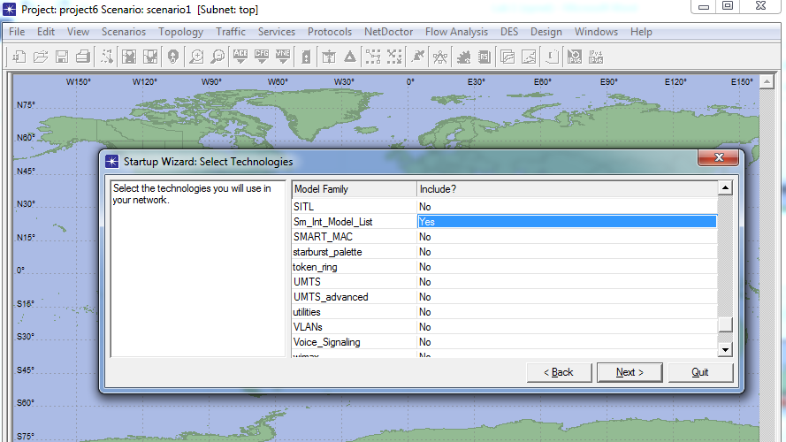

Step 8:

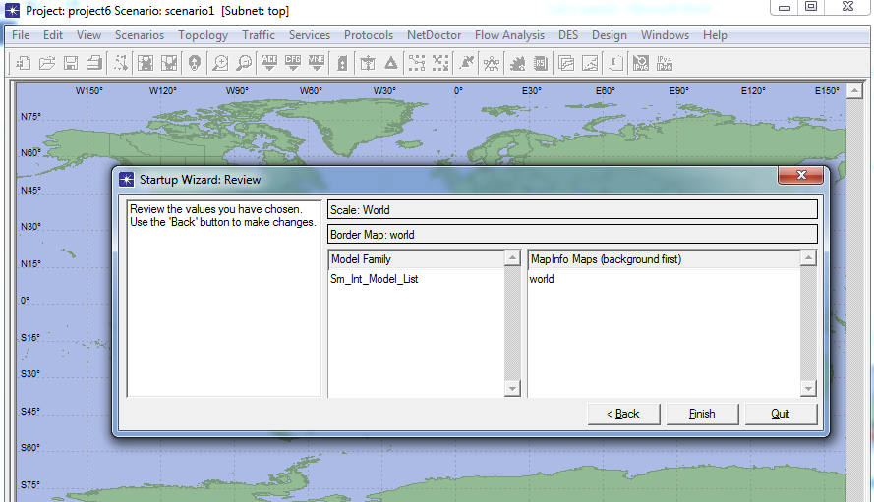
Object palette:

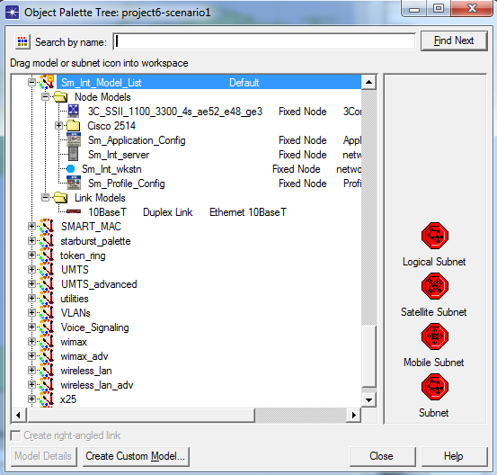

Note: Here you have your first project, now let us to create our project on demand.

Creating Network Models

There are two ways to create new network models:
- Manual Creation
» Drag and drop
» Rapid configuration

- Import from network management tool
» HP Network Node Manager
» Tivoli Netview
» Router configuration files
» ATM text files
» XML
» ACE
» VNE Server

Rapid configuration:

• Rapid configuration allows you to quickly create networks of any size
• Available topology configurations:
Bus; Ring; Star; Tree; Unconnected Net; Mesh (Full or Randomized)
• You control the number of nodes, the node and link models used, how nodes will be arranged, and node locations within the workspace
As first example, we are going to design a star network with one switch and some workstation. In order to implement your star topology network follow the steps:

Step 1:

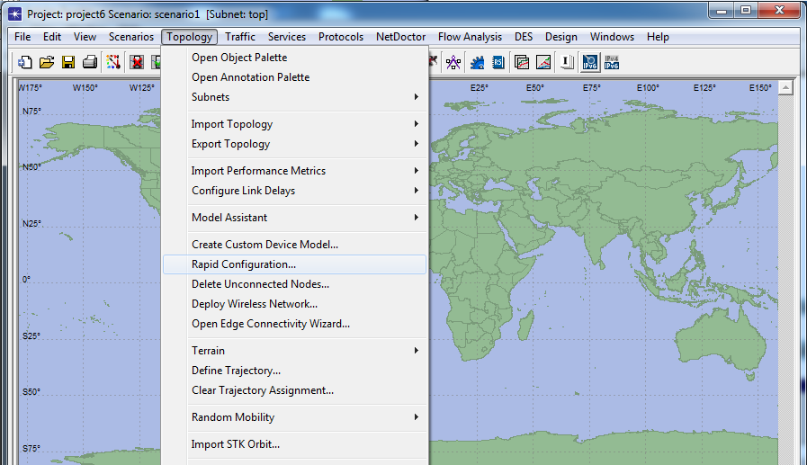

Step 2:

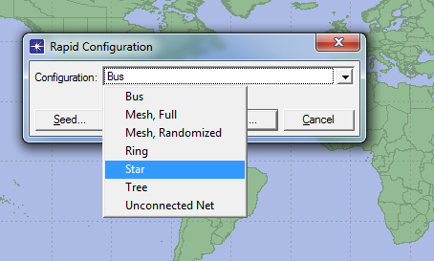

Step 3:

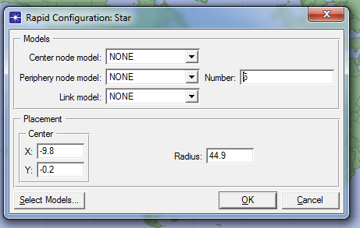

Step 4:

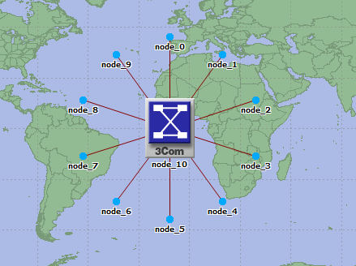

Object Attributes: All objects have attributes that control aspects of their behavior:

• Attributes may vary from one model to the next
• Attribute values may vary between objects of the same model type
• Right-click on an object and select “Edit Attributes” to view or change its attributes

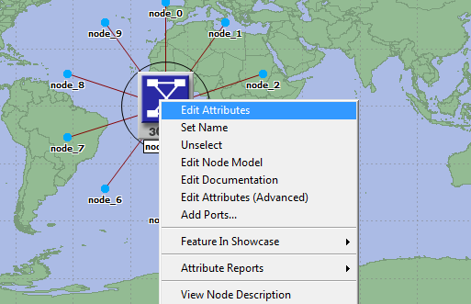

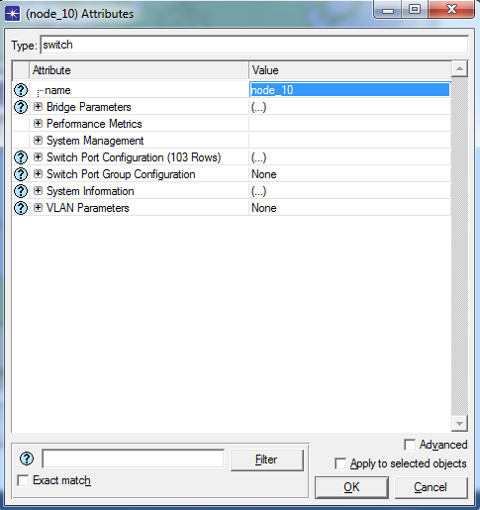
Change the name of nodes:

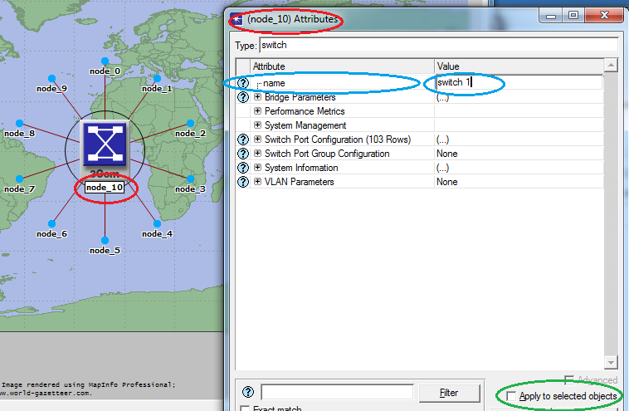
And also add a FTP server as bellow:

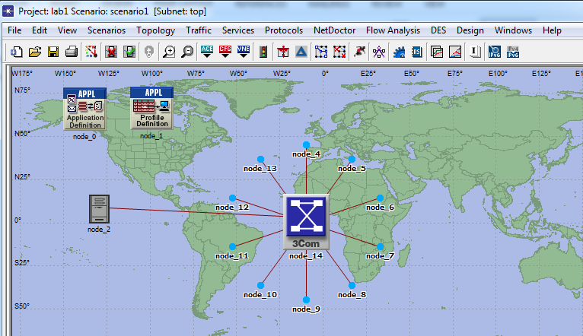
Which application are running in those clients?

Add to the project workspace the following objects from the palette: Application Config, Profile Config, and a subnet. Application Config is used to specify applications that will be used to configure users’ profiles. Profile Config describes the activity patterns of a user or group in terms of the applications used over a period of time. You must define the applications using the Application Config before using this object.
To add an object from the palette, click on its icon in the object palette ⇒move your mouse to the workspace ⇒ left-click to place the object. Right-click when finished. The workspace should contain the following three objects

Right-click on Application Config node ⇒ Edit Attributes ⇒ Change the name attribute to Applications ⇒ Change the Application Definitions attribute to Default ⇒ Click OK.
Right-click on the Profile Config node ⇒Edit Attributes ⇒ Change the name attribute to Profiles ⇒ Change the Profile Configuration attribute to Sample Profiles ⇒ Click OK.

Statistic Collection:

First step is Statistic Collection includes:
• Statistic Attributes
• Descriptions of Statistics
• Statistic collection modes

Three kinds of output:
– Vectors
» List of time-value pairs
– Scalars
» List of values dependent on parametric input
» Not plotted vs. time
– Animations
» Packet flows
» Node movements
• Objects have pre-defined statistics
– For example: throughput, bits received, bits forwarded, etc.

Note: Understanding Statistics:
• It is essential to define the goals of the study and to understand the statistics needed to get useful results
• Browse available statistics and view their descriptions
• Understand the default collection mode to help interpret results

Statistic Attributes
• Right-clicking on a statistic while in the Choose Results dialog box presents a menu of statistic attributes

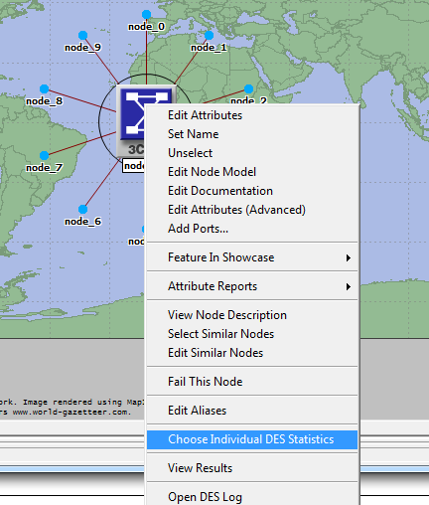

And also we can use DES menu as follow:

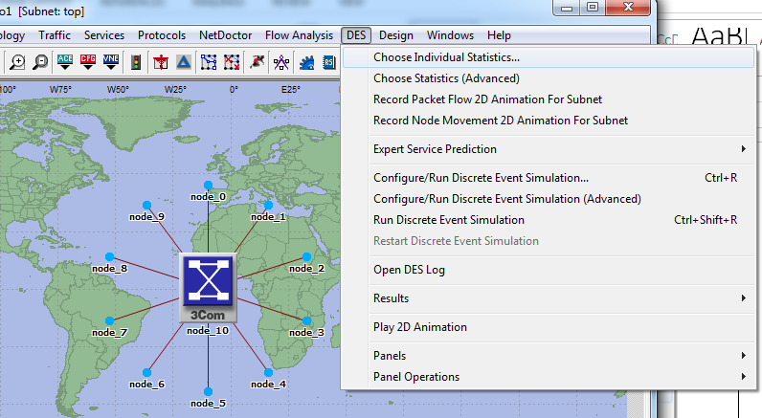

Or for global results Right Click on the work-space and select Choose Individual Statistics to select the statistics to be measured during the simulation
:

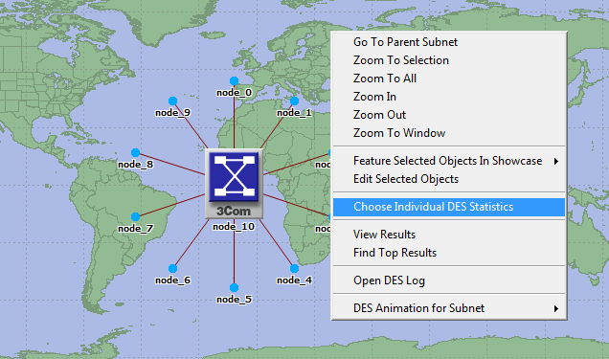

Click it to open Choose Results window

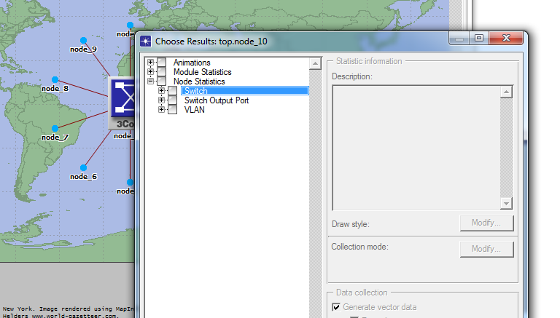

Select global Statistics/Ethernet/Delay

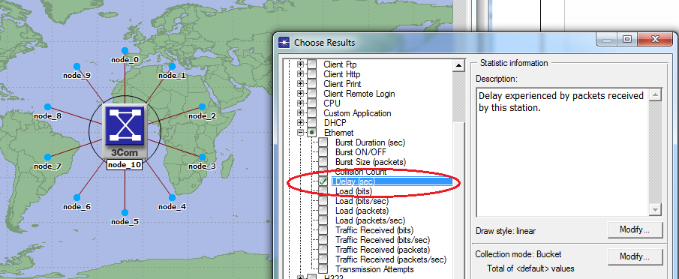

And also, right click on server and follow same approach and select load.

Configuring Simulations:

• Scenarios automatically provide a default duration and random number seed for simulations
• Users can set simulation attributes by choosing “Configure Simulation” from the Simulation menu, or by clicking on the “running man” icon:

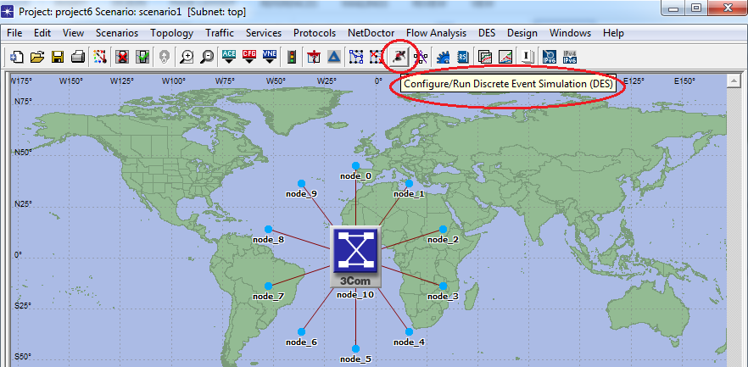
And also we can use DES menu as follow:

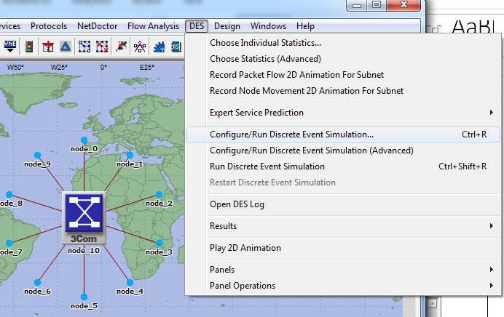
Then,

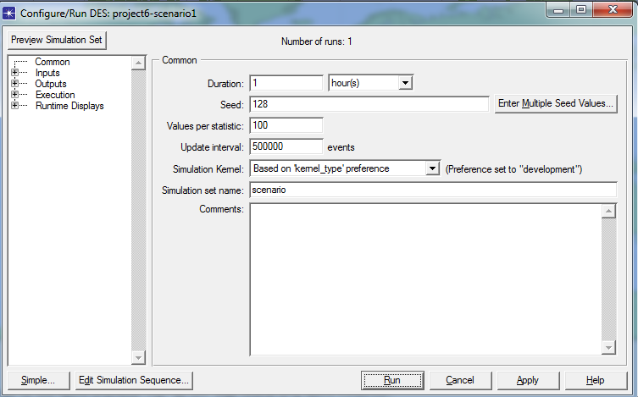

Configure your simulation based on demand and RUN:

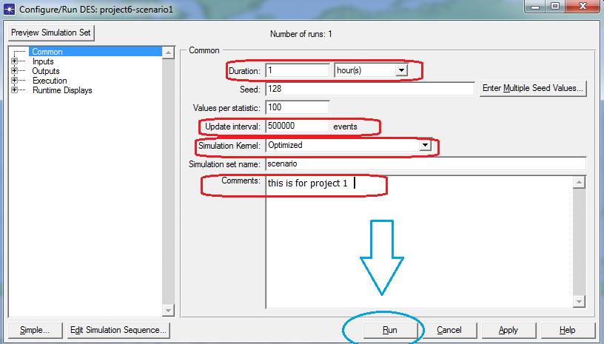

- Elapsed/Remaining Time: Real time elapsed and remaining time
- Simulation Time: Simulation time elapsed and number of events processed

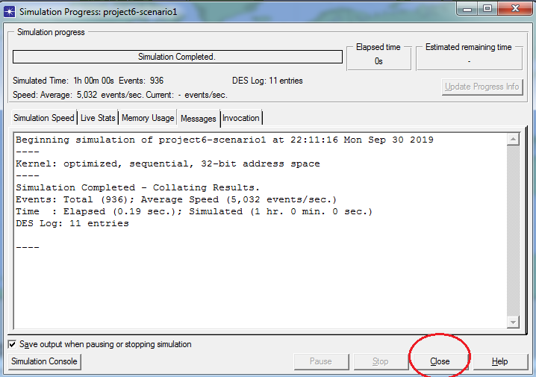

Viewing Results
• Results can be displayed by:
– Selecting the “View Results” button on the tool bar
– Selecting View Results from the Results menu
– Right-clicking the project workspace and selecting from the pop-up menu

• View Results dialog box allows the user to select the results to display.
- Note: Only the statistics you chose for collection will be available
• The “Show” button in the “View Results” dialog box displays a graph of the selected statistics
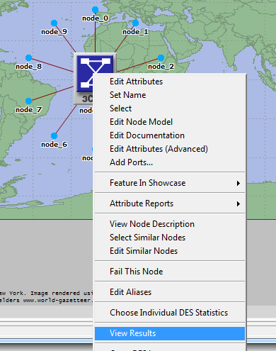

Or:
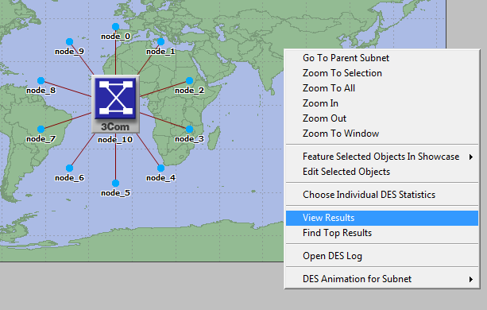
Or from DES menu as follow:

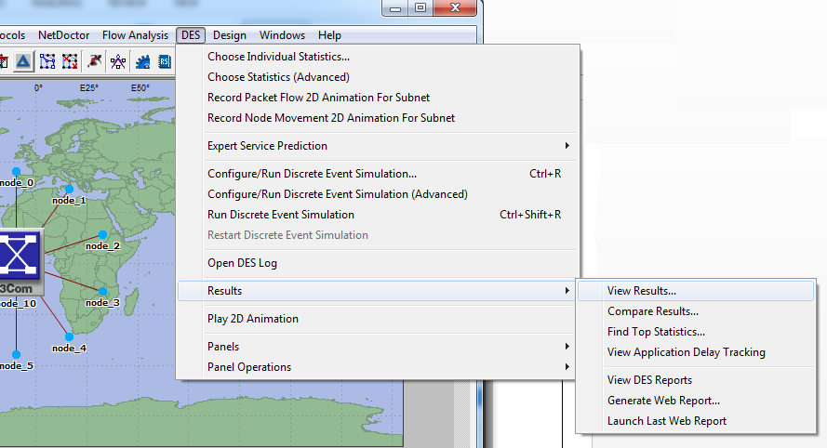

Click on View Results to open Result Browser as follow (Select your outputs on demand):

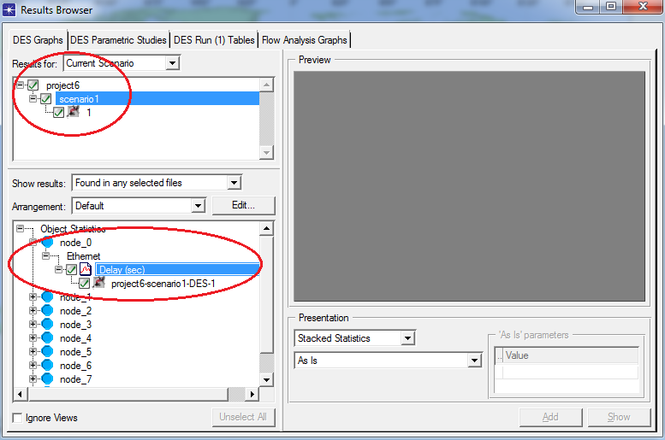

Select your outputs and evaluate the Viewing Results:

• Multiple graph panels can be displayed at the same time
• Each panel can contain one or more traces in an Overlaid or
Stacked layout

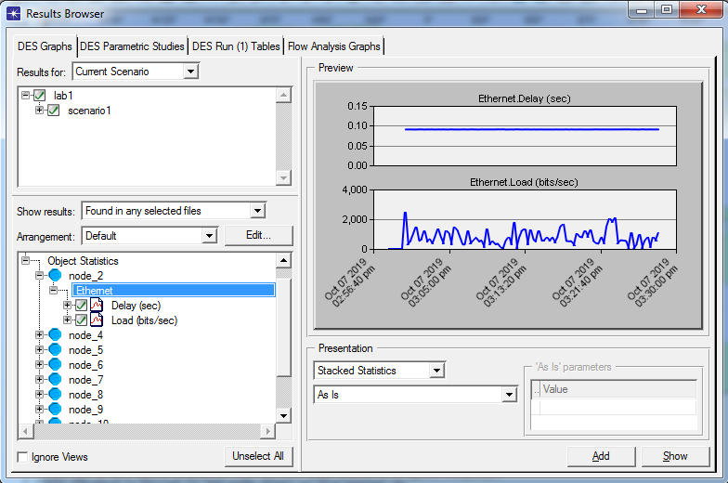

First experiments:

To create our switched LAN:
1. Select Topology → Rapid Configuration. From the drop-down menu choose Star and click OK.
2. Click the Select Models button in the Rapid Configuration dialog box. From the Model List drop-down menu choose ethernet and click OK.
3. In the Rapid Configuration dialog box, set the following six values: Center Node Model = ethernet16_hub, Periphery Node Model = ethernet_station, Link Model =
10BaseT, Number =16, Y=50, and Radius = 42 → Click OK.
Note: Remember that 10BaseT link represents an Ethernet connection operating at 10Mbps.
4. Right-click on node_16, which is the hub → Edit Attributes →Change the name attribute to Hub1 and click OK.
5. Now that you have created the network, it should look like the network on Figure below.

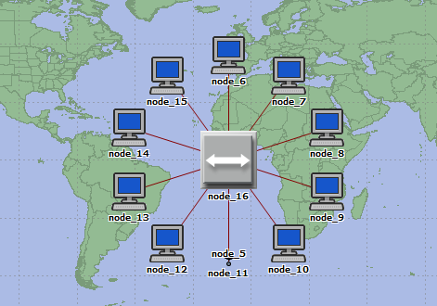

6. Make sure to save your project.

Configure the network nodes
Here you will configure the traffic generated by the stations.
1. Right-click on any of the 16 stations (node_0 to node_15) → Select Similar Nodes.
Now all stations in the network are selected.
2. Right-click on any of the 16 stations → Edit Attributes.
a. Check the Apply Changes to Selected Objects check box. This is important
to avoid reconfiguring each node individually.
3. Expand the hierarchies of the Traffic Generation Parameters attribute and the
Packet Generation Arguments attribute → Set the following four values:

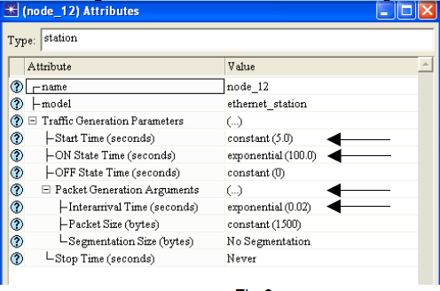

4. Click OK to close the attribute editing window. Save your project Note here that we have introduced a traffic generation at each node. The traffic model follows a well-known ON-OFF model, in which each node switches between On state in which the traffic is generated, and OFF state in which there is no traffic. The duration of ON and OFF states is random, and in this example follows exponential distribution. In this example, the duration of OFF state is 0.

Choose Statistics
To choose the statistics to be collected during the simulation:
1. Right-click anywhere in the project workspace and select Choose Individual Statistics DES from the pop-up menu.
2. In the Choose Results dialog box, choose the following 4 statistics:
a. Ethernet Delay – this represents the end-to-end delay of all packets received by all the stations.
b. Traffic Received (in packets/sec) by the traffic sinks across all nodes
c. Traffic Sent (in packets/sec) by the traffic sources across all nodes
d. Collision count is the total number of collisions encountered by the hub during packet transmissions.
3. Click OK.

Configure the Simulation
Here we need to configure the duration of the simulation:
1. Click on the Configure / Run Simulation button.
2. Set the duration to be 2.0 minutes
3. Click Apply and then Cancel

View Results:

Or from DES menu as follow:

Click on View Results to open Result Browser as follow (Select your outputs on demand):

Select your outputs and evaluate the Viewing Results:

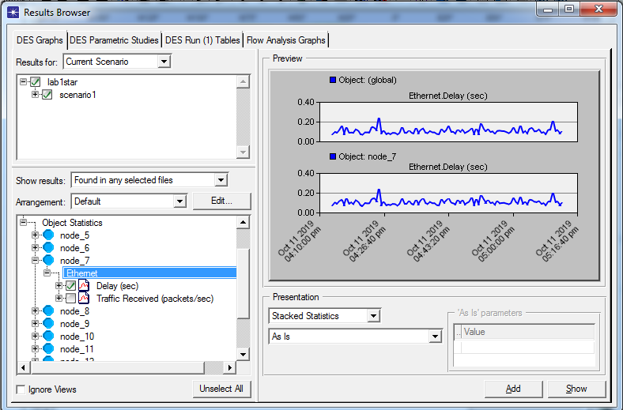

• Multiple graph panels can be displayed at the same time
• Each panel can contain one or more traces in an Overlaid or
Stacked layout
Important warning:
The lab is now completed. Show your result to Lab Assistant.
(In order to grading)

Homework:
- Design a network with star Topology with 15 pc and one switch
- Design a network with Bus Topology with 10 pc at least

