Eastern Mediterranean University
Computer Engineering Department
CMPE344-CMSE346 - Computer Networks– Lab. 3

Title: Create Subnetworks Using OPNET Modeler

Network Design:

The objective of this lab is to demonstrate the basics of designing a network, taking into consideration the users, services, and locations of the hosts.

Create a New Project

- Start OPNET IT Guru Academic Edition ⇒ Choose New from the File menu.
- Select Project and click OK ⇒ Name the project <lab3> and the scenario SimpleNetwork ⇒click Ok.
- In the Startup Wizard: Initial Topology dialog box, make sure that Create Empty Scenario is selected ⇒ click Next ⇒ choose Miles from the Size drop-down menu and assign 1 for both X Span and Y Span ⇒ click Next twice ⇒ click OK.

Create and configure the Network

Initialize the Network:
- The Object Palette dialog box should be now on the top of your project space. If it is not there open it by clicking Make sure that the internet_toolbox is selected from the pull-down menu on the object palette.

- Add to the project workspace the following objects from the palette: Application Config, Profile Config, and a subnet. Application Config is used to specify applications that will be used to configure users’ profiles. Profile Config describes the activity patterns of a user or group in terms of the applications used over a period of time. You must define the applications using the Application Config before using this object.

a. To add an object from the palette, click on its icon in the object palette ⇒
move your mouse to the workspace ⇒ left-click to place the object. Right-click when finished. The workspace should contain the following three objects

- Right-click on Application Config node ⇒ Edit Attributes ⇒ Change the name attribute to Applications ⇒ Change the Application Definitions attribute to Default ⇒ Click OK.
- Right-click on the Profile Config node ⇒Edit Attributes ⇒ Change the name attribute to Profiles ⇒ Change the Profile Configuration attribute to Sample Profiles ⇒ Click OK.

Note: Sample Profiles provides patterns of applications employed by users such as
engineers, researchers, salespeople, and multimedia users.

Configure a subnet:

- Right-click on the subnet node ⇒ Edit Attributes ⇒ Change the name attribute to Engineering and click OK.
- Double-click on the Engineering node. You get an empty workspace, indicating that the subnet contains no objects.
- Open the Object Palette and make sure it is still set to internet_toolbox.
- Add the following items to the subnet workspace: 10BaseT LAN, ethernet16Switch, and a 10BaseT link to connect the LAN with the Switch ⇒ Close the palette.
- Right-click on the 10BaseT LAN node ⇒ Edit attributes ⇒ Change the name attribute to LAN ⇒observe that the Number of Workstations attribute has a value of 10.
- Click in the Value column for the Application: Supported Profiles attribute, and select Edit. You should get a table in which you should do the following:

- Set the number of rows to 1
- Set the Profile Name to Engineer. Note: Engineer is one of the “samples” profiles provided within the Profile Config object.
- Click OK twice.

The object we just created is equivalent to a 10-workstation star topology LAN. The
traffic generated from the users of this LAN resembles that generated by “engineers”.

- Rename the ethernet16 Switch to Switch
- The subnet should look like the one in figure below.

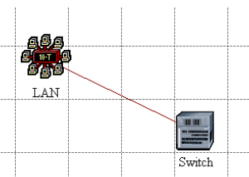

- Save your project

Configure All Departments:

Now you have completed the configuration of the Engineering Department subnet. To go back to the main project space, click the Go to the higher-level button.

- Make three copies of the Engineering subnet we just created. Click on the Engineering node ⇒ From the Edit menu, select Copy ⇒from the Edit menu select Paste three times, placing the subnet in the workspace after each, to create the new subnets.
- Rename (right-click on the subnet and select Set Name) and arrange the subnets as shown below:

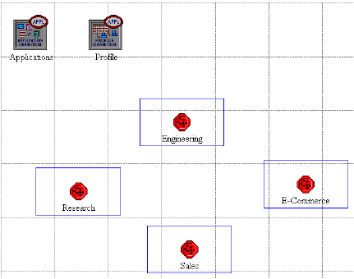

- Double-click the Research node ⇒ Edit the attributes of its LAN ⇒ Edit the value of the Application: Supported Profile attribute ⇒ Change the value of the Profile Name from Engineer to Researcher ⇒ Click OK twice ⇒go to the higher level by clicking related the button.
- Repeat step 4 with the Sales node and assign to its Profile Name the profile Salesperson.
- Repeat step 4 with the E-Commerce node and assign to its Profile Name the profile Ecommerce Customer.
- Save the project.

Configure the Servers:

Now we need to implement a subnet that contains the servers. The servers have to support the applications defined in the profiles we deployed. You can double-check these applications by editing the attributes of our Profile node. Inspect each row under the Applications hierarchy, which in turn, is under the Profile Configuration hierarchy. You will see that we need servers that support the following applications: Web browsing, Email, Telnet, File Transfer, Database, and File Print.

- Open the Object Palette and add a new subnet ⇒rename the new subnet to Servers ⇒ double-click the Servers node to enter its workspace.
- From the Object Palette, add three ethernet_servers, one ethernet16_switch, and three 10BaseT links to connect the servers with the switch.
- Close the Object Palette
- Rename the servers and the switch as follows:

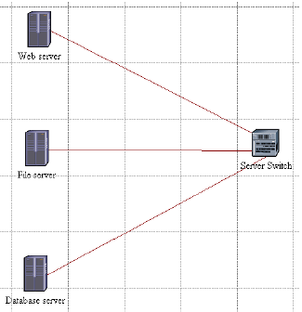

- Right-click on each one of the above servers and Edit the value of the Application: Supported Services attribute.

a. For the Web Server add four rows to support the following services: Web Browsing (Light HTTP1.1), Web Browsing (Heavy HTTP1.1), Email (Light) and
Telnet Session (Light)
b. For the File Server add two rows to support the following services: File
Transfer (Light) and File Print (Light).
c. For the Database Server add one row to support the following service:
Database Access (Light).

- Go back to the project space by clicking the Go to the higher-level button.
- Save the project

Connect the Subnets:
Now all subnets are ready to be connected together.
- Open the Object Palette and add four 100BaseT links to connect the subnets of the departments to the Servers subnet.
- As you create each link, make sure that it is configured to connect the “switches” in both subnets to each other. Do this by choosing them from the drop-down menu. 2. Close the Object Palette.
- Now your network should resemble the following one:
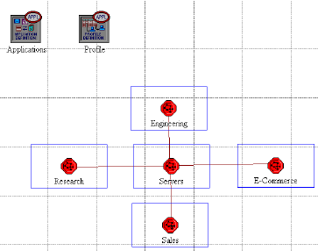

- Save the project

Choose the Statistics

To test the performance of our network we will collect one of the many available statistics as follows:
- Right-click anywhere in the project workspace and select Choose Individual Statistics from the pop-up menu.
- In the Choose Results dialog box, choose Global statistics => HTTP => Page
- Response Time (seconds). Page response time is the required time to retrieve the entire page.
- Click OK.

Configure the Simulation
Here we need to configure the duration of the simulation

- Click on the Configure/Run Simulation button.
- Set the duration to be 30.0 minutes
- Press OK

Duplicate the Scenario
In the network we just created we assumed that there is no background traffic already in the links. In real networks, the links usually have some existing background traffic. We will create a duplicate of the SimpleNetwork scenario but with background utilisation in the 100BaseT links. Link utilisation is the percentage of the used link bandwidth.

- Select Duplicate Scenario from the Scenarios menu and give it the name BusyNetwork⇒ click OK.
- Select all the 100BaseT links simultaneously (click on all of them while holding the Shift key) ⇒ Right-click on anyone of them ⇒ Edit Attributes ⇒ Check the Apply Changes to Selected Objects check box.

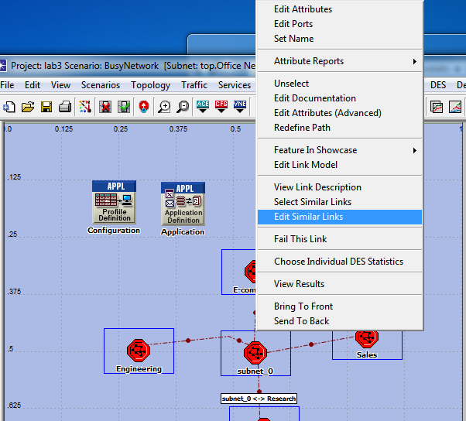

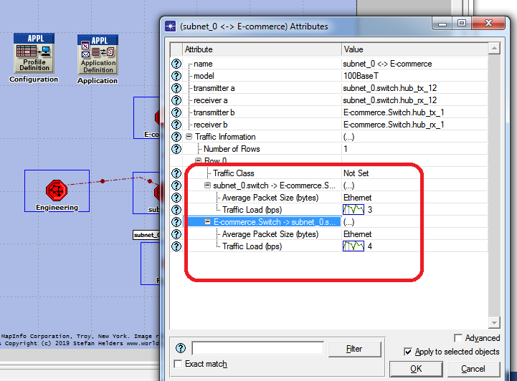

- Enter the “Traffic Information”change traffic load for both side as the pictures show you.

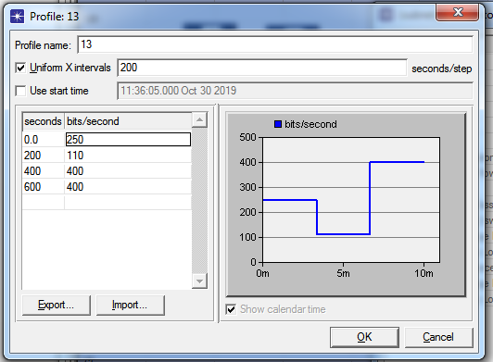

8. Save your project

Run the Simulation

To run the simulation for both scenarios simultaneously:

1. Go to the Scenarios menu ⇒ Select Manage Scenarios.
2. Change the values under the Results column to <collect> for both scenarios. Compare.
4. Click OK to run the two simulations.
5. After the two simulation runs complete (one for each scenario), click Close.
6. Save the project

View the Results

To view and analyse the results:

1. Select Compare Results from the Results menu
2. Change the drop-down menu in the lower-right part of the Compare Results dialog box from As Is to time_average.
3. Select the Page Response Time (seconds) statistics and click Show.

Important warning:
The lab is now completed. Show your result to Lab Assistant.
(in order to grading)

Homework:

- Design a network for your university included: computer engineering department, electronic and electrical engineering department, civil engineering department, register office and rector office. And have the same server as lab sheet.

