Sample Questions for Midterm From students
Set 1 : Can Pahalı
List the types of requirements and shortly describe each other.
- User requirements
  - Statements in natural language plus diagrams of the services the system provides and its operational constraints.
  - Written for customers.
- System requirements
  - A structured document setting out detailed descriptions of the system’s functions, services and operational constraints.
  - Defines what should be implemented so may be part of a contract between client and contractor.
  - Written as a contract between client and contractor
- Software specification
  - A detailed software description which can serve as a basis for a design or implementation.
  - Written for developers

Give one example for library system from each of these requirement types:
- Functional requirements:
- Non-functional requirements:
- Domain requirements:

List the readers of,
User Requirements:  - System end-users  - Client Engineers  - System architects  - Client Managers  - Contractor Managers | System Requirements:  - System end-users  - Client Engineers  - System architects  - Software developers

Draw the V-model and shortly describe each phase.

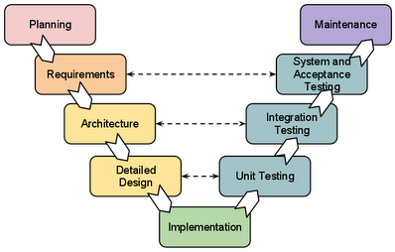

Draw the waterfall model and shortly describe each phase.
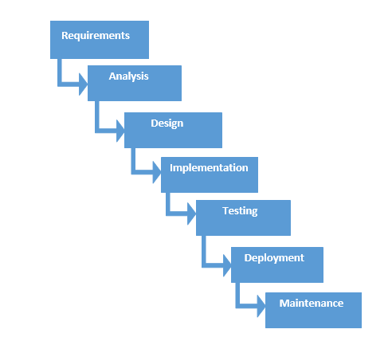

Draw the Evolutionary model as the spiralmodel and shortly describe each phase.
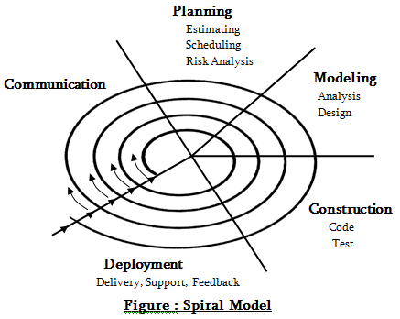

Set 2 Erdogan Alper
Q1) Briefly describe what Configuration Management is and which parts does it necessary on software systems?
Ans
It is the disciplines and techniques of initiating evaluating and controlling change to software products. And CM is necessary when a software system has many developers and many versions.

Q2) List the Origin of Changes
Ans
- New business or marketing conditions
- New customer needs
- Reorganization or business growth
- Budgetary or scheduling constrains
- Most changes are justified
Q3) Draw Configuration Management Process
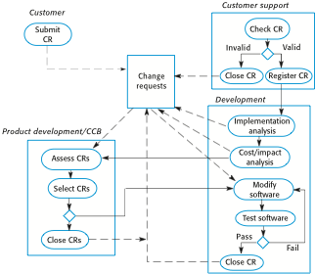
Ans

Q4) What is the different between codeline and baseline
Ans
Codeline normally appy to components of systems but baseline is the component versions that are included in the system.

Q5) Draw and explain the storage management using deltas?
Ans
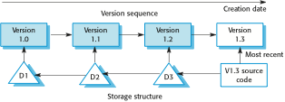
Reduce the disk space required and system simply stores a delta to maintain all system versions

Q6) Difference between white box and black box testing?
Ans
On black box testing, tester can only look at the interface of the program but on the other hand white box test, tester can able to study the code to see the logic of the program correct.
Q7) What is validation and its techniques?
Ans
The requirements that define the system that the customer really wants.
Techniques:
- Review
- Prototype
- Writing test cases
- Verification of properties
Q8) List requirements checking
Ans
- Validity
- Consistency
- Completeness
- Realism
- Verifiability

