EASTERN MEDITERRANEAN UNIVERSITY
COMPUTER ENGINEERING DEPARTMENT
CMPE224 DIGITAL LOGIC SYSTEMS
EXPERIMENTAL WORK #4
COUNTERS IN VeriLog HDL

OBJECTIVES:
This laboratory work aims to introduce a practical work on the design of Counters from architectural and behavioral descriptions. The architectural description covers both the schematic and the software implementation of circuits designed through the conventional design procedure. The behavioral descriptions cover the implementation using state transition diagrams.

Important Note: For each of the following experimental tasks (in each phase), open a new project to avoid compilation errors due to multiple use of components within the same project’s files.
Phase 1: Schematic-Entry
Assume that we want to design the following multi-function counter that is controlled by two control inputs S1 and S0 as follows:
Mode Control |  | Register  Operation
S1 | S0
0 | 0 | Count Up
0 | 1 | Count Down
1 | 0 | Parallel Load
1 | 1 | No Change

The schematic circuit corresponding to this multi-function counter is given below:
  - Draw the circuit of this multifunction counter, compile and simulate it in VeriLog HDL environment and verify its mode of operations. Adjust and apply appropriate waveforms to observe different function modes easily.

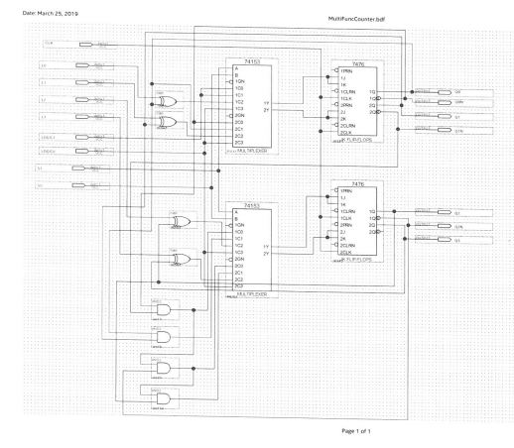

Phase 2: Implementing the Architectural Design of Multi-Function Counter in Verilog HDL
Enter the following architectural VeriLog code of multifunction counter design into Quartus Lite development suite. Compile and simulate your code to verify its correctness.
/* Multifunction counter controlled by two control inputs S1 and S0 as follows:
S1 S0 Operation Mode
0 0 Count up
0 1 Count down
1 0 Prallel load
1 1 No change
*/

module MultiFuncCounter_Arch(CLK,Clear,S,PL,Q);
input CLK, Clear;
input [1:0] S;
input [3:0] PL; // Parallel load
output reg [3:0]Q; // Counter outputs

wire [3:0] W;
wire [3:0] QT;

MUX_4_1 m1(W[0],S[1],S[0],I31,I21,I11,I01);
MUX_4_1 m2(W[1],S[1],S[0],I32,I22,I12,I02);
MUX_4_1 m3(W[2],S[1],S[0],I33,I23,I13,I03);
MUX_4_1 m4(W[3],S[1],S[0],I34,I24,I14,I04);

T_FF t1(QT[0],W[0],CLK,Clear);
T_FF t2(QT[1],W[1],CLK,Clear);
T_FF t3(QT[2],W[2],CLK,Clear);
T_FF t4(QT[3],W[3],CLK,Clear);

assign

I31=1'b0,
I21=QT[0]^PL[0],
I11=1'b1,
I01=1'b1,

I32=1'b0,
I22=QT[1]^PL[1],
I12=QT[0],
I02=~QT[0],

I33=1'b0,
I23=QT[2]^PL[2],
I13=QT[1]&QT[0],
I03=~QT[1] & ~QT[0],

I34=1'b0,
I24=QT[3]^PL[3],
I14=QT[2]&QT[1]&QT[0],
I04=~QT[2] & ~QT[1] & ~QT[0];

always
Q <= QT;

endmodule

module MUX_4_1(Y,S1,S0,I3,I2,I1,I0);
input S1,S0,I3,I2,I1,I0;
output reg Y;

always @(S1,S0,I3,I2,I1,I0)
begin
if (S1==0 & S0==0)
Y=I0;
else if (S1==0 & S0==1)
Y=I1;
else if (S1==1 & S0==0)
Y=I2;
else if (S1==1 & S0==1)
Y=I3;
end
endmodule

module T_FF(QT,T,CLK,CLR);
input T,CLK,CLR;
output reg QT;

always @(posedge CLK)
if (CLR == 1'b1)
QT<= 1'b0;
else
QT<= T^QT;
endmodule

HOMEWORK #4 : (Behavioral Description of a Multi-function Counter)
Behavioral VeriLog code of the above described multifunction counter is given below:
/* Behavioral description of a multifunction counter in veriLog HDL
s1 s0 =00 Count up
S1 S0 =01 Count down
S1 S0 =10 Parallel load
S1 S0 =11 No change
*/

module MultiFunctCounter_Behav(CLK,Clear,S,PL,Q);
input CLK, Clear;
input [1:0] S;
input [3:0] PL; // Parallel load
output reg [3:0]Q; // Counter outputs

reg[3:0] QT;

always @(posedge CLK)
begin
if (Clear == 1)
QT <= 4'b0000;
else if (S[1]==0 & S[0]==0) // Count up
QT <= QT+1;
else if (S[1]==0 & S[0]==1) // Count down
QT <= QT-1;
else if (S[1]==1 & S[0]==0) // Parallel load
begin
QT[3] <= PL[3]; QT[2] <= PL[2];
QT[1] <= PL[1]; QT[0] <= PL[0];
end
else if (S[1]==1 & S[0]==1)
begin
QT=QT;
end
end

always
Q <= QT;

Endmodule

Modify the above-given behavioral code to design a 4-bit multifunction counter that operates as follows:
Enable S1 S0 Operation Mode
0 x x No change
1 0 0 Complement
1 0 1 Count up by two
1 1 0 Count down by two
1 1 1 Shift left

Submit your homework at the beginning of the 5-th experimental work.

Prepared by Assoc. Prof. Dr. Adnan ACAN

