MRKT 435 ADVERTISING TEAM WORK 1 (15%)
What is the task about?
Please have a compresenhensive strategic brand management plan for any of the following trainings:
- Negotiation and bargaining skills OR
- Elegance and protocol skills
Why should you do this task?
- For 15%
- To acquire and hone team work skills
- To acquire new vantage points from your teammates
- To hone strategic brand management skills
Task: You are expected to choose one of the topics and create a marketing communication plan in your team. Because you are students of Faculty of Business and Economics, as the potential brand managers of near future, you are expected to have a very comprehensive analysis of the issue, beside the marketing communication plan. A brand manager is usually responsible for not only the advertising and/or visuals of a product/service. S/he is in charge of managing every aspect of a brand ranging from product, pricing, location, design to commercials, not only for now but also for future, otherwise known as strategic brand management. In this task, you are expected to create hypothetical brand management strategies. You can assert any methods, techniques, strategies as long as you have a robust rationale (justification). If you can recall what I say in the class, strategic alignment is crucial in brand management. Strategic alignment is the smooth harmony of marketing mix. For example, if a university promotes itself as a truly international university but attracts students from only 2 countries or if a dentist targets the high income segment but her clinic is outdated and old, the brand will send confusing messages to customers. They should be on the optimal balance. That is why as the brand manager of any of these two training courses your marketing strategy should be in alignment. This task can be completely hypothetical. You can create interesting but logical strategies and justifications. Each team is expected to submit only one project. Please do not hesitate to add your feelings, opinions, conflicts into the project. I would like to see your discussion in the project. Please send your projects to ozan.inamlik@emu.edu.tr latest on the final exam day. Penalties for lateness may be applied at the rate of 2 percentage points per University working day after the due date, up to a maximum of 5 working days late. After this period the work may be counted as a nonsubmission.
For example: Your client came to Cyprus from the USA and has 15 years experience in the field. S/he sees potential in Cyprus. By the way s/he has access to Greek side too. S/he can speak Turkish and English fluently. S/he has training certificates from the USA. I am writing some questions to guide you. However, you are free to go beyond that. I strongly advice you to use some critical thinking tools such as SWOT, SMART, PESTEL, Gantt Chart. Your end product is expected to be more or less 20-25 pages (Times New Roman, single space, justified from the corners)
You are guided to follow a controlled way of thinking if you follow the below IMC Plan. Please use the following headings and order in your study.
PART I – PRELIMINARY REFLECTION
- Which topic did you choose? Why? Each team member is expected to write one paragraph (around 300 words, +/-50 words accepted) about why this topic has attracted his/her attention.
PART II – GET TO KNOW EACH OTHER WITH THE CLIENT
- What questions have you asked him/her to understand his/her character, personality, professional background, the product attributes s/he serves? What answers did you get from your client? Which answers do you think will ensure a competitive advantage for your marketing strategies. Your questions and answers are all hypothetical. As long as all aspects of your research in alignment and each item is justified sky is the limit! In this task, I would like to see if you can create a meaningful and aligned context from one end to the other. Please be reminded that your questions should be carefully worded to give a professional impression to the client. Please write your preliminary opinions about why you should work with this person. How will you work with him/her? Will you be working on commission based? Or fixed amount for your service?
PART III- ANALYSIS OF YOUR FINDINGS
Review of the Marketing Plan

The first step in the IMC planning process is to review the marketing plan and objectives. Before developing a promotional plan, marketers must understand where the company (or the brand) has been, its current position in the market, where it intends to go, and how it plans to get there. Most of this information should be contained in the marketing plan, a written document that describes the overall marketing strategy and
programs developed for an organization, a particular product line, or a brand. Marketing plans can take several forms but generally include five basic elements:

1. A detailed situation analysis that consists of an internal marketing audit and review and an external analysis of the market competition and environmental factors.
2. Specific marketing objectives that provide direction, a time frame for marketing activities, and a mechanism for measuring performance.
3. A marketing strategy and program that include selection of target market(s) and decisions and plans for the 6 elements of the marketing mix.
4. A program for implementing the marketing strategy, including determining specific tasks to be performed and responsibilities.
5. A process for monitoring and evaluating performance and providing feedback so that proper control can be maintained and any necessary changes can be made in the overall marketing strategy or tactics.
For most firms, the promotional plan is an integral part of the marketing strategy. Thus, the promotional planners must know the roles advertising and other promotional-mix elements will play in the overall marketing program. The promotional plan is developed similarly to the marketing plan and often uses its detailed information. Promotional planners focus on information in the marketing plan that is relevant to the promotional strategy.

Promotional Program Situation Analysis
After the overall marketing plan is reviewed, the next step in developing a promotional plan is to conduct the situation analysis. In the IMC program, the situation analysis focuses on the factors that influence or are relevant to the development of a promotional strategy. Like the overall marketing situation analysis, the promotional program situation analysis includes both an internal and an external analysis.

Internal Analysis The internal analysis assesses relevant areas involving the product/service offering and the firm itself. The capabilities of the firm and its ability to develop and implement a successful promotional program, the organization of the promotional department, and the successes and failures of past programs should be reviewed. The analysis should study the relative advantages and disadvantages of performing the promotional functions in house as opposed to hiring an external agency (or agencies). For example, the internal analysis may indicate the firm is not capable of planning, implementing, and managing certain areas of the promotional program. If this is the case, it would be wise to look for assistance from an advertising agency or some other promotional facilitator. If the organization is already using an ad agency, the focus will be on the quality of the agency’s work and the results achieved by past and/or current campaigns. Another aspect of the internal analysis is assessing the strengths and weaknesses of the firm or the brand from an image perspective. Often the image a firm brings to the market will have a significant impact on the way the firm can advertise and promote itself as well as its various products and services.
The internal analysis also assesses the relative strengths and weaknesses of the product or service; its advantages and disadvantages; any unique selling points or benefits it may have; its packaging, price, and design; and so on. This information is particularly important to the creative personnel who must develop the advertising message for the brand.

External Analysis The external analysis focuses on factors such as characteristics of the firm’s customers, market segments, positioning strategies, and competitors. An important part of the external analysis is a detailed consideration of customers’ characteristics and buying patterns, their decision processes, and factors influencing their purchase decisions. Attention must also be given to consumers’ perceptions and attitudes, lifestyles, and criteria for making purchase decisions. Often, marketing research studies are needed to answer some of these questions. A key element of the external analysis is an assessment of the market. The attractiveness of various market segments must be evaluated and the segments to target must be identified. Once the target markets are chosen, the emphasis will be on determining how the product should be positioned. What image or place should it have in consumers’ minds? This part of the promotional program situation analysis also includes an in-depth examination of both direct and indirect competitors. While competitors were analyzed in the overall marketing situation analysis, even more attention is devoted to promotional aspects at this phase. Focus is on the firm’s primary competitors: their specific strengths and weaknesses; their segmentation, targeting, and positioning strategies; and the promotional strategies they employ. The size and allocation of their promotional budgets, their media strategies, and the messages they are sending to the marketplace should all be considered. The following questions will help you focus on the depths of the issue.

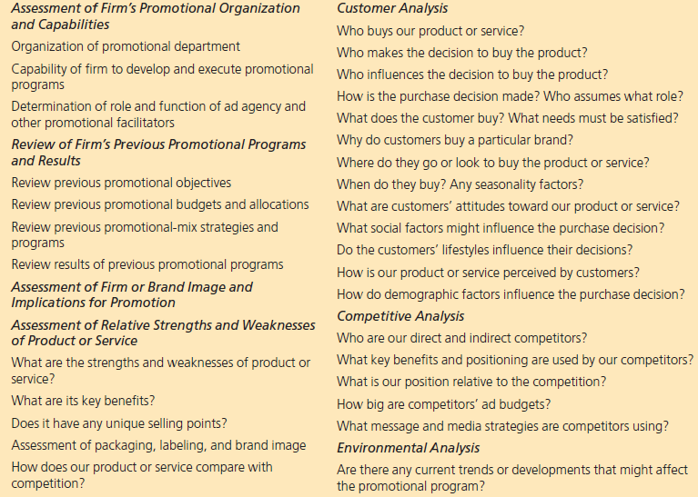

Please carefully follow the below model throughout your study.

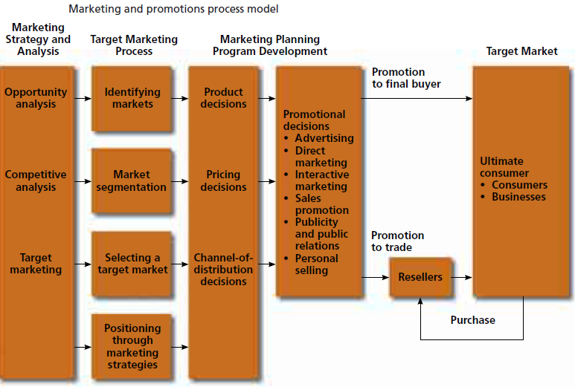

- Please use the following critical thinking tools and methodologies. Before starting 6Ps, it is so pivotal to decide on which segment you will target. How will you decide on your segment? Geographic location? income? specific gender/profession? level of education? Psychographical characteristics of potential buyers? Why? In other words, who will buy your product? Why do you think they will be attracted to buy? What is in it for them? What is the consumer insight?
MACRO ENVIRONMENT ANALYSIS - PESTEL
When you go to a new country/city/place to do business, a detailed environmental analysis is very important because macro level changes change the direction of businesses. For example, an economic progress will positively affect household income and disposable income, which can create a potential business evironment
Please make a detailed PESTEL analysis and explain which Political, Economical, Sociocultural Technological, Legislative changes can bring your business Opportunities and Threats. For example:
- POLITICAL: Both sides of the island are optimistics about the peace talks. In case of a unification, negotiation and bargaining skills can be very useful. After the formation of a new country and unification of two nations...That is why our team considers this political progress will help us raise customers’ awareness on Negotiation and bargaining skills

- ECONOMICAL/SOCIOCULTURAL: People are getting richer. GDP rose 16% within the last 2 years. Households have more disposable income. Even though there were no obvious social stratas between Cypriots, new social group have been formed and families spend more money for their kids’ education. A high society has emerged... That is why our team considers progresses will help us raise customers’ awareness on Elegance and protocol skills
Please make detailed explanations for each letter (P/E/S/T/E/L). I made a start by giving only one example. Please in detail write what kind of progresses can bring you more opoortunity to sell your course. While doing that brainstrom who can get the course you are offering (businessmen, students, lawyers, housewifes, politicians, university students, summer school students from other countries, etc) Please come up with not only opportunities but also threats from other service providers if any or government against marketing my services.

6 Ps of Marketing
- Product – How will you shape the product? What sort of products would you be serving to the market? Why? Who will be your target? Explain your rationale in detail.

What products (trainings) will you offer, in what form? You are an expert on the trainings you chose to work on? However, your experience and skills can give you the luxury of offering many sub-aspects of the training. You have the knowledge and content that can be customized according to the needs of the target. (from 2-50 hours) So you can divide your training into smaller chunks and offer according to the needs and demand of the people.

e.g. A two-hour F2F training for corporations on Game Theory
A two-hour F2F dressing code training for kids.
A two-hour online course on conflict resolution
A two-hour online course on flower selection

Please develop at least 5 products and justify the target population. (businessmen, students, lawyers, housewifes, politicians, university students, summer school students from other countries, sales staff, etc) In other words, why do you think they should buy your training? Your answer will be a great help for your promotion materials and sales materials. While branding especially a product/service is not well-known or awareness is not high, you should explicitely state “You should take this training because...” You are expected to write a small paragraph stating that e.g. a university student in the Faculty of Law should take this training because... an International Relations students should take Elegance and protocol skills because...
If you are going to offer online courses, why do you think developing online courses will contribute? Do you think it is logical to offer online courses? How will you prevent multiple entries and shares? Do you think it is logical to offer trainer training courses? Why?

- Price – What will be your pricing strategy? Why? Explain your rationale in detail.

Referring to the previous section and recalling your segment, how much will you charge for each training? Is your pricing strategy different if you sell the service to a company or independent individuals? What will be the maximum participant size in the course? Does the number of participants affect your pricing strategy?
Would you pursue a bundling strategy? How would it affect your pricing strategy?
Would you pursue an economies of scale or niche segment strategy? Would this affect your pricing strategy? Why and how?
While answering this part please consider your clients’ and your financial expectations?

- Place – Where will you be offering your product? Explain your rationale in detail.
Online-Brick and Mortar-Rent a place-Buy a place-B2B alliance
Would you rent an office and training center? Why? Would you collaborate or affiliate any organizations such as private courses, Continuous Education Centers of universities, municipalities.
- Promotion – Integrated Marketing Communication Mix.

Integrated marketing communication is a strategic business process used to plan, develop, execute and evaluate coordinated, measurable, persuasive brand communications programs over time with consumers, customers, prospects, employees, associates and other targeted relevant external and internal audiences. The goal is to generate both short-term ﬁnancial returns and build long-term brand and shareholder value.

What communication techniques and tools will you be using? Why? Explain your rationale in detail.

How would you reach the target population? Mass communication (TV, radio, newspaper)? Social media marketing? Evangelist/Word of mouth marketing? SMS marketing? Collaboration with strong social capital holders such as SALTO Youth Organization? F2F and B2B talks with universities/schools/companies? For this section please specify the target population and in detail explain why and how do you think you can use this communication medium and strategy to reach the target? Also justify your selection considering marketing communication budget.
Would you use free webinar system to raise awareness? Would you shoot some short promotion videos? Why? how? and what will be the content?
How would you use marketing PR? (e.g. an NLP trainer comes to EMU and offers a free seminar or webinar to attract attention and raise awareness on NLP but the aim is to get some customer for his/her expensive course...like an apetizer) Would you collaborate with columnists? Why and how?

Would you pursue a push strategy? In push strategy your product/service is recommended and sold a customer by another person. For example when one goes to a restaurant requests Yeni Rakı but the waiter recommends another one.

Will you have facebook/twitter/instagram acoounts? Why? How will you use them?

Would you have a web site? Why? How will you use it? What kind of content (informative pdf file, video, etc) would you add into your web site thus people can share?

What messages would you emphasize on your website?

What tactics would you use to trigger viral/buzz marketing via customers and also noncustomers?

What kind of negative publicity may emerge against you? What proactive PR activities can you develop? or should you?

Would your target market be affected by seasonality (change in terms of season (summer/winter)?

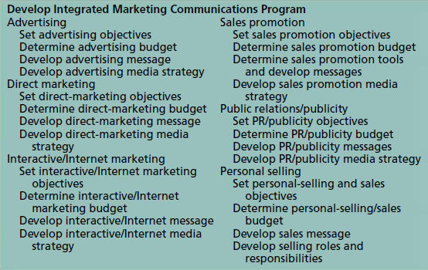

- Physical evidence – What are your tangibles? How should they be like? How much investment cost would you consider for the tangibles? Why?
- People – Who else would be your people? Why do you need them? Or do you need anyone else than the trainer? Explain your rationale in detail. What qualities and/or characteristics should they have?
PORTER’s 5 FORCES
- Power of buyers
- Power of suppliers
- Nature of competition
- New entrants
- Substitute products/services
According to Michael PORTER, a company must consider the above-mentioned forces in order to ensure sustainability and market share. They are all potential risks and preemptive actions must be taken to survive and reap above-market profit. Please GOOGLE PORTER s 5 Forces. I will be explaining it in the class. Please conduct a Opportunity and Threat analysis. After the analysis please come up with defence or offence strategies.
PART IV
Please prepare a SW (what are your strengths and weaknesses in marketing this training)? OT (What are the potential threats and opportunities in marketing this training?) analysis. Please list.
PART V
Please write SMART objectives those will be your road map to reach success
S – Specific
M- Measurable
A- Achievable
R – Relevant
T –Time Bounded
- By the end of this month, we will have had at least 30 F2F talks with medium and large scale company owners and introduce our trainings,
- By the end of this month, our free webinars will be watched by at least 1000 people....
PART VI
Marketing communication budget
How much will you spend for promotion? Please show your breakdown in detail. How will you make a decision?
Gantt Chart is a very simple but effective management tool especially for projects or campaigns. Please prepare a Gantt Chart for the first 21 working days. Example:
 | 1 | 2 | 3 | 4 | 5 | 6 | 7 | 8 | 9 | 10 | 11 | 12 | 13 | 14 | 15 | 16 | 17 | 18 | 19 | 20 | 21
Facebook marketing
Webinar
Company visits
Mass media

PART VII
REFLECTION
- Please write an individual reflective paragraph explaining what you have learnt/realized/acquired in this task and teamwork. (Nothing! can also be an answer, if you have really not acquired anything)

